 | Swarna Bharat Party स्वर्ण भारत पार्टी
 | Liberty first
26 July 2017 | Annual Report, 2016-17

SBP is your platform to fight for your freedom and transform India's governance.
Lifetime membership fee is Rs.100. Please also donate liberally.

G-249 Palam Vihar Gurgaon 122017
www.swarnabharat.in email: info@swarnabharat.in
Registration No. No. 56/102/2013/PPS-1
Contents
Annual report 2016-17 4
KEY HIGHLIGHTS OF THE YEAR 5
Article in Times of India by Sanjeev Sabhlok which introduced the party to the country: For a liberal India: The country now has its first liberal party, the Swarna Bharat Party 5
Horasis Conference 6
office bearers AS AT 30 JUNE 2017 8
National office bearers 8
State Coordinators 9
Key activities of the Party in 2016-17 10
SBP’s press conference in Pune on 12 April 2016 10
SBP’s payment gateway operational from 14 April 2016 10
SBP’s second press conference in Pune on 25 June 2016 in a build up to the local municipal elections 10
Swarna Bharat Party’s Youtube channel activated on 21 July 2016 11
Coverage of the party by Liberty Viral in July 2016 12
Meeting with activists in Jaipur, 28 July 2016 12
National Conference of SBP, 30 and 31 July, and 1 August 2016 13
Public meeting at Bhadohi on 2 August 2016 14
Public meeting at Mirzapur on 3 August 2016 16
Public meeting at Pune on 6 August 2016 18
Press Conference in Bengaluru on 8 August 2016 19
Meeting in Jaipur on 8 August 2016 21
Swarna Bharat Kisaan app launched by party members on 8 August 2016 22
Party workers meeting at Hyderabad on 9 August 2016 23
Press Conference in Hyderabad on 9 August 2016 23
Launch of the national reform movement on 2 October 2016 25
SBP team working to alleviate effects of Demonetisation – November 2016 27
Skill development workshop in Bihar 28
The liberty song. 30
Press Releases 32
We must support Constitutional, not sectarian nationalism, says SBP President, Vishal Singh 32
Modi government has failed to create the conditions for new jobs, says SBP President, Vishal Singh 32
The mantra of Swachh Bharat cannot deliver results. Only governance reforms can, says SBP President, Vishal Singh 33
Swarna Bharat Party, India’s only liberal party, has arrived 34
Public sector banks are a major channel to loot India, says SBP President, Sanjay Sonawani 35
The law should punish all atrocities, not just against SC and ST communities, says Swarna Bharat Party President Sanjay Sonawani 36
The deprived sections of society will be the most to benefit from Swarna Bharat Party’s policies, says the party’s President Sanjay Sonawani 37
Small businesses need good governance, not sops or protection, says SBP President, Sanjay Sonawani 38
Governments should stop looting sugarcane farmers, says Swarna Bharat Party Vice-President, Alok Kumar 38
Swarna Bharat Party is deeply concerned about India’s defence, says its President, Sanjay Sonawani 39
Swarna Bharat Party will now launch a national movement since the PM is not interested in governance, says the party President, Sanjay Sonawani 40
Swarna Bharat Party President Sanjay Sonawani has launched a national movement for good governance 41
Only Swarna Bharat Party’s liberal policies can save us from mosquito-borne diseases: Alok Kumar, Vice President 42
Quotas only redistribute jobs. To create new jobs will need liberal governance reforms, says Swarna Bharat Party president Sanjay Sonawani 43
Swarna Bharat Party demands that public grazing lands be protected from encroachment: President Sanjay Sonawani 43
Swarna Bharat Party’s position on the Uniform Civil Code 44
Swarna Bharat Party’s President asks Mr Modi why he is doing nothing to eliminate the causes of corruption 45
Swarna Bharat Party asks Mr Modi to abrogate all unnecessary free speech restrictions in India 46
Swarna Bharat Party says that demonetisation has been implemented badly and will do nothing to address the causes of corruption and black money 47
Swarna Bharat Party asks the PM to implement state funding of elections on per vote basis 48
Widespread police corruption unabated under Mr Modi’s regime, says Swarna Bharat Party 49
Swarna Bharat Party’s new President, Rahul Pandit, reaffirms his commitment to liberty 50
Swarna Bharat Party calls for a national emergency to stop 5 lakh Indians dying from TB each year 50
Swarna Bharat Party demands immediate revocation of the new rules regarding sale of animals 51
Swarna Bharat Party wants the Indian government to immediately sign free trade agreements 52
Sanjay Sonawani, Swarna Bharat Party leader to launch a mission to encourage dehydration of fruits and vegetables 53
Letter to Indian citizens, 1 September 2016 54
Media Coverage of Swarna Bharat Party 57
News published in Freedom First 6 September 2016 57
Daily Punyanagari, Pune edition 59
News in Daily Punyanagari, Amravati edition 59
Ground Report India 60
Chaprak (page 1 and 8) 60
Maharashtra Times, Ahmednagar edition. 62
Daily Pudhari, Ahmednagar 63
Article discussing SBP's position re: Atrocities Act 64
Daily Prahar, Mumbai 64
Ground Report India Coverage – Sugarcane Farmers’ Rally 65
Ground Report India coverage – Small Businessses need Good Governance 66
Ground Report India coverage – Caste system 67
Rajasthan Patrika 67
Daily Pudhari, Pune, about SBP's demands on Small Scale Industries 68
Maharashtra Times 68
Punyanagari 69
Parsiana 70
The Public World 71
MyMarathi - Coverage of SBP 2 October Rally 72
Jagran - Coverage of SBP 2 October Rally 73
Divya Marathi, Solapur 73
Daily Sanchar, Solapur 73
Lokmat - SBP President, Sanjay Sonawani's public talk in Sholapur 74
News on Mymarathi 75
Daily Samachar Post, New Delhi 76
Punyanagari, (page 17, Pune edition) 77
Pune Darpan 78
Tennews 79
Saptahik Chaprak,(page 8) 80
Daily Pudhari 80
Tarun Bharat 81
Saptahik Chaprak 81
NewsGram 82
Write-up by Sanjeev Sabhlok in the The Wire- The urgent necessity for state funding of elections. 83
Newsgram 85
Dainik Bhaskar 86
Lokmat epaper 87
Op-ed in the Times of India by SBP leader Sanjeev 88
Sirf News Coverage 88
SBP was the only party other than BJP and SBP invited by Horasis or the India Meeting 2017 92
Outline strategic plan and budget, 2017-18 93
Outline of the party’s strategic plan for 2017-18 93
Financial statement – FY2016-17 94
Scanned copies of financial statements 94
Financial statement – FY2016-17 96
Scanned copies of financial statements 96
Copy of report on donations sent to Election Commission 98
Copy of Income Tax return of the party, 2016-17 101
Scanned copy of the income tax return 101

Annual report 2016-17

SWARNA BHARAT PARTY- India’s NATIONAL liberal party
It is our privilege to present to you the annual report of accounts and of activities undertaken by Swarna Bharat Party, India’s only liberal party, during the Indian financial year 2016-17.
Due to the timing of the report publication, some information about activities has been updated till end of June 2017 and may partly overlap with the future report for 2017-18.
- 2016-17 is the first full year since the party started work on the ground.

- The party thanks everyone who has participated and contributed to the growth of the party over 2016-17.

- It is high time for Indians to demand liberty and good governance and take India to an entirely new level

- The party has now got a national and international presence.

- There is increasing confidence that the job at hand is doable. However, the task remains extraordinarily challenging.
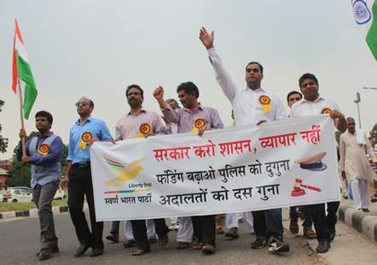

KEY HIGHLIGHTS OF THE YEAR

Article in Times of India by Sanjeev Sabhlok which introduced the party to the country: For a liberal India: The country now has its first liberal party, the Swarna Bharat Party
Published in Times of India on 1 April 2017
Till 1991, decades of central planning, licence raj and big government had crushed the confidence of Indian youth in their ability to compete globally. Liberalisation changed all that. India integrated into the global economy, started modernising, and its national income shot up. No longer was it necessary to wait for one’s relatives settled abroad to bring in tiny blocks of imported cheese. No longer was it necessary to apply for permissions in triplicate to get foreign exchange.
But something was amiss. For whatever reason, no one was stepping forward to claim credit for this Big Bang reform. No leader told us why liberalisation is good. And the many failures of basic governance continued, unabated. Two things stood out in particular: low levels of freedom and high levels of corruption.
Even today, nearly 70 years after independence, India ranks close to the bottom of the world in all global indicators of freedom and justice. And we have a Censor Board, we have laws about matters that should be within the purview of religion, and our governments directly manage or fund religious bodies and events.
As far as corruption is concerned, my stint in the IAS since 1982 showed me that India’s politicians were hopelessly corrupt and that corruption always started from the top. I was getting sick of serving under these despicable “leaders”.
In 1998 i decided to look for a political solution. Joining mainstream parties was not an option because of their involvement in corruption. What i was looking for was a liberal party that would fight for a small but strong government, for free markets and for equality of opportunity (not equal outcomes). It would form a government that undertakes a limited role – of defence, security and justice. Such a government would have very little discretion in regulating people’s social preferences or economic affairs except to the extent they physically harm others. Such a government would never be allowed to use taxpayers’ money to operate businesses such as Air India or Ashok hotel.
Since the reforms needed for this to happen would require controlling the central government, this party would have to be national (as opposed to regional).
After an initial failed discussion with a few liberals about forming such a party, i resigned from the IAS in 2001 and moved to Australia to learn about modern governance and to continue my search for a liberal party. The key was to find leaders to take this forward. In a book that i wrote in 2008 to outline policies that such a party would implement, i invited liberals to form a team. This team grew bigger and we launched the Swarna Bharat Party in 2013. A huge task lay ahead.
SBP offers the vision of a golden India, an India that would lead the world in freedom and wealth, an India capable of competing with the best in every field. An SBP government would perform core functions (which current governments do not much care for) and leave the people alone to live their lives in a manner consistent with their beliefs (or lack thereof). It goes without saying that an SBP government would treat everyone equally under the law, not divide them on the basis of religion, caste, language or class.
Liberalism is the belief that we are born free and that freedom is the highest value. Liberalism is the idea that the common man is sovereign and the government is our servant. It is the belief that through their own free endeavours the people can achieve material (and for those so inclined, spiritual) prosperity: even greatness. And it is the belief that if anyone is left behind – after putting his best foot forward – then the government should top up such a person’s income and lift him above dire poverty.
SBP is growing steadily. There is a small but growing group of young Indians, widely travelled, who understand that working together to increase liberty is pivotal to India’s success. But what about the other new parties that have found favour with the youth? Unfortunately, despite their good intentions, they are offering old wine (socialism and freebies) in a new bottle. One would hope they examine the proven benefits of liberty and reconsider their by now outdated approach.
Unlike in the UK or in the USA, the idea of liberty is skin deep in India. We have no counterpart of the 1215 Magna Carta or the 1689 Bill of Rights. We fought for independence from foreign rule, not so much to advance our personal economic, political and social liberties. Till today, our country’s conservative and socialist leadership operates on the premise that for Indians liberty does not matter.
The first stage will be to awaken the people. We will need to show them the enormous benefits of liberty and the real solutions to their problems, not the hype of Jan Lokpal or the magic of demonetisation. And it will be good enough initially if those who understand liberty step forward to contest elections. Winning will happen when its time comes.
I invite those interested in good governance to assess SBP’s manifesto. Gokhale, Ambedkar and Rajaji were among India’s early liberals. Now it is time for a new generation of liberals to lead.
If this task is undertaken with persistence, the day will come when India votes for a liberal party. And then India’s reform journey and journey to freedom can finally begin.
- By Sanjeev Sabhlok, Overseas coordinator, SBP.

Horasis Conference
Sanjeev Sabhlok was invited by Horasis, an international think tank, to participate as a panellist at an India Meeting organised in Interlaken in Switzerland on 25 and 26 June 2017. The conference was attended by senior business leaders from across India and the West. SBP was the only political party from India other than BJP and Congress invited to the conference. That is probably because it is the only party which has a clearly liberal agenda, in contradistinction to the socialist agendas of other parties.
Horasis’s report on the conference notes that Mr Sabhlok “felt that Indian businesses often are ‘running a one­legged race’. In his opinion, ‘a large part of this issue can be attributed to the fact that India’s government is still corrupt and socialist incentives are spread throughout the government.’”
SBP state coordinator of Karnataka, Mr Asif Iqbal, was a keynote speaker at the conference in his professional capacity as President of the Indian Economic Trade Organization. Mr Iqbal hoped that better branding and quality control would boost India’s role in globalization. Mr Iqbal also highlighted the need to adopt learnings from Switzerland in skill development and apprenticeship so that manufacturing industries and employment can get a boost, so that “Make in India” does not remain a slogan. This reform will require the government stepping back, facilitating private enterprise in vocational education, and only supporting the poorest of the poor for their education and apprenticeships.
The Horasis India Meeting report is available at http://bit.ly/2tP8TRK and Mr Sabhlok’s Times of India opinion editorial is available at http://bit.ly/2tMQDs1. SBP has prepared a short video on its contribution at the Horasis conference, at http://bit.ly/2vgni8O.
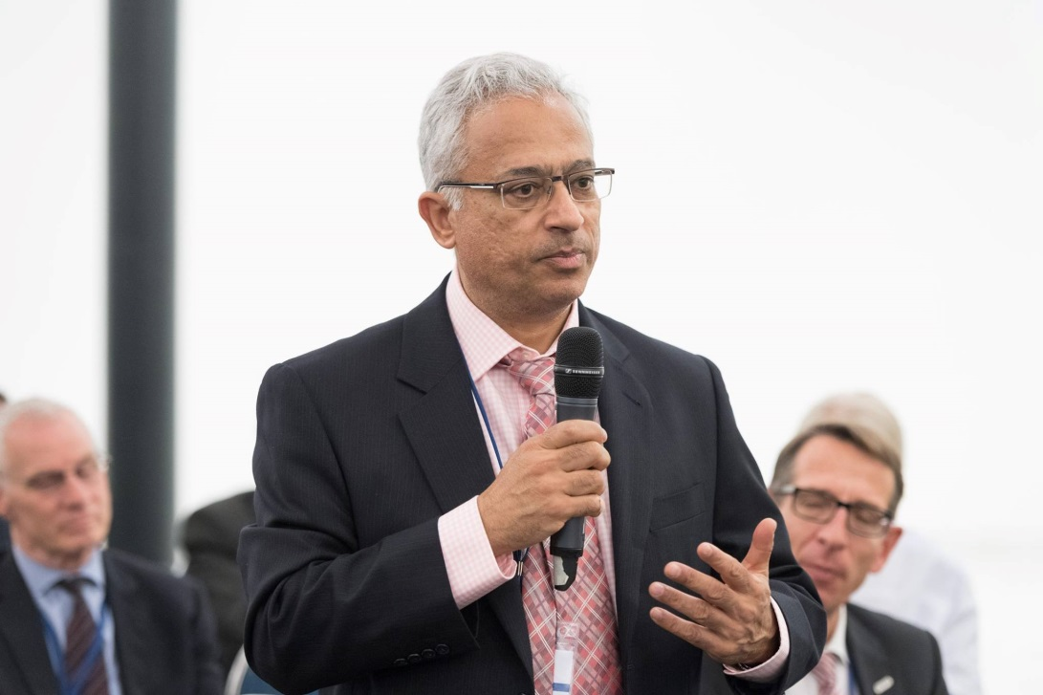
Sanjeev Sabhlok making observations regarding India’s governance at the conference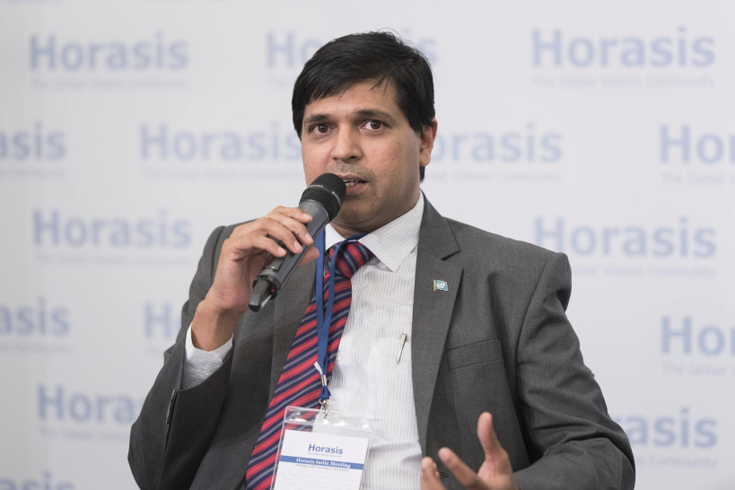
Asif Iqbal was a keynote speaker at the conference

office bearers AS AT 30 JUNE 2017

National office bearers
The party's National Office Bearers as at the date of publishing this report are listed below:
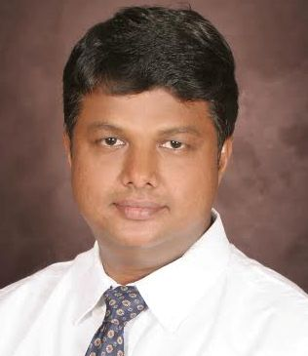 | Rahul Pandit (Hyderabad), President,  +91 9703425422, rahulpanhyd@gmail.com  Rahul comes from an international business development background and currently serves as a C level corporate leader. It is his dream to see India as a developed nation. He believes India and Indians have the potential to be a world leader. He believes SBP is the much needed liberal political platform for India that can restore its lost glory. Rahul currently volunteers significant amount of his time for developing youth in India.
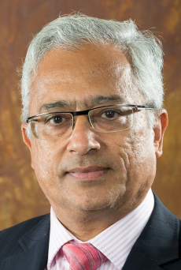 | Sanjeev Sabhlok (Melbourne), Overseas Coordinator  Sanjeev worked in the IAS from 1982 to January 2001, when he resigned to focus on providing India with a liberal political alternative. He works in the Department of Treasury and Finance in the Victorian Government in Australia as an economist, providing public policy advice on a range of issues. He is author of Breaking Free of Nehru (Anthem Press, 2008) and Discovery of Freedom (manuscript). He floated the Freedom Team of India (FTI) in December 2007. Swarna Bharat Party is an offshoot of this effort.
EXECUTIVE SECRETARY:
Mr Bhoopendra Singh Kanaujia (Ghaziabad) performs the executive functions as Secretary of the party.
TREASURER:
Sureshan Payyaratta

PAST OFFICE-BEARERS
Presidents:  1. Dipinder Sekhon  2. Vishal Singh  3. Sanjay Sonawani | Vice-Presidents  PK Sabhlok  Alok Singh (left the party in April 2017 due to ill-health)  Secretary  K K Verma

State Coordinators
The party's current State coordinators are listed below, in no particular order.
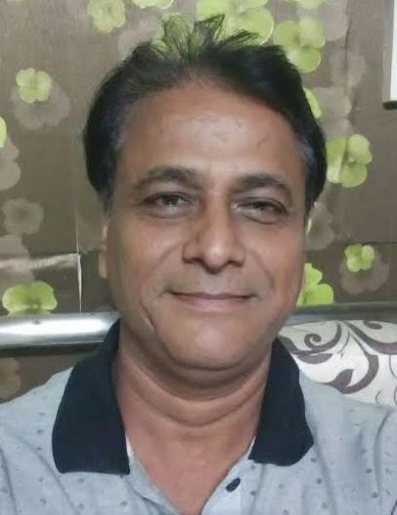 | RAJASTHAN STATE UNIT  Sanjay Garg (Jaipur), State Coordinator, +91 9829157043  Sanjay Garg is a former mechanical engineer who came to value liberty through his own thinking and experience. He came across Swarna Bharat Party and decided to join it, given its determination to fight for Indians liberty. He decided in mid-2016 to devote his entire time and energy to the development of the party in Rajasthan. Sanjay Garg runs the Centre for Policy Solutions and is active in RTI related matters.
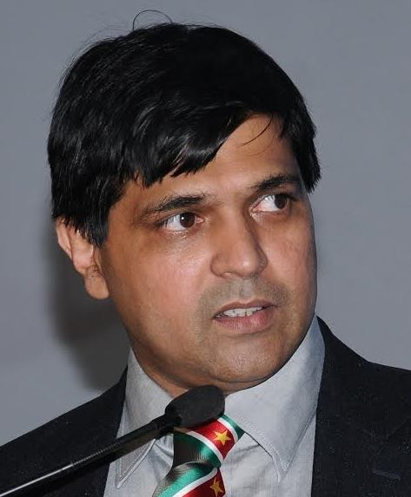 | KARNATAKA STATE UNIT  Asif Iqbal (Bengaluru), State Coordinator, Mobile: +91 8553010064 Email: ietoblr@gmail.com  Asif Iqbal is the President of the Indian Economic Trade Organisation (IETO), an enterprise that serves in 39 countries of the world. Asif is an architect by profession and held several management positions with Martins group in France, UNDP. He has been a director of both listed and private companies as well as member of a number of industry, academic and non-profit boards. Asif believes that liberalsm creates a framework to look for solutions to scale down the role of the government and to direct it more narrowly and intensely. In socialism, the state tries to do too much and therefore does it badly. Asif want the people to have real freedom.

TELANGANA STATE UNIT

Rahul Pandit (Hyderabad), State President, +91 9703425422, rahulpanhyd@gmail.com
Rahul comes from an international business development background and currently serves as a corporate leader. It is his dream to see India as a developed nation. He believes India and Indians have the potential to be a world leader. He believes SBP is the much needed liberal political platform for India that can restore its lost glory. Rahul currently volunteers significant amount of his time for developing youth in India.

Key activities of the Party in 2016-17
This section of the annual report provides an update on all key party activities during 2016-17 and up to the end of April 2017.

SBP’s press conference in Pune on 12 April 2016
Swarna Bharat Party held a press conference in Pune on 12 April 2016, its first press conference in the state of Maharashtra.
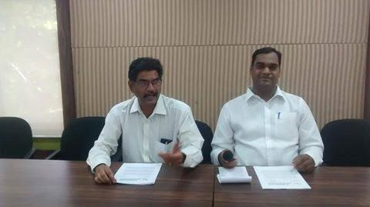
SBP Maharashtra State President Mr. Mrunal Dhole-Patil and the (then) Party Spokesperson Sanjay Sonawani addressing the press in Pune.

SBP’s payment gateway operational from 14 April 2016
A portal for payments through credit card and internet banking was operationalised on SBP’s website from 14 April 2016. With this, SBP has finished creating a comprehensive platform to bring liberty to India.
SBP’s second press conference in Pune on 25 June 2016 in a build up to the local municipal elections
SBP’s second press conference was focused on preparing for the forthcoming Pune municipal elections. The conference was attended by about 13 journalists and an electronic media person. Major local and state level social organizations, such as the Samta Parishad, Vasundhara Mitra Parivar, OBC Sangharsh Samiti and OBC Mahasanghatana also supported this effort.
SBP was represented by the State President Mrunal Dholepatil and the Party’s spokesperson, Sanjay Sonawani.
Many parties are contesting reserved seats on the basis of fraudulently obtained false certificates. It is understood that false OBC caste certificates can be obtained by paying a sum of 20 lakh rupees to corrupt officials. In particular, SBP noted that in the Pune and Pimpri- Chinchwad areas, around half the seats meant for the reserved OBC class are being held by people who belong to the Maratha caste but have obtained false Kunbi caste certificates. Similar malpractices are occurring in elections to Gram Panchayats, Zilla Parishads and municipal corporations all over Maharashtra.
Legal recourse is not an option due to the time consumed by courts. By the time a court verdict is issued against such persons, their term may well be over, hence this route becomes pointless.
Data gathered under RTI shows that this is happening not only in elections, but is observed in education and employment reservations.
SBP stands for liberty and the rule of law. While we are committed to policies of equal opportunity which will make the need for reservations redundant, the immediate need is to ensure that the law of the land is followed.
SBP called upon all political parties to thoroughly scrutinize caste certificates before issuing tickets to contest elections. SBP also believes that the Election Commission should ban political parties that have issued tickets to candidates with false certificates. Also, officials who take bribes to issue false certificates should also be prosecuted, to avoid making a mockery of the law.
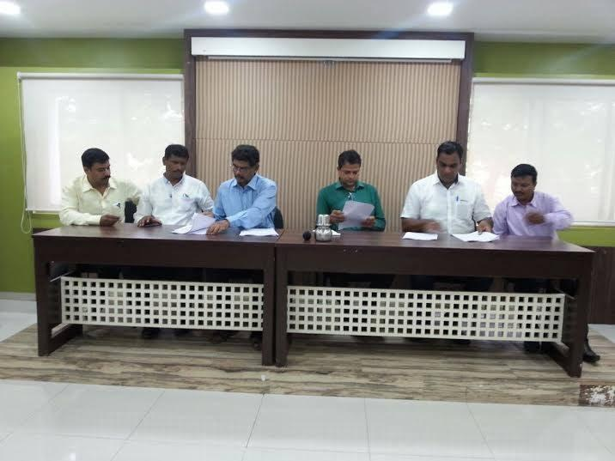

Swarna Bharat Party’s Youtube channel activated on 21 July 2016
The party uploaded two video posts by Sanjay Sonawani on 21 July 2016 on its new youtube video channel https://www.youtube.com/c/SwarnabharatIn

Coverage of the party by Liberty Viral in July 2016
Liberty Viral, an organisation dedicated to liberty identified SBP as a top 10 liberal party of the world.
http://libertyviral.com/the-top-10-international-freedom-fighters-you-didnt-know-about/
“Vishal Singh is the president of the ONLY classically liberal party inside of India. Singh talks about how even though the country was liberated in 1947, it never came to adopt freedom. He rails against the socialist goals of the government, and its perpetuation of crony capitalism. Singh says that his party, the Swarna Bharat Party is the only one in India which looks to protect and defend all Indian people’s freedoms. To that point, he is often critical of India’s Prime Minister Modi, saying things like he came to power “with the slogan of limited government, but all his actions are diametrically opposite to what he was saying during elections.” It’s obvious that Singh has a passion for freedom, and that he is determined to change the hearts and minds of those in India.”

Meeting with activists in Jaipur, 28 July 2016
Nearly 25 key activists and media persons from Jaipur attended a discussion with Sanjeev Sabhlok and Sanjay Garg of SBP on 28 July 2016.
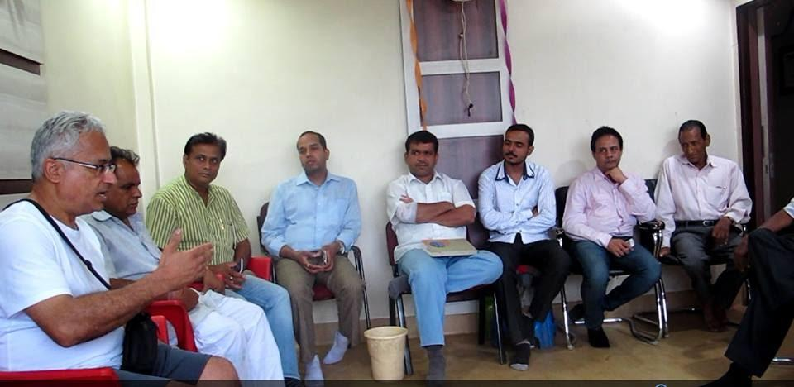
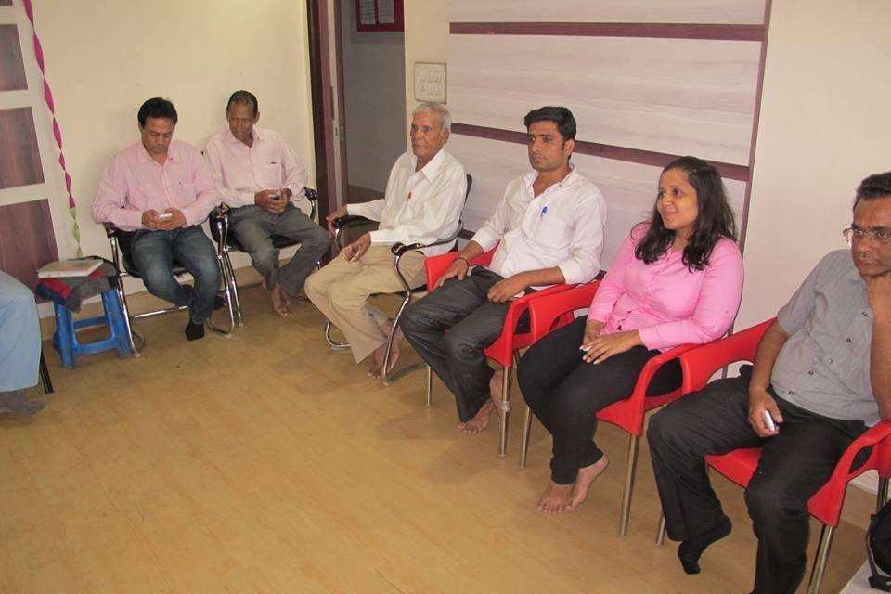 | 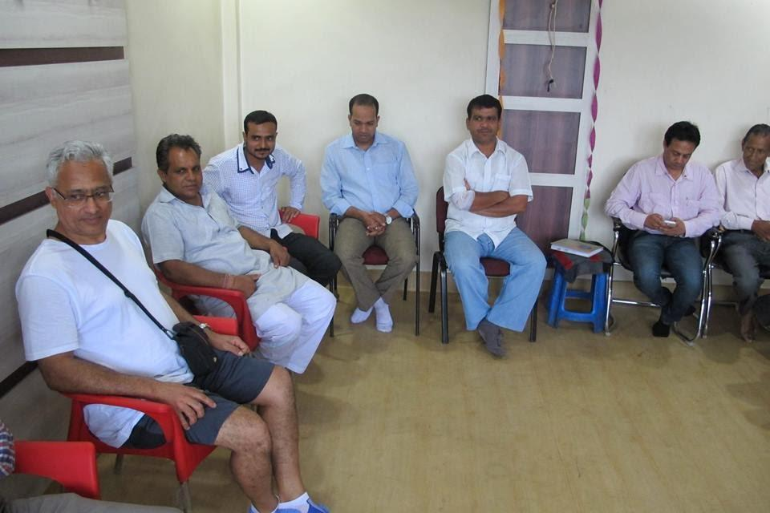
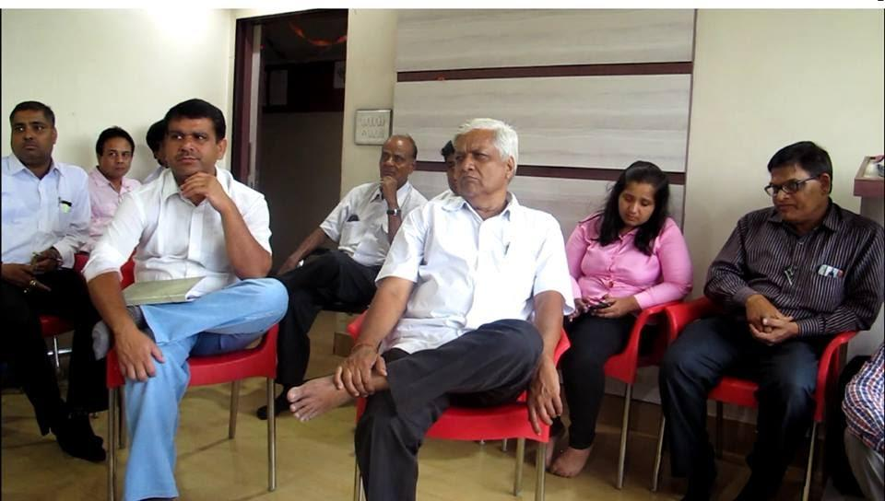
Videos from this meeting are available on SBP’s Youtube channel

National Conference of SBP, 30 and 31 July, and 1 August 2016
The party held its 3-day national conference, with key members of the national executive and a few other participants/ observers. A photo of the participants late in the evening on 30 July 2016 is provided below.
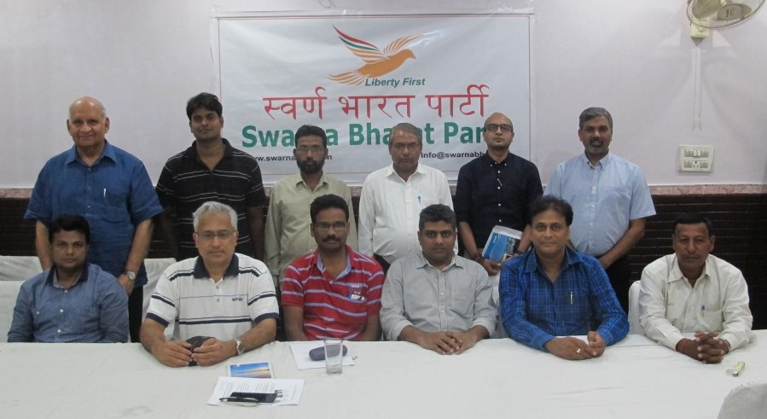
Another photo, below, from earlier on the first day:
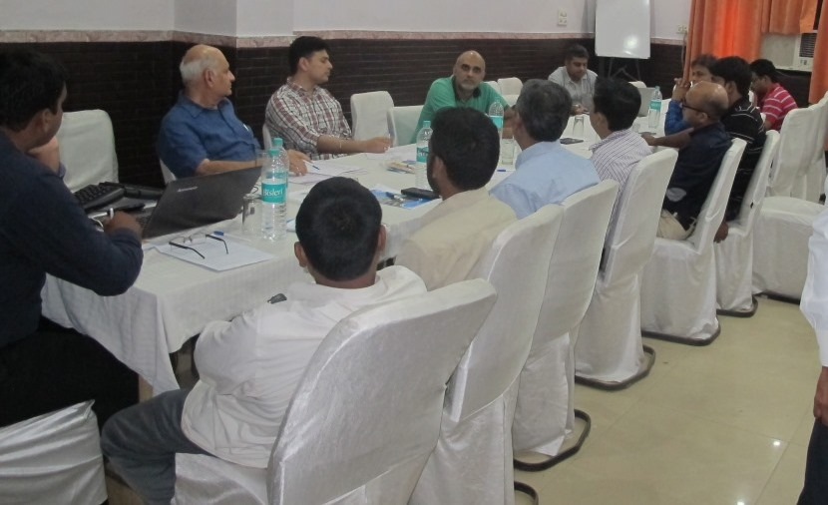

Public meeting at Bhadohi on 2 August 2016
Some photos of the audience at the Bhadohi public meeting organised by the local SBP unit on 2 August 2016 are provided below. Videos from the meeting are available on the party’s Youtube channel. Anil Sharma and the local Bhadohi team organised the event. Deepak Rawat of the party ably compered the event.
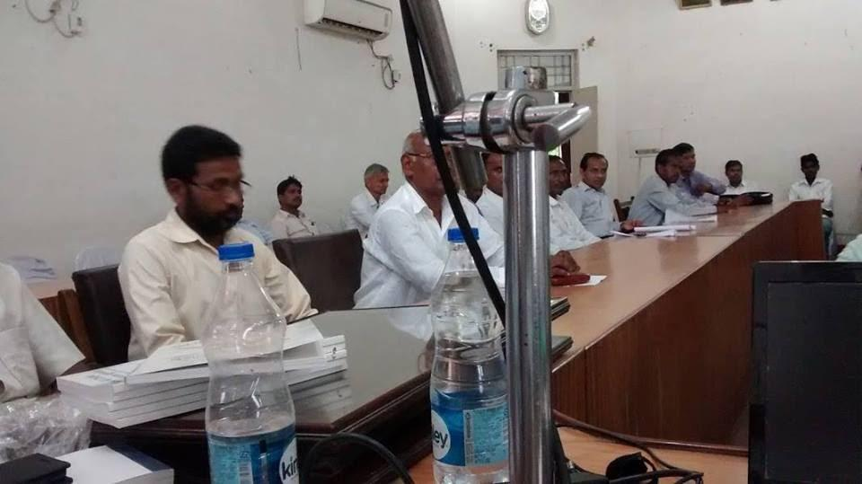
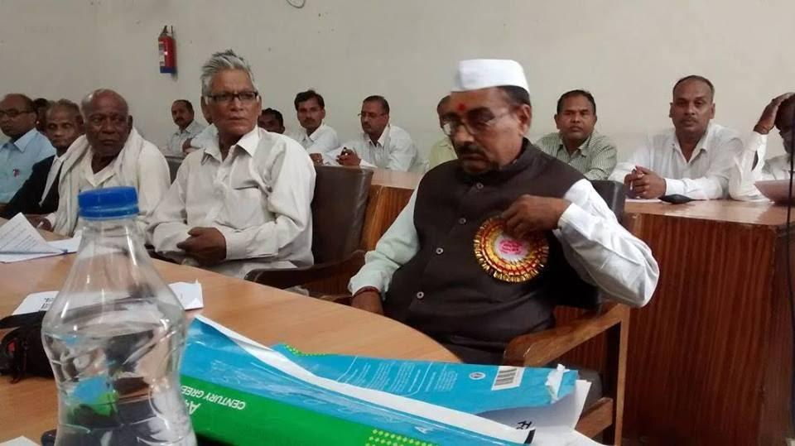
The event received significant press coverage. Some clippings are provided below.
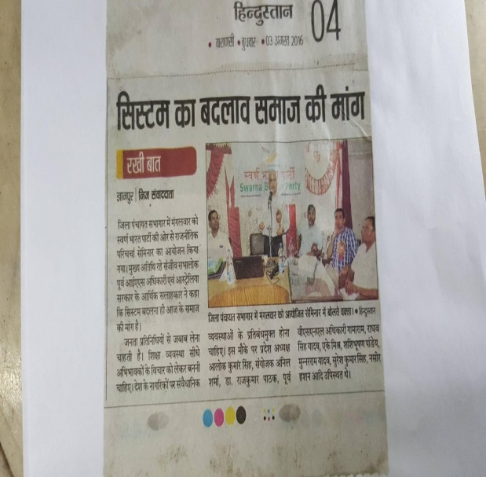 | 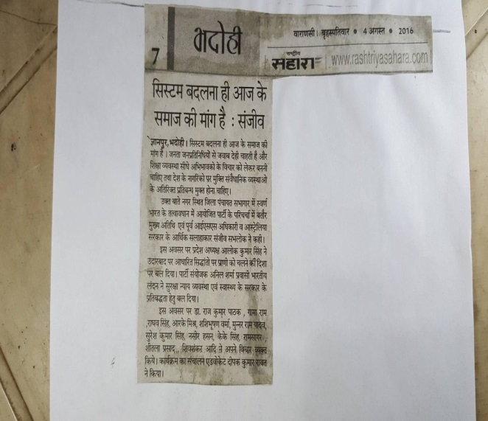
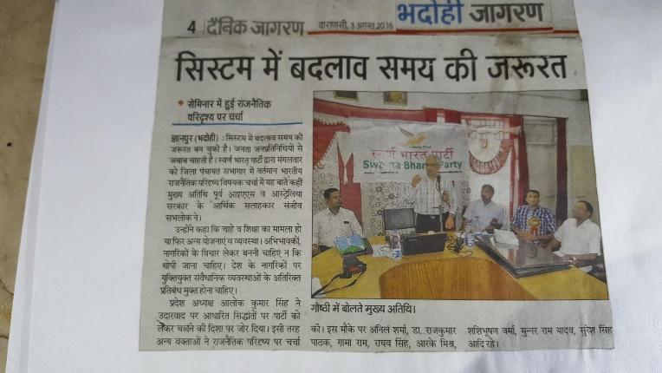

Public meeting at Mirzapur on 3 August 2016
Some photos of the audience at the Mirzapur public meeting organised by the local SBP unit on 3 August 2016 are provided below. Videos from the meeting are available on the party’s Youtube channel.
Mr Anil Sharma and Mr Ghanshyam Sharma organised the event. Mr Ghanshyam Sharma ably compered the event.
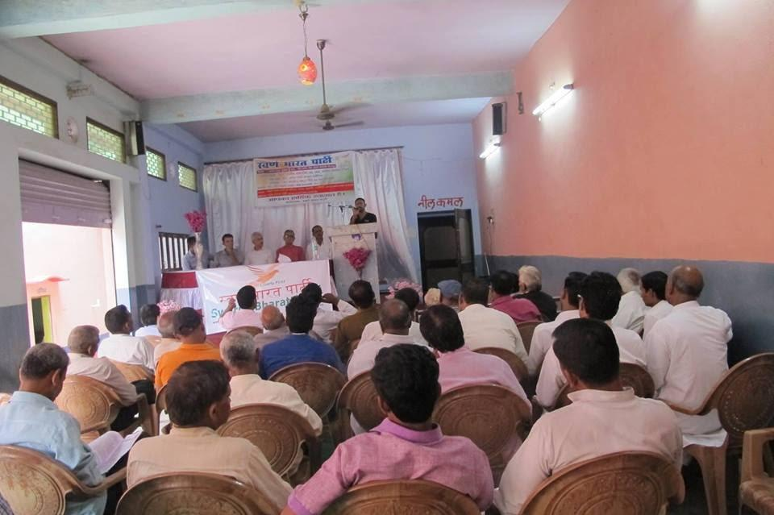
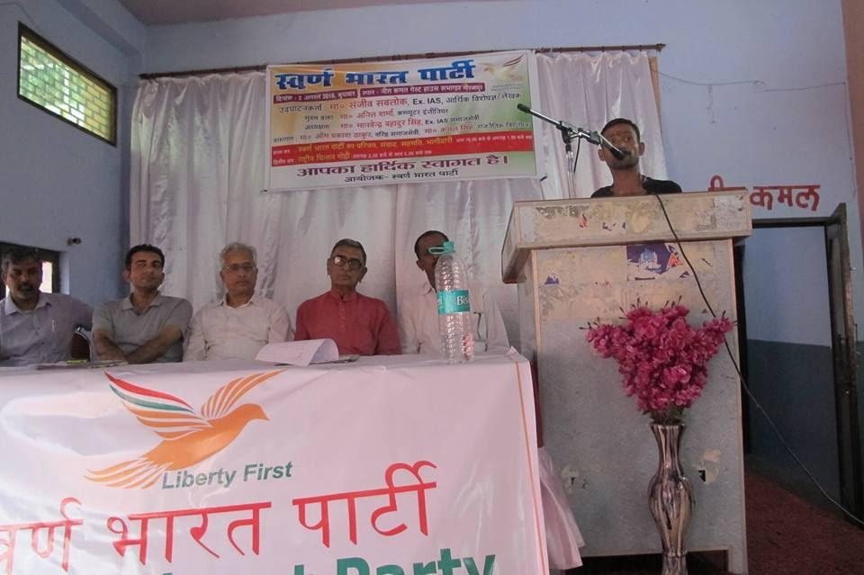 | 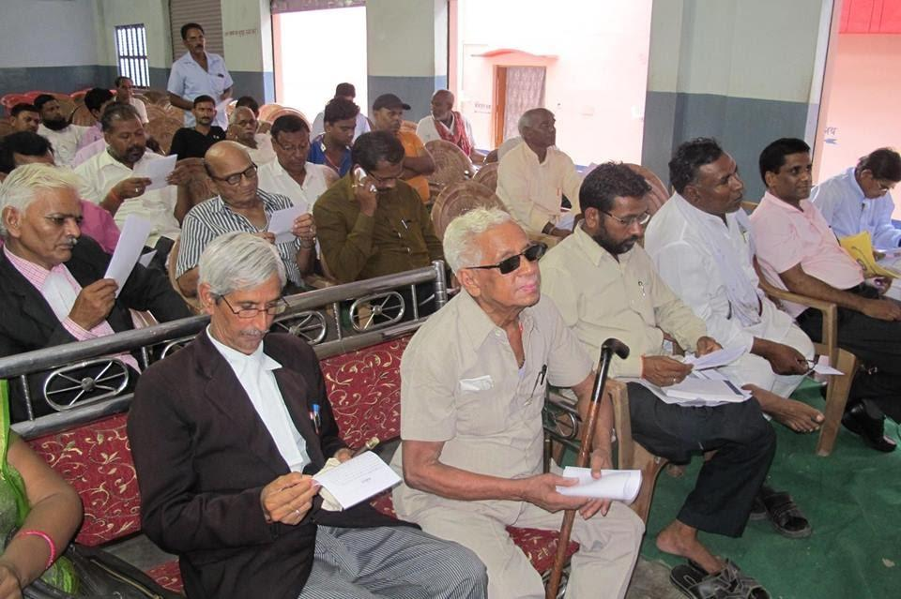
Press coverage of the event in Mirzapur:
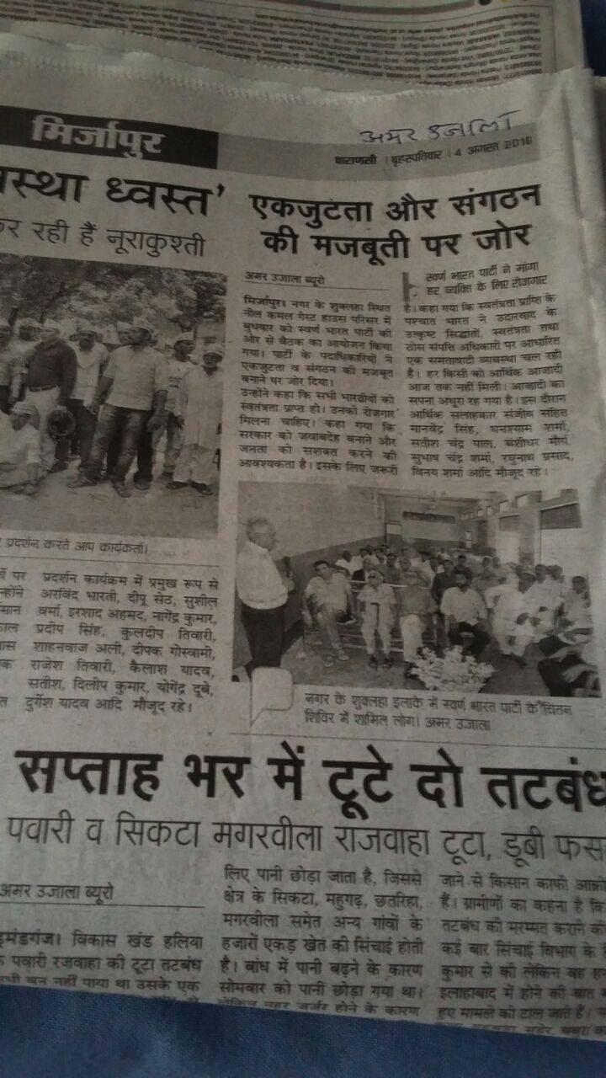

Public meeting at Pune on 6 August 2016
Some photos from the Pune public meeting of 6 August 2016 are provided below. Around 35 people attended. Sanjeev Sabhlok was keynote speaker. The question and answer session showed the high level of interest and understanding from the audience. Sanjay Sonawani, Mrunal DholePatil and Loknath Rao should be commended for their efforts. Videos from the meeting are available on the party’s Youtube channel.
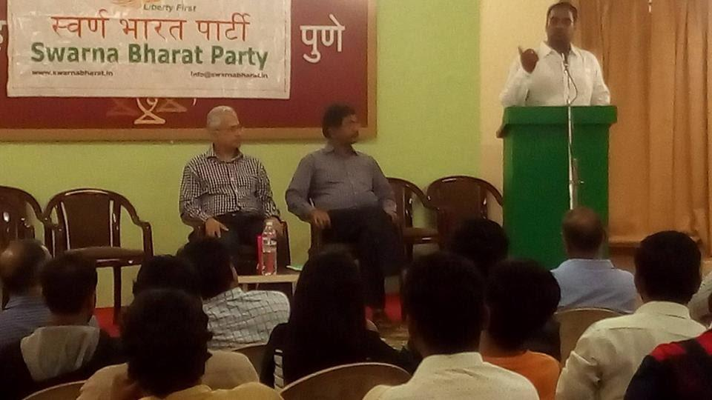
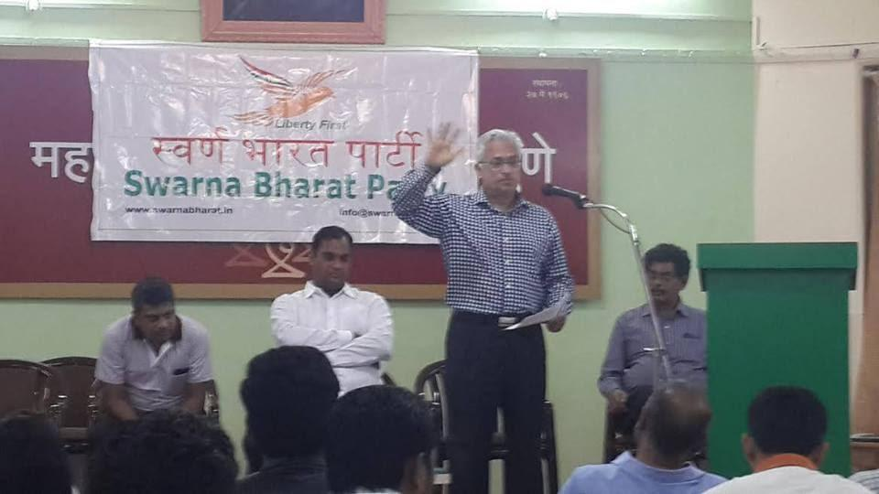

Press Conference in Bengaluru on 8 August 2016
A successful press conference was held in Bangalore on 8 August 2016, coordinated by the local team including Vishal Kumar Singh, Cdr. Bhirappa Khilari (retd.), and Anubhava Srivastava. Videos from the meeting are available on the party’s Youtube channel.
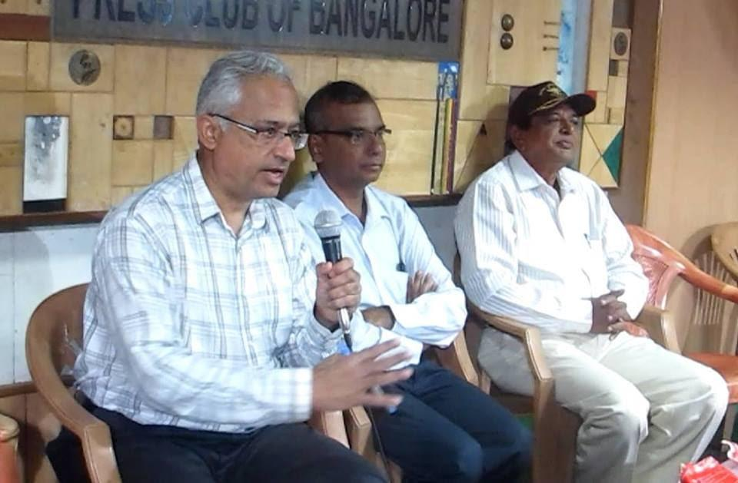
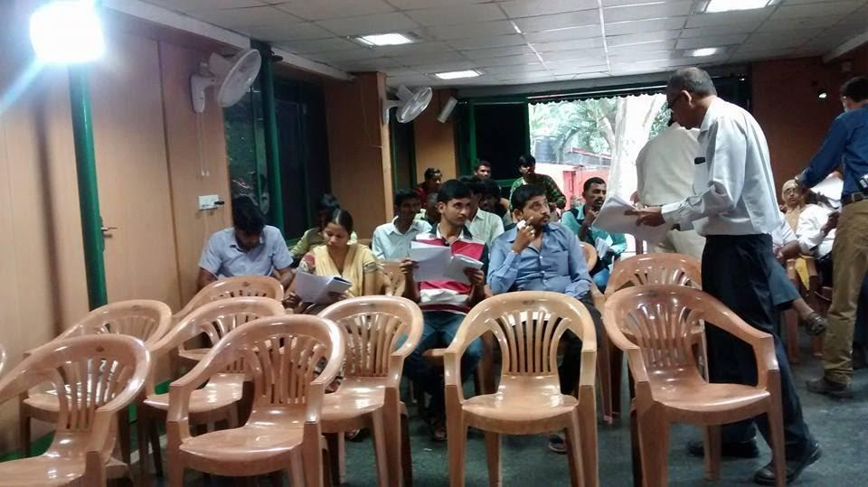
Coverage of our Bangalore press conference, below:
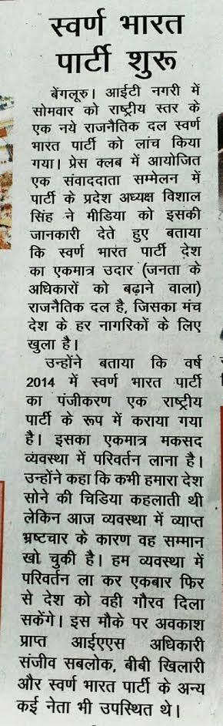

Meeting in Jaipur on 8 August 2016
A Swarna Bharat Party meeting was held on 8 August 2016 at the residence of Mr. Sanjay Garg, State President, Rajasthan State Unit, SBP. The values, policies, manifesto and ideology of the party were discussed in detail.
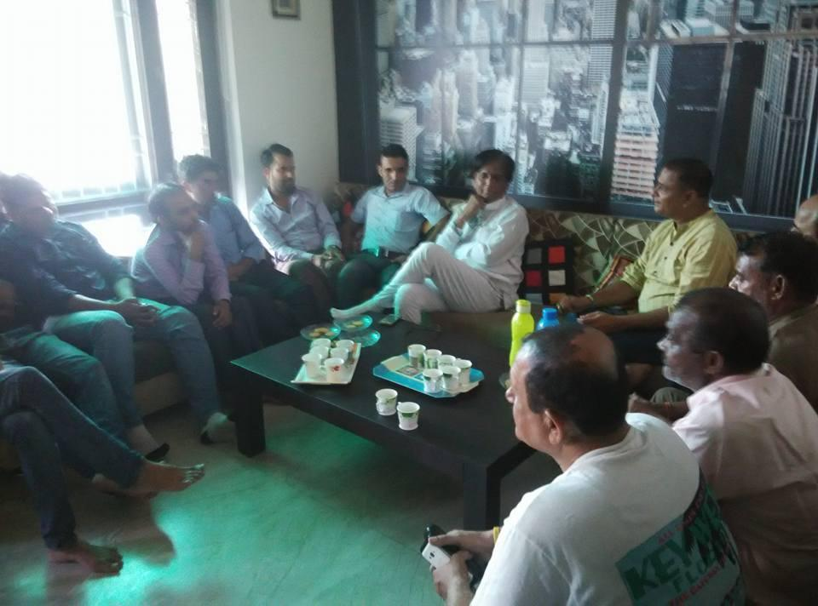 | 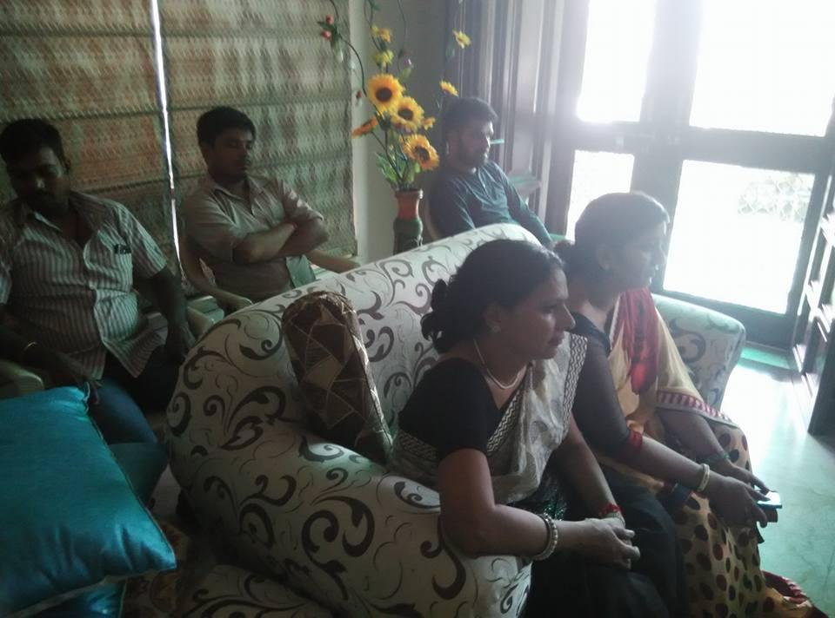
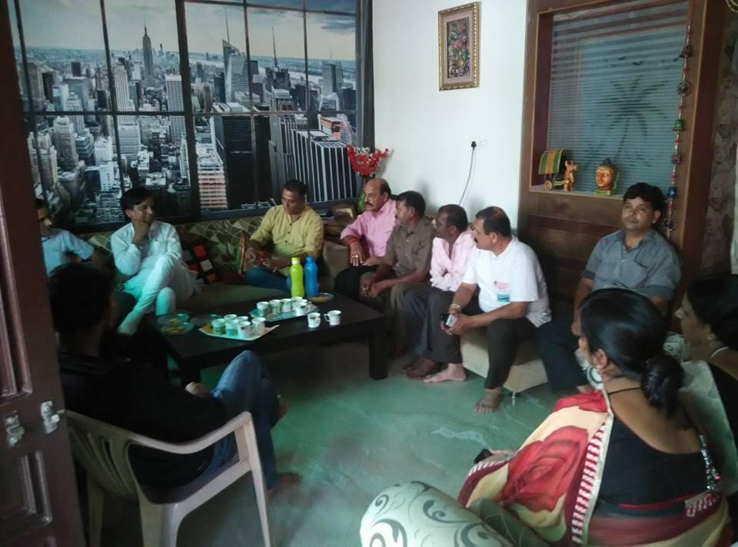 | 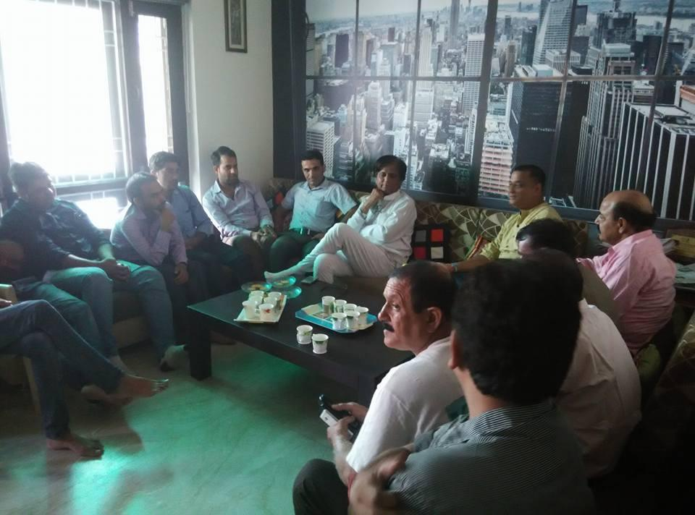

Swarna Bharat Kisaan app launched by party members on 8 August 2016
Mr Loknath Rao of the party released Swarna Bharat Kisaan app on Google Play Store on 8 August 2016. The app was co-developed with Sanjay Sonawani. The app is intended to enable enable farmers to sell their produce directly to retailers and receive a higher price. The party has no direct affiliation with the app, but notes that the Freedom Team of India has lent its bird logo (which is also the logo of SBP) to the app, to help familiarise the farmers with the concept of sone ki chidiya.
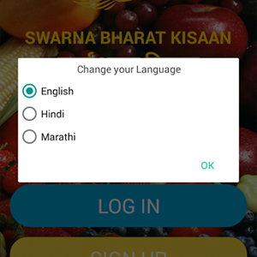

Party workers meeting at Hyderabad on 9 August 2016
A number of people came to Rahul Pandit’s house on in Hyderabad on 9 August 206 to discuss the need for SBP and its unique reform agenda.
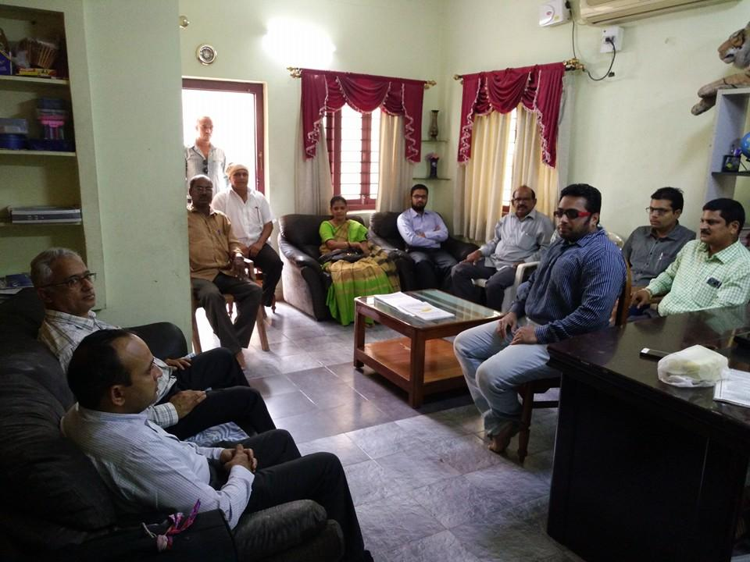

Press Conference in Hyderabad on 9 August 2016
A successful press conference was held in Hyderabad on 9 August 2016, coordinated by the local team including Madhusudhan K and Rahul Pandit. Videos of the meeting are posted on the party’s Youtube channel.
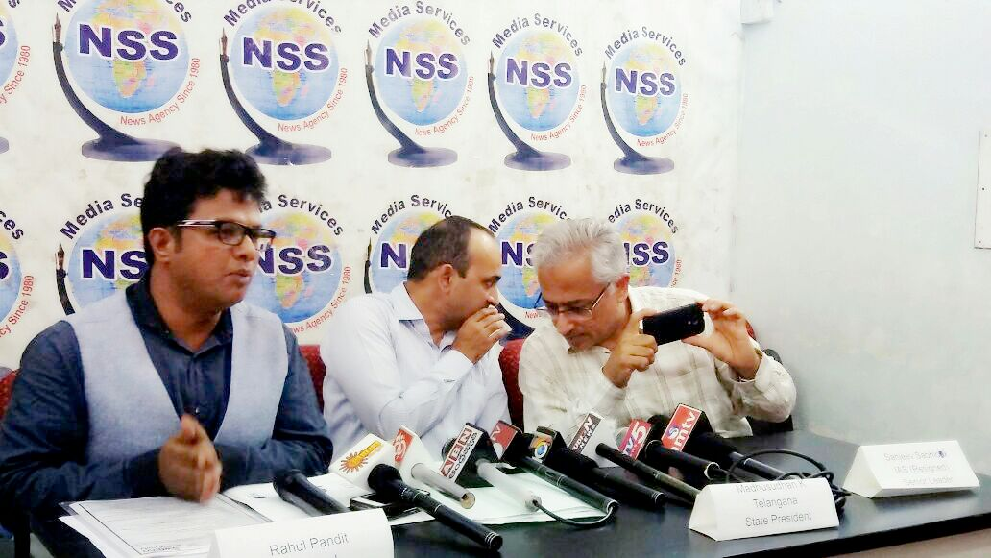

Press coverage in local papers on 10 August 2016, below.
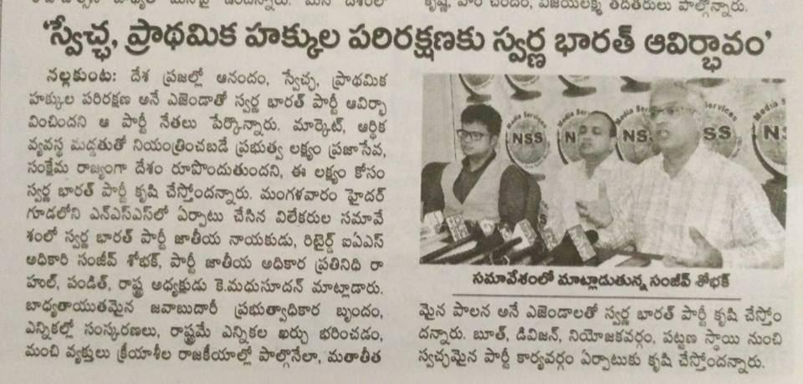  Andhra Jyoti | 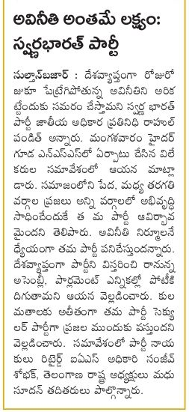  Sakshi

After the press conference, around 15 people went to a nearby restaurant to discuss SBP in greater detail.
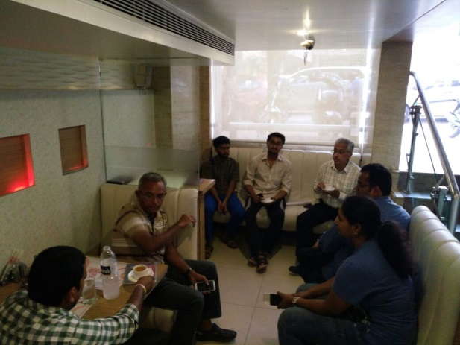

Launch of the national reform movement on 2 October 2016
Swarna Bharat Party commenced a national movement for good governance on 2 October 2016. Our key messages were: Government should not dabble in business. Government should increase funds for police and judiciary.
Delhi Police were informed about this Rally. This rally follows from the Party's letter of 26 August 2016 to the PM of India. SBP waited till 26 September 2016. After that, as there was no response from Mr Modi, SBP launched a national movement on 2 October 2016 to demand urgently needed reforms.
Some photos of the rally and associated meetings are appended below:
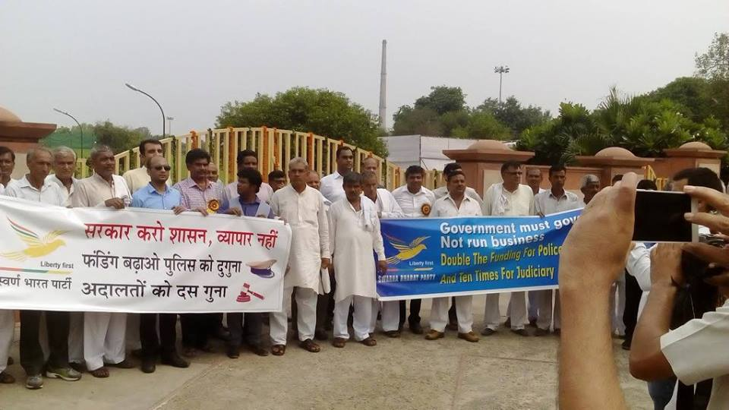 | 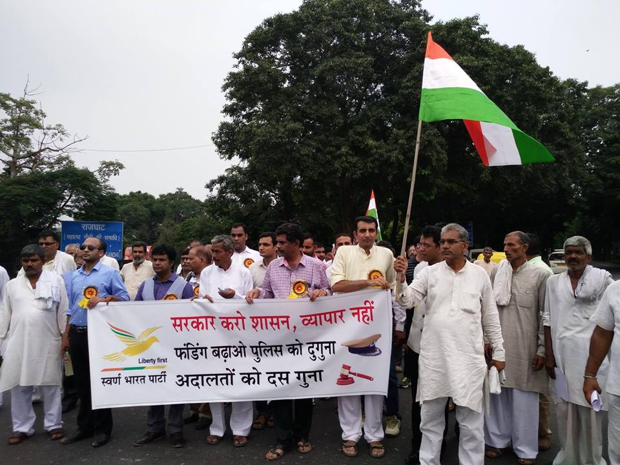
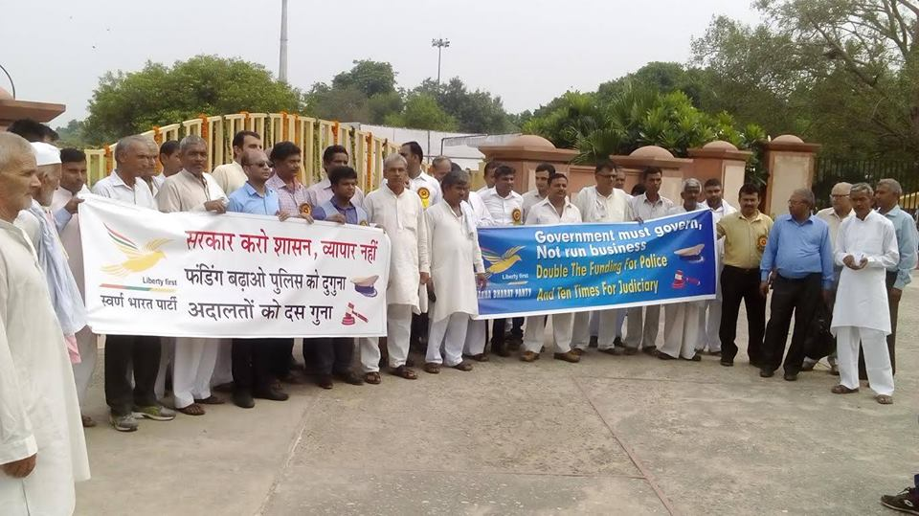 | 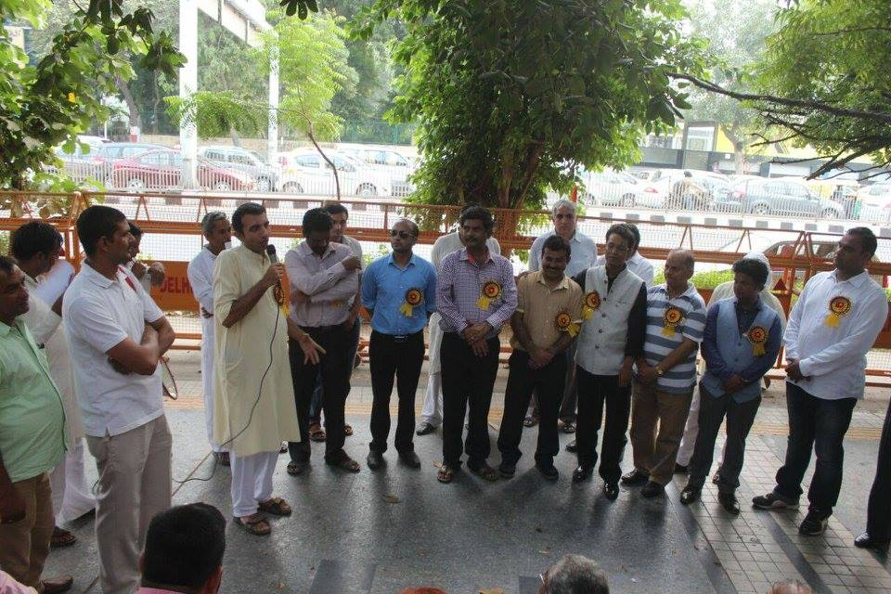
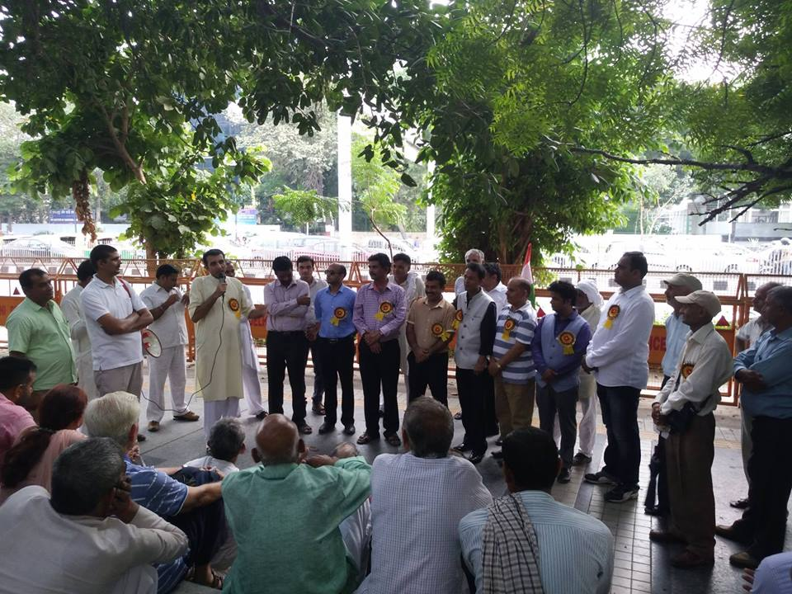 | 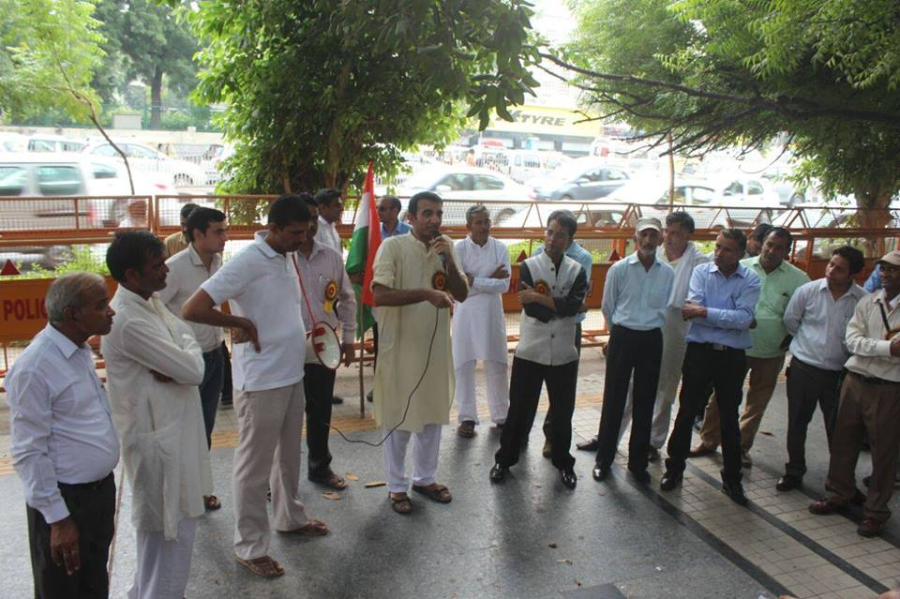
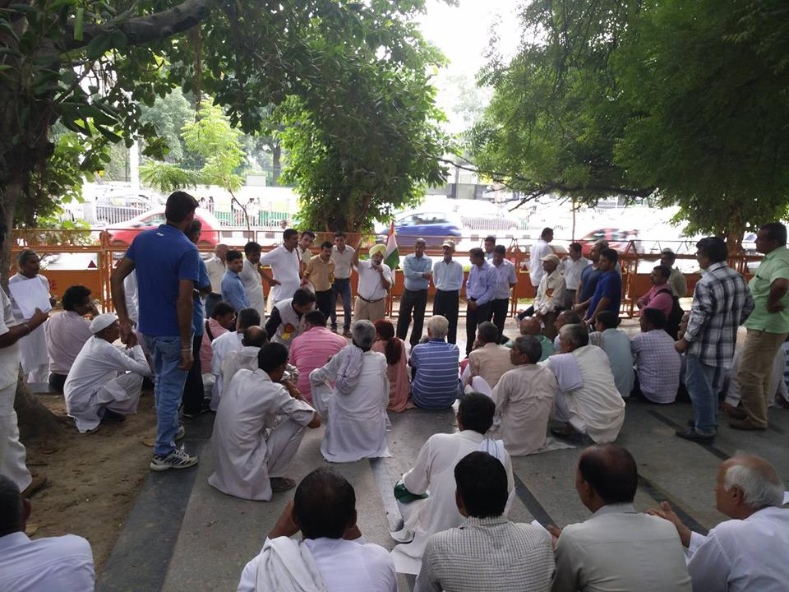 | 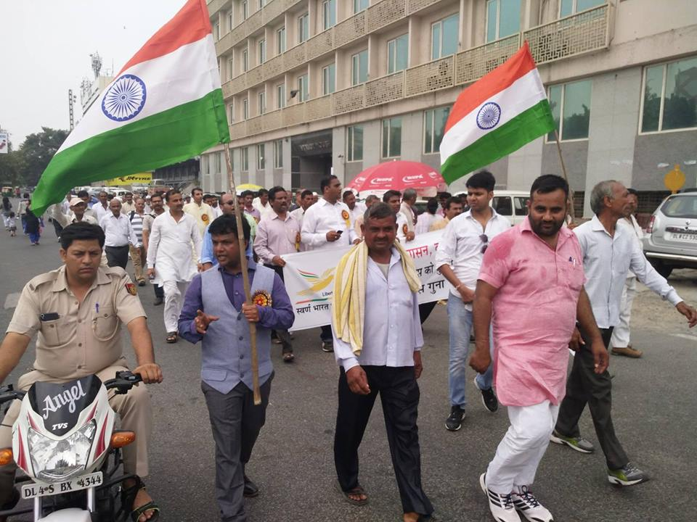
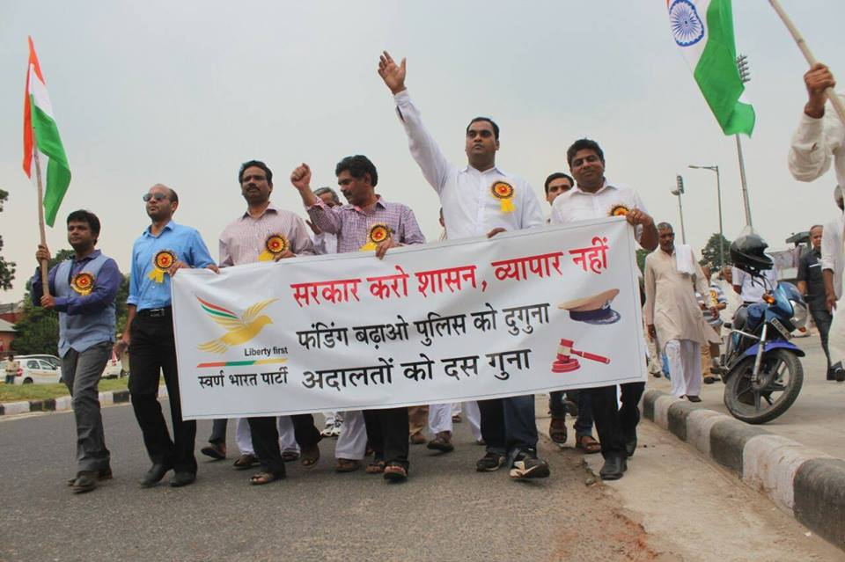 | 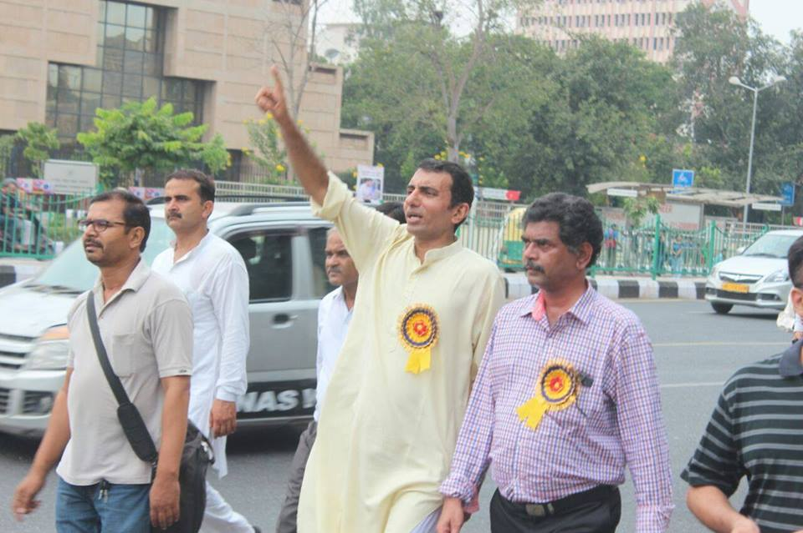

This is another photo of the 2nd October rally. This photo is important as it shows both the President and Vice President of the party, along with other key leaders.
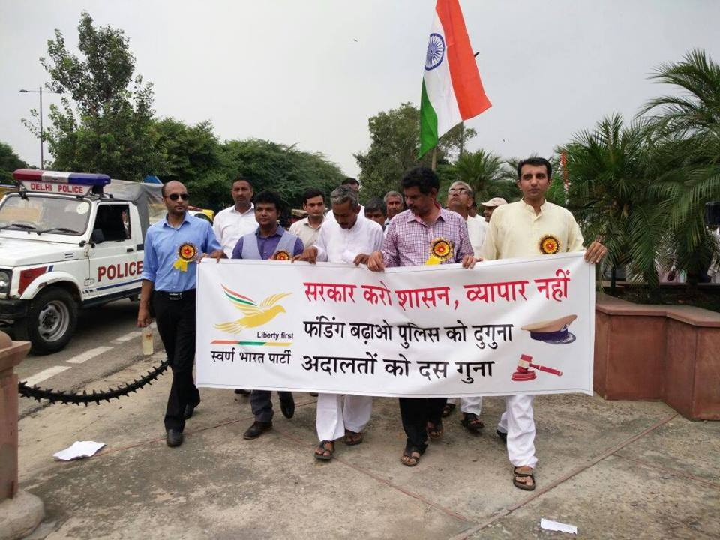

SBP team working to alleviate effects of Demonetisation – November 2016
The SBP team in Hyderabad swung into action immediately after media reports that patients and their attendants were starving at hospitals around the country as no cash was available on-hand for people reaching from far villages and towns.
SBP Team reached Gandhi hospital in Hyderabad and enquired within the hospital premises if either the patients or their attendees were left stranded without food.
Later, the team purchased fruits on credit card and distributed to pregnant women coming from very poor families. These patients were going through a very difficult phase given very limited or no cash was available at their disposal.
SBP team in Hyderabad monitored the situation in Govt hospitals, where primarily extremely poor people come for treatment without any options of cashless transaction, until such time the Government ensures the life of citizens gets to normalcy in the given demonetisation exercise by the Union Government.
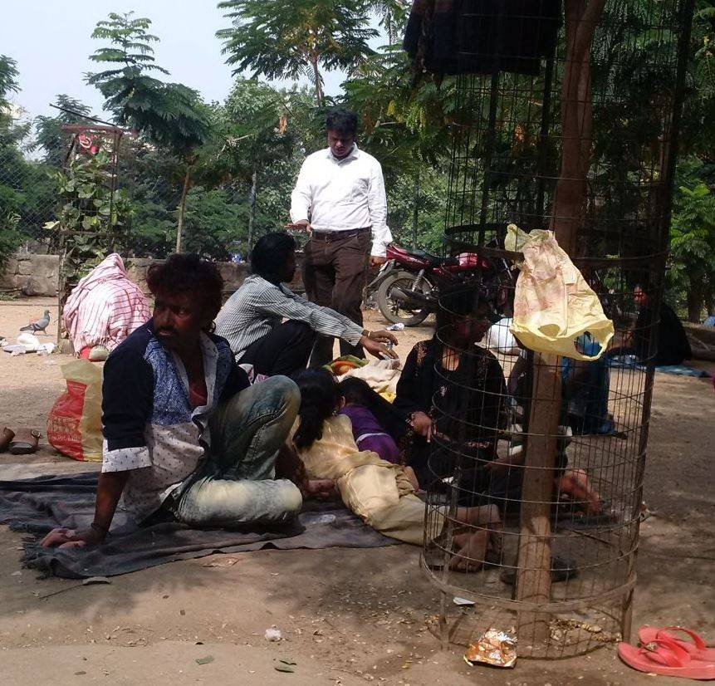 | 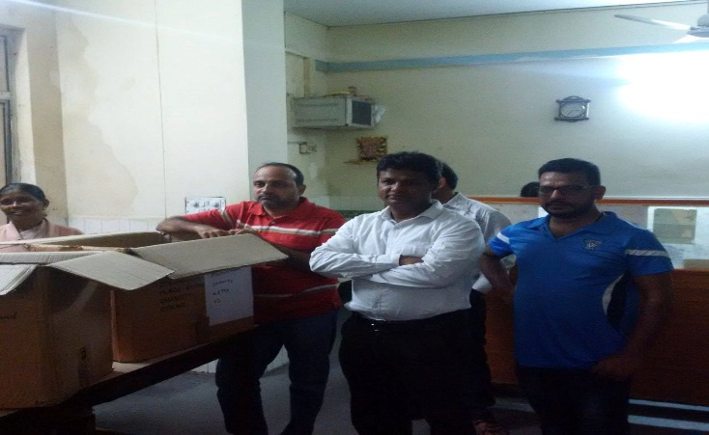
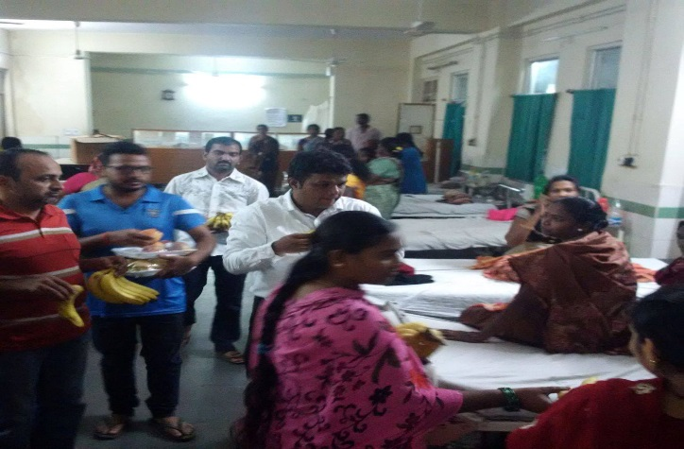 | 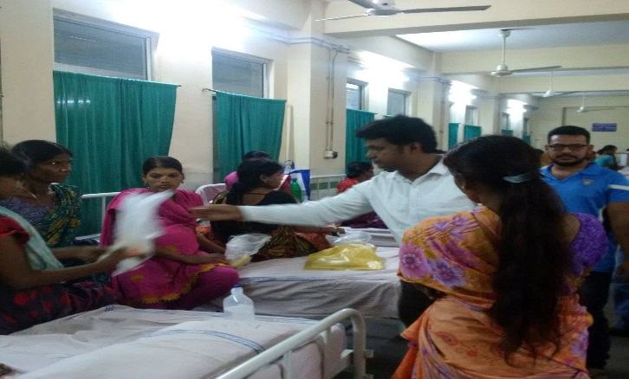

Skill development workshop in Bihar
Rahul Pandit, President, SBP, along with some local communities' members, successfully concluded a 2-day skill development workshop in Belhar of Banka district in Bihar. Youth were trained in communication, technical skills and personality development.
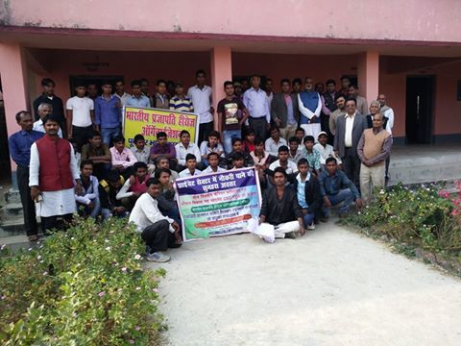
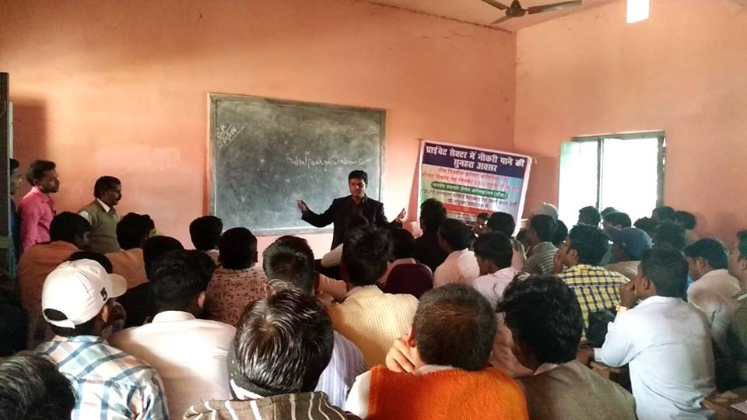
The liberty song.
Former SBP President Sanjay Sonawani is a man of many talents. In October 2016 he wrote and composed a song of liberty. Satyajit Kelkar and his musical team have played the instruments and provided the voice to the song. You can listen to the song here: https://soundcloud.com/sanjay-sonawani/swarna-bharat-pary-song.
Do listen and share - a song written and composed by Sanjay Sonawani
भर लें पंछी जैसी उडान
भर लें बाहों मे आसमान
हमारा भविष्य बनें सुंदर
यहीं हैं हमारे अरमान

तो चलें स्वतंत्रता की ओर....हम चलें स्वतंत्रता की ओर!

सब जगह बेडिंया ही बेडियां
तरक्की करें तो करें कैसे?
बनायेंगे देश को सोने कि चिडिया
बंधनों मे बनेगा वो कैसे?

दें प्रतिभा को जो मुक्तद्वार...
ऐसी चाहिये हमें सरकार
तो चलें स्वतंत्रता कि ओर....हम चलें स्वतंत्रता कि ओर!

इन्सां हो जहां का महान
वही देश महान कहलाए
हम नीति वही अपनाएं
इन्सां का जो तेज निखारे

दें आजादी का हम सब नारा
मानव-मुक्ती का एक ही सहारा
तो चाहिये हमें छोटीसी सरकार
इक ताकतवर सरकार
जो करे आजादी की रक्षा
ना बंधनों की बौछार
ना बंधनों की बौछार..

तो चलें स्वतंत्रता की ओर...हम चलें स्वतंत्रता की ओर!

भर लें पंछी जैसी उडान
भर लें बाहों मे आसमान
हमारा भविष्य बनें सुंदर
यहीं हैं हमारे अरमान

तो चलें स्वतंत्रता की ओर...हम चलें स्वतंत्रता की ओर!

Press Releases
These Press Releases were issued by SBP during the year.

We must support Constitutional, not sectarian nationalism, says SBP President, Vishal Singh
April 4, 2016
Mr Vishal Singh, President of the Swarna Bharat Party, said that India needs Constitutional nationalism, not sectarian nationalism of the kind that some saffron groups, supported by India’s ruling party, are attempting to forcefully impose on the country.
While a nation needs a narrative, a sense of history, India is perhaps the world’s oldest melting pot and has a multiplicity of such narratives. Expecting everyone to adopt a common shared history is an illusion. “Unity in diversity” is the correct language for a multitudinous nation like India.
Further, India is a constitutional republic, not a theocratic state. Our Constitution does not ask us to imagine the nation in the form of a human being, god or goddess. People are free to chant Vande Mataram or Bharat Mata ki jai if they wish, but no one has the right to mandate such slogans. Mr Singh noted that many SBP members are happy to chant such slogans, but this is a matter of their personal choice.
There is a vast difference between well-considered patriotism and rabid, divisive nationalism. SBP condemns the atmosphere of euphoric sectarian nationalism created by saffron groups in which rowdies are starting to beat up people for not chanting slogans.
In our Constitution, the individual is sovereign. SBP opposes fascist approaches that restrict individual liberty. Compulsion attacks the very basis of nationhood. Attempting to force a particular worldview upon the vast nation of India has already backfired once, leading to India’s partition. Aggressive saffron nationalism is causing new and dangerous fissures.
Mr Singh said that BJP, like all other Indian political parties, has sworn to bear true faith and allegiance to the Constitution of India. How can it justify its support for divisive saffron groups? He also wondered whether the BJP is raising the bogey of sectarian nationalism to draw attention away from its poor performance.
Mr Singh expressed regret that the liberal values underpinning our Constitution are being eroded at a time when India needs them most in order to develop into a modern nation. He noted, for example, how the Delhi High Court made unwarranted comments on nationalism recently in a bail case relating to Kanhaiya Kumar, thus losing sight of its Constitutional obligations.
SBP supports Constitutional nationalism in which patriotism is a well-considered rational response to the nation’s unrelenting commitment to reason and liberty. The intrusion of compulsion into such matters can only take weaken India. Let all flowers bloom in the great garden of India.

Modi government has failed to create the conditions for new jobs, says SBP President, Vishal Singh
June 3, 2016
Swarna Bharat Party President, Mr Vishal Singh said that by continuing the failed policies of the past 65 years, the Modi government has prevented the rapid creation of urgently needed new jobs.
Every month, nearly 10 lakh children turn 18 in India, so at least 10 lakh new jobs are needed each month. But only a small fraction of this are being created. Jobs growth in eight labour intensive industry sectors is now the lowest since 2009.
Jobs are not created by governments but by the people. Jobs are created when governments support markets through the rule of law, property rights and essential infrastructure to make it easy to do business. But today, Indians are prevented from working by regulation, corruption and dismal infrastructure. They are forced to spend precious time in navigating a maze of government imposed restrictions.
Jobs also need workers to have the required skills. But the youth are not being imparted the essential skills. According to The Economist, only 60 per cent of ten-year-old students are able to complete work at the level of a five-year-old. More than half cannot subtract. Employers tell us that India graduates millions, but too few are fit to hire.
Unfortunately, the Modi government is neither letting people work, nor giving workers the skills they need.
Mr Singh said that unless India’s anti-business policies are urgently reformed, the youth will increasingly take to the streets. The youth have started agitating for government jobs since the private market is essentially defunct. Worse, many are getting radicalised since they have too much time on their hands.
He said that only Swarna Bharat Party has the policies that can break through this nightmare for the country. Only policies in SBP’s manifesto can fix India’s deep-rooted problems of governance. But the Modi government seems to have no clue about governance, and is continuing the same old failed policies.
India needs leadership with a vision. SBP provides that leadership. Mr Singh asked the youth to read SBP’s manifesto to understand why socialist policies can never work. Mr Singh asked the youth to insist on total reforms. India must reform for their sake.

The mantra of Swachh Bharat cannot deliver results. Only governance reforms can, says SBP President, Vishal Singh
July 7, 2016
The President of Swarna Bharat Party, Mr Vishal Singh, said that chanting slogans won’t deliver a Swachh Bharat. A rubbish-free India simply cannot be delivered under the current governance system.
The cause of the vast amounts of filth that litters Indian streets, rivers and lakes has nothing to do with the habits of the people of India but everything to do with the inefficiency and corruption of our unaccountable political system and colonial bureaucracy.
SBP’s manifesto provides the full details of the reforms essential for India’s transformation. We need electoral reforms to ensure that the country gets honest politicians at all levels. We need to get rid of tenure and automatic promotion at all senior levels, including in local governments. Key performance indicators need to be included in municipality CEO contracts, so that if a CEO fail to deliver, he or she can be immediately fired. These CEOs must be empowered to hire and fire their senior officials on the basis of performance. Of course, the contractual CEOs and other contractual senior officials need to be paid very well and rewarded if they perform.
Without all these reforms Swachh Bharat will fail, and funds earmarked for it will be stolen or misused.
Mr Singh said that only highly competent local governments can implement the wide range of policies necessary to deliver a clean India. For example, e-procurement that uses modern auction design must be used to procure professional services to clean streets and public places. The contract design must ensure that successful bidders are held to account. Constructive compliance policies must be implemented. On the one hand, citizens must be educated and given access to waste bins at convenient locations. On the other hand, compliance officials equipped with cameras must to be empowered to impose significant on-the-spot fines.
However, the key is that the buck must stop with the CEO. “Deliver or go” must be our motto.
As part of this process, a vast number of new jobs will be created. India will also attract millions of new foreign tourists and investment. The stink of India puts off almost every person from the developed nations.
Mr Singh noted that the Modi government is unfortunately unable to understand the concept of governance reforms. It believes in chanting slogans. That is a delusion. The Modi government is guaranteed to fail.
Without implementing SBP’s policies , the stink and filth of India streets, rivers and lakes can never be removed.

Swarna Bharat Party, India’s only liberal party, has arrived
August 8-9, 2016
[Broadly similar press releases were issued in Bangalore on 8 August 2016 and in Hyderabad on 9 August 2016 at press conferences. Only the key contents are being provided below]
The party informed the press that it is India’s only liberal political party. It announced that its platform is now available to the people of Karnataka.
The Party’s President, Mr. Vishal Singh then explained how SBP is entirely different from all other political parties.
To set the context, he recalled that India was the richest country in the world for 12 out of the past 20 centuries and second richest for six out of the remaining eight. Even 65 years ago, India was in as good or better economic condition than many other countries such as South Korea and Singapore.
Then something happened. Our political parties took us down the socialist path, while these other countries chose the path of freedom of occupation and trade. Today, countries that chose the path of freedom are 10 to 20 times richer than us. Moreover, some of these countries have overtaken the richest countries of the West.
Instead, our socialistic political parties created a governance system that is guaranteed to fail. As a result, every public service has failed. Life has become hell in India.
SBP’s manifesto is based on 35 years of experience including 20 years of research and consultation with thousands of Indians. Mr Sanjeev Sabhlok, one of SBP’s key founders, served in the IAS for 18 years, took a doctorate in economics from the USA and after resignation 15 years ago has been advising on economic policy in the Victorian State Government in Australia. His analysis has shown that India’s systems are fundamentally flawed.
For example, Indian politicians spend crores of rupees on elections but there is no system to compensate them for this cost. As a result, only the criminals and the corrupt are able to enter politics today. But this need not be so. Some developed countries fund a pre-determined amount to each candidate for each vote received. We need a similar system of state funding of elections so that good candidates are able to step forward and contest elections.
Further, we give a 35-year tenure to public servants and protection under Article 311 of the Constitution. In many parts of the developed world, senior officials are on a performance based contract. They are paid for delivery of results, else they are dismissed. But in India there is no accountability. Would we ever pay a personal servant for doing nothing? Why should our government servants be paid for doing nothing?
Finally, socialist parties have imposed innumerable obstacles on Indians to stop them from producing, trading, and speaking. And they have taxed those who produce very heavily. So the Indian governance system inevitably leads to corruption.
SBP believes that only a free society can produce the best results. SBP believes that the government – which is our servant – should focus on key functions such as defence, law and order and justice. It must ensure infrastructure and equal opportunity, including direct support for the poor. And the government, as our servant, must not interfere in our freedom of occupation and speech.
Registered in mid-2014, SBP is now ready to transform India. The last such effort was by Rajaji’s Swatantra Party, which was formed in 1959. That party got 44 seats in Parliament in 1967 but unfortunately, dissolved in 1973. SBP is not only taking that effort forward in a big way, it is doing so through what is arguably the best manifesto amongst all political parties in the world.
We invite all Indians to read and understand our platform. As Einstein said, ‘The definition of insanity is doing the same thing over and over again, but expecting different results’. India desperately needs to change its governance system, and only SBP knows how to do so without causing disruption.
SBP is a national party from its very inception. Our agenda is offered to the whole of India. Work has started in Uttar Pradesh, Maharashtra and Rajasthan. Work is starting in Telangana, Karnataka, Jharkhand and Delhi. We will contest elections wherever possible.
We invite everyone to join this platform and lead the India to freedom. SBP is the only party that can make India a sone ki chidiya again, the world’s leader in every possible way.

Public sector banks are a major channel to loot India, says SBP President, Sanjay Sonawani
3 September 2016
President of Swarna Bharat Party, Sanjay Sonawani asked whether Mr Modi wants to implement “Minimum Government, Maximum Governance” or to connive at the loot of India.
On 19 July 2016 the Modi government decided to pump in Rs. 22,915 crores into thirteen public sector banks – even as the entire judiciary receives a tiny fraction of that amount. This is over and above the Rs. 1.02 lakh crores of taxpayer funds already poured into public sector banks between 2009 and September 2015.
Mr Sonwani said that there is a dark side to this funding. A corrupt nexus between political parties and businesses is using banks to loot the country’s wealth. Private companies are hollowed out through bogus losses and political pressure is then used to get public sector banks to write off vast amounts of business loans.
Public sector banks wrote off Rs.59,547 crores in “bad loans” in 2015-16. This is only the tip of the iceberg of unrecoverable debt. Lakhs of crores of rupees of India’s wealth is being brazenly stolen. Crony socialism is alive and kicking under Mr Modi. Even the British were not so brazen.
Mr Sonawani asked Mr Modi whether running businesses, banks and hotels is part of his Maximum Governance plan. Can the people of India not run banks on their own? There is a saying in India: Jis desh ka raaja ho vyapari,us desh ki praja ho bhikhari.
The BJP government cries that there are insufficient funds for the police and judiciary. But there is a limitless supply of funds for the banks. Mr Arun Jaitley said in February 2016: “If additional capital is required by these banks, we will find the resources for doing so. We stand solidly behind these banks.”
The Government doesn’t “stand solidly” behind the police or judiciary or our defence forces, but it “stands solidly” behind banks.
On 26 August 2016 Mr Sonawani asked Mr Modi in an Open Letter to declare by 26 September 2016 the doubling of funds for police and increasing by ten times the funds for the judiciary. Mr Sonawani said that unless the Prime Minister starts performing core functions of government and stops running businesses, SBP will consider a nationwide movement for good governance from 2 October 2016.

The law should punish all atrocities, not just against SC and ST communities, says Swarna Bharat Party President Sanjay Sonawani
8 September 2016
The law should punish all atrocities, not just against SC and ST communities, says Swarna Bharat Party President Sanjay Sonawani
Mr Sanjay Sonawani, President of the Swarna Bharat Party called for an urgent review of the Scheduled Caste and Scheduled Tribe (Prevention of Atrocities) Act, 1989 under which only atrocities against members of the Scheduled Castes and Scheduled Tribes are punished. Even SC/ST community members cannot use this law to seek redress against atrocities committed against them by members of their own community.
This law violates Article 14 of the Constitution which guarantees every citizen that the laws shall apply equally to everyone. Lawmakers have also violated Article 35 while making a law that seeks to protect one section of India from others without providing constitutional remedies to the accused.
The implementation of this law has also been problematic. Sometimes the police have invoked this Act for civil issues, such as land disputes. There are reports of the misuse of the Act to humiliate innocent people, even to blackmail them. There are examples of intellectuals being threatened that a complaint will be lodged against them under the Act, merely for holding a particular view.
Bail, particularly anticipatory bail, is usually not permitted in cases under this Act, even for relatively minor matters. Bail should be a matter of Constitutional right, except in the most extreme cases. As a result of all this, this law has merely worsened social relations between communities. Atrocities against the Dalits continue unabated after 17 years of this law. This law is more of lip service to the Dalits than a genuine solution to their problems.
Mr Sonawani said that there are many other badly designed laws in India about which he will talk about in detail in due course. Such ill-thought out laws are being generated by populist governments as a knee-jerk response to outrage arising from bad implementation of existing laws. These governments are incapable of implementing existing laws, so they make more laws to hide their incompetence.
India doesn’t have a shortage of laws. India has a defunct governance system. SBP is committed to halting the atrocities against Dalits, but the Atrocities Act is not the way to do that. This Act which is ill-designed and gives rise to enmity between groups should be immediately reviewed. Mr Sonawani emphasised that SBP is not questioning welfare provisions for the SC and ST communities, but wants a uniform criminal code and reform of governance to ensure that all atrocities are brought to an end.
Equal treatment under the law requires that an atrocity against any citizen be punished, not just an atrocity against an SC or ST individual. Mr Sonawani said that all serious offences listed in the Atrocities Act should be included in the Indian Penal Code after such a review, so that these crimes can apply to everyone, regardless of caste.
The government must get out of running hotels and businesses, so it can focus on security and justice. It must implement the reforms detailed in SBP’s manifesto so that all criminal cases are fast tracked, not just a few. The whole country needs justice and peace. We need a functioning government.
He called upon the Modi government to immediately review all such unreasonable Acts, failing which SBP will consider filing Public Interest Litigation to test their constitutionality.

The deprived sections of society will be the most to benefit from Swarna Bharat Party’s policies, says the party’s President Sanjay Sonawani
13 September 2016
The deprived sections of India’s society have long been misled by the empty slogans of the socialists. Only the policies of liberalism can break their bondage and provide the security and opportunity to lift them socially and economically. The liberal policies of Swarna Bharat Party will most benefit the poorest of the poor and the socially oppressed, said Mr. Sanjay Sonawani, President of SBP.
One of the greatest leaders India had in the past two thousand years was Dr. Ambedkar. If one word can be used to characterise Dr Ambedkar’s worldview, it would be that he was a liberal. During the drafting of India’s Constitution he vigorously fought against any dilution of liberal principles incorporated in it, including through his opposition to the incorporation of the word “socialist” in the Preamble.
That he cared deeply for liberalism is also clear from his 1943 lecture in which he regretted the demise of Ranade’s Liberal Party. “The collapse of the Liberal Party is a tragedy to the Liberals. But it is really a disaster to the country”, he said. And to his mind, democracy is “first, an attitude of mind, an attitude of respect and equality towards their fellows. The second is a social organization free from rigid social barriers”. These are the ideas a liberal believes in. These are the ideas that SBP, India’s only liberal party, stands for.
Mr Sonawani said that it is unfortunate that illiberal forces have attacked the spirit of liberalism in India and have increased pre-existing caste divisions in India for their political gain. Many liberal principles in the Constitution have been eroded or even removed, and laws made that violate the Constitution. Dr Ambedkar would have deeply regretted the way India has progressed since his death.
India needs a national liberal political party that stands for the principles Dr Ambedkar stood for. SBP believes in equality of all under the law. It has a vision and plan to ensure equality of opportunity for all. SBP offers specific governance reforms to ensure that governments ensure security and justice and deliver (not directly manage) world class education for the poorest of the poor.
SBP does not believe that the state should dabble in religious matters such as caste. However, we are supportive of evidence-based analysis that underpins the current transient Constitutional welfare provisions for the scheduled castes and tribes. But these provisions do not deal with the underlying causes, which can only be addressed by making available world-best education to the poorest of the poor. Only SBP knows how to do that. Thereafter they will compete in the free market and their shackles will fall apart.
Mr Sonawani invited the deprived and oppressed sections of India to understand SBP’s ideology, policies and manifesto and support the party, so that security, justice and equality of opportunity can be made a living reality for the socially deprived peoples of India.

Small businesses need good governance, not sops or protection, says SBP President, Sanjay Sonawani
20 September 2016
Mr Sonawani, president of Swarna Bharat Party, India’s only liberal party, said that India’s small business sector is suffering from the ongoing chronic dysfunction of our governance system.
India has a complex (and often irrational) regulatory regime, and insufficient or non-existent infrastructure. The inspector raj is still alive and well, 25 years after liberalisation; there is corruption at each step. And inadequate and costly finance is a huge impediment. Nationalized banks prefer to fund large companies instead of small businesses. These banks support corrupt politicians and businesses that are siphoning away vast amounts of taxpayer wealth. And the government has almost entirely choked private finance.
Hundreds of obstacles at every step make it difficult to start and operate a new business, specially in the manufacturing sector. India remains one of the world’s worst places to do business. The talk of “Make in India” is meaningless if even Indians are not allowed to make in India. The small scale sector is the engine of growth in all successful countries, but in India it is not allowed to even start. We need to empower Indian youth to start business and grow them. Instead, they are being blocked at every step.
Businesses don’t need much from the government. All they need is an assurance of security, justice and the defence of property rights. The government must also facilitate (not necessarily supply) essential infrastructure. And the government should never distort price signals through administered prices. Likewise, mandatory requirements to declare a Maximum Retail Price should go. Businesses must be free to set their prices and compete in the open market.
Unfortunately, the Indian government doesn’t perform its basic functions but directly competes with small businesses, such as by selling cigarettes and alcohol in duty free shops. And in a perverse attempt to mitigate the effects of its own dysfunction, the government doles out sops and reservations for small businesses, making things worse. Sops merely distort incentives and misallocate resources.
The key to prosperity is freedom of occupation. Mr Sonawani said that India cannot grow unless its governance is totally reformed and India adopts policies of freedom. Mr Sonawani said that SBP’s policies will create a world-class governance system for India and unprecedented prosperity for all.
In relation to small businesses, SBP will ensure accountability of the bureaucracy so that small businesses are not harassed by an army of inspectors; dramatic reduction in red tape; and eliminate any unreasonable restrictions on hiring and firing employees. We will make ESIS enrolment voluntary and allow workers to get health insurance from private companies until SBP’s broader health policy takes effect. We will also increase the level of revenues for presumptive tax till SBP’s broader tax policies take effect.
Mr Sonawani invited small businesses to review SBP’s manifesto and provide any suggestions for improvement.

Governments should stop looting sugarcane farmers, says Swarna Bharat Party Vice-President, Alok Kumar
22 September 2016
Alok Kumar, Vice-President of India’s national liberal party – Swarna Bharat Party – said today that sugarcane farmers are being looted by governments through corrupt ministers and crony capitalists in the false pretext of protecting the farmers. Governments have choked the market and are using these laws to strangle the livelihood of 60 million farmers.
Socialist laws control both the movement and prices of sugarcane and associated by-products. The central government sets what is alleged to be a “fair and remunerative price” for sugarcane. State governments set a “state-advised price”. But these prices are far from fair. These prices are far lower than the market price. State governments also fix quotas for end-uses for molasses and impose restrictions on trade across state borders on molasses and bagasse. Farmers are thus forced to sell their produce (indirectly, due to the restrictions on molasses) at throw-away prices.
Mr Alok Kumar gave the example of molasses, a major sugarcane by-product. Molasses form a key input to alcohol production. The market price of molasses is around Rs.7,000 per ton but the UP state government pays mills a no more than Rs.2000 per ton. The remaining value (which is in the hundreds of crores) is shared between corrupt ministers and liquor licence holders.
Moreover, government delays making even these low payments, which leads to further losses for producers. As per the Sugarcane (Control) Order, 1966, farmers must be paid 15% interest on any payments delayed beyond 14 days. However, farmers’ payments are always in arrears and they never get the promised interest. The law says that mills that delay payments to farmers cannot charge transportation fees for carrying sugarcane from collection centres to the mills. However, this law is never followed.
Mr Alok Kumar asked: What business does government have to interfere in the open market? Why should farmers and mills not have freedom to sell their produce at the best price they can get? Mr Alok Kumar said that these scandalous anti-people laws must go. India must have a free market in agriculture. SBP wants the free movement of sugarcane and its by-products across India and the abandonment of all end-use quotas.
Liberating the sugarcane industry will allow mills to get a much higher price for sugar and molasses. Farmers will benefit enormously from these higher prices. Further, mills will receive money in a timely manner from the market and will be able to pay the farmers immediately.
SBP wants the whole of India to be free. It wants to release India from the grip of socialists who have destroyed India. SBP is committed to destroying the crony capitalist system operating in India.

Swarna Bharat Party is deeply concerned about India’s defence, says its President, Sanjay Sonawani
24 September 2016
Mr Sanjay Sonawani, President of Swarna Bharat Party mourned the loss of 18 soldiers in Uri to terrorists from Pakistan. The party salutes all India’s soldiers, who do a great job in the face of enormous challenges.
India wants peace with its neighbours but we must remain vigilant to persistent threats, ranging from state-sponsored terrorism to nuclear warheads. The defence of the nation remains the most important function of a government. Without secure borders, a nation cannot exist, leave alone prosper. SBP will therefore support any well-considered response by the Modi Government to intrusions from Pakistan.
However, SBP believes that the Modi government needs to do far more for the defence of India. There are too many failures of intelligence, instances of outdated war equipment and reports of inadequate ammunition and supplies. Yet the Modi government continues to run duty-free shops, hotels, airlines and banks. It is reluctant to perform its core functions. This tendency of the Modi government must stop.
Mr Sonawani said that our service personnel and intelligence agencies must have state of the art defence equipment, surveillance and intelligence systems including unmanned aircraft, satellites and robotic systems, and adequate ammunition and supporting supplies, to defend Indian territory.
There is also a vital issue of the morale of our defence forces. SBP wants the status of defence forces to be significantly raised. Those who choose the profession of defence take on high risks, forego many fundamental rights as citizens, and perform their work round the clock in harsh and difficult environments. SBP’s manifesto has a detailed plan of action for to raise the stature of our defence forces.
A Chief of Defence Staff (CDS) in the rank of a Minister of State must be given charge of an integrated Military Command on the lines of Pentagon. The CDS should report directly to the Defence Minister. The Army, Navy and Air Force Chief’s order of precedence must equal that of the Cabinet Secretary.
SBP wants a separate Pay Commission for the defence forces, OROP for those under the pension scheme, and government contribution towards life insurance premiums of armed force personnel to the extent their premiums exceed the average market rate. For new hires, alternate systems of pensions/re-employment need to be considered.
Funds for such essential defence reforms can be raised if the government stops running businesses. Also, cantonments can be moved outside cities and towns, releasing land for sale. Cantonments can also be more effective outside the cities. Mr Sonawani said that the government should follow SBP’s manifesto to make India strong and prosperous.

Swarna Bharat Party will now launch a national movement since the PM is not interested in governance, says the party President, Sanjay Sonawani
27 September 2016
Mr Sanjay Sonawani, President of Swarna Bharat Party, said that he wrote an Open Letter to Prime Minister Mr Modi on 26 August 2016 asking him to double funding for the police and ten times for the judiciary. SBP provided detailed reasons why this is necessary, as well as photographs of the deplorable conditions that our police and judicial systems face on the ground.
In its letter to PM, SBP also showed how these additional funds can be obtained, mainly by divesting public sector undertakings. SBP said that there is no reason for a government to operate businesses and run banks. But only recently we heard that ITDC has opened its 10th duty free shop. The Modi government is more interested in selling duty free liquor and cigarettes than in governing.
SBP had also asked the PM in its Open Letter to implement a range of essential reforms to ensure that India’s governance system and policies are consistent with liberty and world-best practice. That is the only way forward India to get out of its Third World corruption and poor performance. The results of India’s chronic misgovernance face us every day, at each step.
Essential governance reforms include state funding of elections on a per vote basis to allow honest people to contest elections, and elimination of the guarantee of tenure for senior bureaucrats. The government must be held to account for results. And we need to urgently strengthen India’s defence.
Mr Sonawani said that the party's Open Letter was sent by courier to the PM. The letter gave the PM till 26 September 2016 to declare his agreement to implement all reforms listed in SBP’s manifesto.
The party keenly waited till yesterday but no response was received. In the letter we had written: “Should you choose not to implement these demands, we will infer that you have no intention to implement governance reforms and that you do not care about India’s development.”
It appears that the Modi government does not care about governance or development. With regret, the Party is now forced to launch a national movement for good governance from 2 October 2016. We will march at 2 pm from Raj Ghat to Delhi Police HQ. Well over a hundred people will participate. The Party has informed Delhi Police of this event and invites everyone to join. It also invites the media to cover this occasion.
Mr Sanjay Sonawani invited the people of India to demand these reforms from wherever they are located. There is no reason for government to run business. It should perform its core functions. And it should implement world-best reforms to India’s governance system, as listed in SBP’s manifesto.

Swarna Bharat Party President Sanjay Sonawani has launched a national movement for good governance
2 October 2016
Swarna Bharat Party President Sanjay Sonawani today launched a national movement for good governance by marching, along with over 100 persons, from Raj Ghat to Delhi Police HQ. In the march were other senior leaders of the party, including Alok Kumar, National Vice-President, Vidyut Jain, National Joint Secretary, and Rahul Pandit, Spokesperson.
Mr Sonawani said that Mahatma Gandhi would have been extremely unhappy with the spread of corruption at all levels of government. The results of India’s chronic misgovernance face us every day, at each step.
Mr Sonawani said that Prime Minister Mr Modi has failed to respond to the party’s Open Letter written to him on 26 August 2016 in which the party had asked that funding for the police be doubled and increased ten times for the judiciary. SBP had provided detailed reasons why such funding is necessary, including photographs of the deplorable conditions facing the police and the judiciary.
SBP also showed the Prime Minister how these additional funds can be obtained, mainly by divesting public sector undertakings. There is no reason for a government to operate businesses and run banks.
Mahatma Gandhi said, “eHeGovernment that is ideal governs the least. It is no self-government that leaves nothing for the people to do”. The people can run businesses themselves. If necessary, government can regulate businesses, but it must not directly undertake any business.
Mr Modi claims that he wants “Minimum Government Maximum Governance” and that “Government has no business in business”. And yet the Modi government is busy selling duty free liquor and cigarettes and has no time left to govern. Only recently ITDC has opened its 10th duty free shop.
SBP had also asked Mr Modi in its letter to implement critically needed governance reforms. These include state funding of elections on a per vote basis to allow honest people to contest elections and elimination of the guarantee of tenure for senior bureaucrats. Government servants must be held to account for results. It is also urgently necessary to strengthen India’s defence.
In its letter, Swarna Bharat Party had said: “Should you choose not to implement these demands, we will infer that you have no intention to implement governance reforms and that you do not care about India’s development.” Mr Modi did not care to respond. The nation can now see clearly that Mr Modi is not interested in India’s future.
The Party has therefore launched this national movement on behalf of the People of India to demand these urgently needed reforms. He said that the party will carry on this movement till all reforms are implemented and invited the people to join the movement. Only when all these reforms are implemented will India become a Sone Ki Chidiya: the freest, richest and most powerful nation on Earth.

Only Swarna Bharat Party’s liberal policies can save us from mosquito-borne diseases: Alok Kumar, Vice President
6 October 2016
Chikangunya / Dengue = Mosquitoes or misgovernance?
Only Swarna Bharat Party’s liberal policies can save us from mosquito-borne diseases: Alok Kumar, Vice President
Alok Kumar, Vice President of Swarna Bharat Party, regretted the reported deaths from chikungunya in Delhi and added that till the government is busy running shops and banks, citizens can never achieve a healthy lifestyle.
While the precise number of deaths by chikangunya and dengue is disputed by the experts, at least some people have died from these diseases. Many thousands have been racked by severe pain. Many have had their health permanently damaged.
Mr Alok Kumar said that these diseases are ultimately diseases of misgovernance. Political parties across the country are clueless. The Supreme Court has blamed the BJP and AAP. These parties are, in turn, blaming each other, at the cost of lives and livelihood of the people.
The need of the hour is to build world-class drains, sewerage system and roads and public places that do not allow water to collect. Town planning can also reduce the scope for stagnant water. Mass education is needed so the people use mosquito nets and remove all open containers from their gardens where water could stagnate. Fogging can complement these solutions, noting that it leaves the larvae unharmed, adult mosquitoes not directly hit by the fog remain alive, it pushes mosquitoes into people’s houses, and it can lead to allergic reactions in some people.
Further, Mr Alok Kumar said, we need a website like that of the American Centre for Disease Control, along with SMS alerts to keep the people informed. The government must also directly target the parasite/virus. Sri Lanka depleted the parasite reservoir by promptly treating malaria cases. It is now free of malaria. Early notification and isolation in mosquito nets can reduce the chikungunya and dengue virus reservoir. Transgenic sterilisation methods can also reduce mosquitoes. The government also needs to fast track research into vaccines.
Mr Alok Kumar said that unfortunately, socialist policies have brought India to its knees and the people are dying and in pain. Socialist parties neither know how to govern nor are professional and scientific in their approach. He said that so far the people had no choice. Now, however, Swarna Bharat Party has arrived. It has a clear plan of action and policies of freedom and accountability that will rapidly take India out of the mess and filth created by the socialists.

Quotas only redistribute jobs. To create new jobs will need liberal governance reforms, says Swarna Bharat Party president Sanjay Sonawani
8 October 2016
The economy is not generating enough jobs. This has led to youth unrest across the country, including the recent Jat, Gujjar, Patidar, Maratha agitations. Now Muslims have joined, in Maharashtra.
SBP’s President Sanjay Sonawani said that mischievous politicians have been misleading the public. They should explain that quotas are not going to create new jobs. Only the free economy and good governance can create new jobs. But our politicians will not allow job creation. They continue with the socialist model.
Agriculture, that supports 55% of India’s population, is on verge of the collapse because of restrictions forced upon farmers. Farmers are finding it difficult to survive and their children are no longer interested in farming. Plus there are innumerable controls over businesses. Further, the government is busy running businesses instead of governing.
As a result of these socialist policies, India has not been able to utilize its resources and create new jobs. We must immediately abandon socialism and adopt liberal policies, said Sonawani. India needs to become a free society, a land of opportunity.
Our education system is also in shambles. This is leading to the creation of millions of unskilled youth every year. We need to ensure world-class education according to the policies outlined in SBP’s manifesto.
Instead of addressing India’s underlying problems, political parties like BJP and Congress are stoking the unrest and supporting quotas, thus making things worse. Quotas merely redistribute an ever shrinking pie. We need to grow the pie.
Unless our education system is radically overhauled and there is freedom to do business, the number of jobless youth will continue to grow, with explosive repercussions.
Sanjay Sonawani said that the agitations throughout the country are telling us that socialism has comprehensively failed. The social stability of our nation is at stake. It is high time to address the severe misgovernance which plagues India.
SBP will not join the socialist parties in dividing India. We are the sole voice of sanity – and offer the only solutions that can save India. SBP calls upon the youth to see through the motivations of the socialist parties. We invite them to join the Movement for Good Governance being led by SBP.
Only the total overhaul of our governance system and policies can save India. Else the situation is becoming critical.

Swarna Bharat Party demands that public grazing lands be protected from encroachment: President Sanjay Sonawani
16 October 2016
Mr Sanjay Sonawani, President of Swarna Bharat Party demanded that the encroachment of public grazing lands across the country by corrupt forces in league with local politicians be immediately brought to an end. This encroachment has grievously harmed farmers and the environment.
Livestock rearing contributes around 4% of India’s GDP and sustains over 10 crore people (8.8% of India’s population). A good proportion of these people are landless nomadic pastoralists or marginal farmers who depend on pasture lands for survival. Pasture lands have reduced by around 70% since independence. Nomadic shepherds now trudge three to four hundred miles to feed their herds. Many of them are forced into unemployment each year.
These lands play another critical role. In states where cow slaughter is forbidden, farmers unable to buy fodder for old cows, let them out in the pastures. Where pastures have been encroached, such old cows are discarded in the towns, where they eat plastic. The number of such cows has dramatically multiplied.
In its 28 January 2011 judgement in the case of Jagpal Singh vs. Panjab Government, the Supreme Court of India directed that all encroachments be demolished. Unfortunately, most encroachments still remain. And while many States have amended grazing land laws to stop further allocation of such land they continue to allow Gram Panchayats to allot such lands where no other land is available for an intended (non-grazing) purpose. Grazing land is still being taken away by corrupt forces. This is entirely unacceptable.
There are also grim consequences of this disappearance of grazing lands on the environment and eco-system. Many species of plants and wildlife are being endangered. Further, forest departments often plant incompatible species on these lands, further damaging the eco-system. And forest laws impose draconian restrictions on traditional livestock farmers. They prevent sheep from grazing in forests on such lands, even where the sheep cannot damage big trees.
Mr Sonawani said the country needs the right balance between development, protection of pastures and protection of the environment. We urgently need a law on the lines of the Taylor Grazing Act of USA. Under such a law, permits would be issued (at cost) for grazing and for making improvements to grazing land by pastoralists, such as temporary fencing. Such permits can be revoked under severe drought or other natural disaster conditions. Further, a separate authority would manage all such lands and demolish all encroachments. There is also an urgent need to promote high output grass species. The livestock industry has vast potential, given huge demand for cattle and cattle products from China.
Mr Sonawani demanded that the Modi government immediately draw up a clear policy on this issue, failing which Swarna Bharat Party will consider launching a movement to regain control of the nation’s common public lands.

Swarna Bharat Party’s position on the Uniform Civil Code
1 November 2016
Mr Sanjay Sonawani, President of Swarna Bharat Party, India’s only liberal party, has lodged the party’s response to the Law Commission’s questionnaire on the uniform civil code (UCC). The response is available on the party’s website (http://bit.ly/2fomZpB).
Unfortunately, Article 44 of the Constitution has become a proxy fight for religious dominance. SBP does not agree with the concept of a UCC as it is commonly understood. The question before us is not be whether we should have a UCC but what is the legitimate role of government (our servant) in the affairs of citizens.
A government’s role in our lives must be limited to minimising or addressing real harm. A government can only step into personal relationships between citizens as a registrar of property rights or of any long term relationships; as an entity that clarifies property rights and enforces them; and as an entity that prescribes and enforces minimum standards of accountability where any physical harm is involved.
Accordingly, just as it is legitimate to establish a minimum age for marriage, SBP believes that it is a legitimate role for the government to set minimum standards regarding personal relationships in matters where harm might otherwise arise (e.g. adoption, maintenance of children and unemployed spouse after divorce, etc.). These standards could also include reasonable minimum requirements on the process of signing up to (or revoking) long term personal relationships: for instance, minimum “time for reflection” for marriage and divorce.
A government can also lay down a standardised set of processes for of marriage or divorce, should people wish to choose such a standardised process. However, it is not the job of government to comment on (leave alone codify) processes prescribed by different religions or cultures in regard to personal relationships, to the extent these processes comply with minimum standards. Religious freedom and freedom of conscience are paramount for a free society; subject to no harm being caused through such freedom.
SBP does not agree with the concept of Directive Principles of State Policy since a Constitution should limit the government’s role and powers and focus on citizens’ fundamental rights. Policy matters should remain the domain of elected governments. The party is also committed to repealing all parliamentary laws that identify or attempt to codify specific religions.
The state and religion must be kept separate at all times. A government must focus on its core functions, not dabble with the personal beliefs of its citizens so long as they do not physically harm others.

Swarna Bharat Party’s President asks Mr Modi why he is doing nothing to eliminate the causes of corruption
3 November 2016
Mr Sanjay Sonawani said that Swarna Bharat Party had explained to Mr Modi on 26 August 2016 about how he can eliminate the causes of corruption. Under the design of India’s governance system, only the Prime Minister has the power to initiate the reforms to eliminate the causes of corruption.
However, Mr Modi has chosen to do nothing. He is continuing to follow the same system that UPA followed and that all other PMs have followed since independence. This system is unfortunately designed for corruption. As a result, corruption continues to flourish at all levels.
SBP is made aware every day about the rampant corruption that is breaking the back of the people. The poor are being forced to pay bribes to get ration cards. Public sector banks are looting the taxpayer through bogus loans backed by corrupt politicians. And all government programs (e.g. NREGA, “Skill India” etc.) are known only for one thing: total corruption.
Mr Sonawani said that Mr Modi must implement two key reforms most urgently.
First, we all know that candidates in elections spend crores of rupees of black money, both to bid for a party ticket (tickets are auctioned by the major parties at prices of Rs.4 crores or more) and for campaigning. Why then, would any elected politician not be corrupt? Those who get elected seek to recover their costs, with compound interest. We have a democracy only in name. Honest and competent people are blocked by the system. We therefore only get corrupt people as our Ministers.
The solution is to minimise candidates’ losses during elections. SBP has a proven solution for this. All candidates must be reimbursed an amount, say, Rs.20 per valid vote cast. This will allow honest candidates a chance to contest elections since they will be able to recover at least some of their costs.
Second, India’s bureaucracy was created for colonial masters. It is designed not to be accountable to the people of India and has become a major cause of corruption. SBP has a solution for this. Senior officials should be appointed on hire-and-fire contracts that ensure total alignment with performance. Such contracts should dispense with any unnecessary red tape that dilutes accountability. Officials must lose their jobs (not just be transferred) for non-performance. All India Services, which have choked the life of the country at every level, must go.
There is much more, and details are provided in SBP’s manifesto. Mr Sonawani asked the people to put pressure on Mr Modi to implement these reforms, else corruption levels of India will get even worse by 2019. The question is: do the people want good governance or are they happy with India being one of the world’s most corrupt countries?

Swarna Bharat Party asks Mr Modi to abrogate all unnecessary free speech restrictions in India
6 November 2016
Mr Sanjay Sonawani, President of Swarna Bharat Party, India’s only liberal party, said that the NDTV incident will signal to the world that India does not respect freedom of speech. The incident is, however, symptomatic of a strong anti-free speech bias found in many Indian laws.
The Cable TV laws under which the 1-day suspension has been meted out to NDTV do not have well-considered options to address any genuine national security concerns. Instead, the law gives the government broad ranging powers to punish a cable TV organisation.
The Modi government, at a minimum, should provide for independent judicial review over any punitive decisions taken under the Programme Code under Cable TV Network Rules, 1994, before such decisions are implemented. In any event, there are many other targeted ways to deal with genuine security concerns, such as identifying and prosecuting specific individuals.
A key concern is that the Cable Television Networks (Regulation) Act of 1995 and the Cable Television Network Rules, 1994 (both created by the Congress) provide excessive powers to interfere in speech. The purpose of such laws (even assuming these are necessary) should be limited to essential technical matters and consumer protection. While there can be some regulation regarding classification of programs and providing information to parents to guide their children’s viewing, this goal can be achieved through light touch co-regulation. The cable industry can be asked to supply rating standards and operate within its own agreed code of conduct.
Mr Sonawani called upon Mr Modi to abrogate free speech restrictions not just in cable TV laws but across the board, as detailed in the SBP manifesto. Such laws have infantalised India and curtailed critically needed debate and education. They have set India on the path to becoming a banana republic. India now ranks 133 out of 180 – well below Bhutan, Nepal, Afghanistan, Zimbabwe, Indonesia and Palestine – in the latest World Press Freedom Index released by Reporters Without Borders.
A free country deserves absolute freedom of speech. India should lead the world and make India a Heaven of Freedom that Tagore wrote about a hundred years ago. Let India become a free country. It is not good enough to just be an independent country.
Mr Sonawani added that it is hypocritical for the Congress to make noises re: the NDTV issue for it has led the charge against free speech since 1950, including by truncating essential protections in the Constitution. Let the Congress also commit to supporting the removal of all unnecessary restrictions on speech.

Swarna Bharat Party says that demonetisation has been implemented badly and will do nothing to address the causes of corruption and black money
13 November 2016
Mr Sanjay Sonawani, President of Swarna Bharat Party, India’s only liberal party, said that demonetisation can at best play a minor supportive role in the systemic reform of the governance system to attack black money and counterfeiting. Implementing demonetisation without associated system-wide reforms is at best a band aid, at worst a signal that the Modi government has no understanding of the causes of black money.
So long as an incentive to trade exists, a range of mechanisms can be used to exchange value. Black money is a trade (including corruption) that is not declared to government. If cash is made harder to use, that means other means will be used. Money is fungible. This means a wide range of assets ranging from furniture, laptops, cars, scooters cars, to gold, real estate, shell companies, Bitcoin, foreign currency and assets can be used to complete an undeclared trade.
Even if the economy becomes 100 per cent cashless, there will be no major change to black money and corruption till the underlying causes are addressed. The way to extinguish black money is to extinguish the incentives for undeclared trades. That requires a deep understanding of the governance system.
Additionally of course, a huge deadweight loss has been imposed on India by the manner in which demonetisation has been rolled out. People who wait in long lines to exchange currency are producing nothing with their time. Apart from this, the personal plans of millions of people have been disrupted, causing additional costs.
Logistically, the design of the scheme is a nightmare. Cash has run out repeatedly in banks. Hardly 20 per cent of the ATMs are working in some cities. Many ATMs have not been reconfigured to dispense Rs. 100 notes. Many people are receiving only Rs. 2000 denominations from banks, which is useless for there is no change available. Moreover, it is unclear to what extent some of the poor are losing a part of their lifetime savings because of lack of access to financial institutions, thereby being forced to sell their savings at a discount. The scheme seems to have been implemented without due diligence to logistics. SBP also understands that the truck industry is suffering badly, potentially creating a risk to the supply of essential commodities.
The objective of reducing counterfeit money will probably be achieved, but it is unclear whether sudden demonetisation was the most efficient way to do this. The greatest problem with this policy, Mr Sonawani said, is that the people are being made to believe that demonetisation will destroy black money and root out corruption. It will do nothing of that sort. Black money and corruption are symptoms of our system. Unless we repair the system, nothing will change; black money will return with a vengeance. So long as our politicians are necessarily corrupt due to our electoral system, and bureaucrats are necessarily unaccountable (and often corrupt) – as detailed in SBP’s manifesto – black money cannot be rooted out.
Mr Sonawani wondered aloud whether this action is intended to divert attention from the Government’s chronic failures in number of areas, including its unfulfilled promise to bring back black money from abroad, the festering Kashmir problem, and total failure of Swachh Bharat and Nirmal Ganga Sahbhagita.
Mr Sonawani oped that Mr Modi will soon roll out real reforms, instead of engaging in further theatrics. Should that happen, SBP will be the first to applaud him. The government should immediately start implementing the reforms of the electoral system and bureaucracy listed in SBP’s manifesto.

Swarna Bharat Party asks the PM to implement state funding of elections on per vote basis
13 December 2016
Mr Sanjay Sonawani, President of Swarna Bharat Party, India’s only liberal party, welcomed Mr Modi’s proposal for state funding of elections. As explained at length in SBP’s manifesto, state funding of elections on a per vote basis is an urgently needed, vital reform of governance.
It is in our interest to ensure that honest and competent candidates contest elections. Good candidates are a public good, more important than any other public good. We, the people, must be willing to incentivise such candidates to contest.
While the level of electoral expenditure is never the only determinant of electoral success, good candidates are defeated in our system even before they start. Honest competent middle class or poor persons refuse to contest elections since they stand to lose their hard earned savings if they lose the election. To add to the conundrum honest people face, honest political parties – which do not sell their soul to corrupt businesses – receive almost no funding.
State funding on per vote basis is a simple and transparent solution. It is transparent. It is incentive-compatible. It has been successfully implemented in many countries. SBP suggests a reimbursement of Rs.20 per valid vote cast to the relevant candidate up to a maximum of Rs. 70 lakhs per parliamentary constituency. This calculation can be refined.
Along with this, the security deposit will need to be increased significantly to ensure that only serious candidates contest elections. MP and MLA salaries will need to be significantly raised, while eliminating all perks and pensions.
Some people object to state funding, arguing that politics is a social service. It is preposterous to suggest that those who serve us as electoral representatives should be required to lose their lifetime’s savings “for the country’s sake”. The current system is fundamentally misguided. The results are there for all to see. Everyone who comes to power is guaranteed to become corrupt.
In the reformed system, even though corrupt candidates will probably still outspend honest candidates, good candidates will start participating since their risk of bankruptcy is reduced. That is enough to start changing the system. Such a payment by taxpayers is excellent value to taxpayers, for the opportunity cost of corruption and incompetence is in the tens of trillions of dollars – more than ten times India’s GDP. We have been short-changed by corrupt and incompetent representatives for seventy years. Let’s give the honest people of India a chance.
Mr Sonawani said that SBP strongly supports Mr Modi’s suggestion for state funding – but only on a per vote funding basis. It is important, however, to emphasise that it is not sufficient to implement only this reform. A range of fundamental reforms, as detailed in SBP’s manifesto, are needed in order to make the country a “sone ki chidiya” once again.

Widespread police corruption unabated under Mr Modi’s regime, says Swarna Bharat Party
26 December 2016
Police corruption, which has been increasing relentlessly for 70 years in India, seems to have reached a new peak, Swarna Bharat Party President Mr Sonawani said today. And Mr Modi is doing nothing to implement the essential governance reforms that can eliminate political, bureaucratic and police corruption.
Professor James Tooley’s recent book, Imprisoned in India, shows the extent to which the rot has spread in the system. Prof. Tooley is a world-leading researcher in the field of school education. He has undertaken extensive research and supported low cost private schools in India for a decade. But to the police, none of that matters. He was imprisoned in Hyderabad by the Police without any charges. The alleged “investigation” against him by the Police entirely fraudulent. Not only is every police officer cited in the book corrupt, many acted like ruffians, including trying to frighten Prof. Tooley with a gun.
Prof. Tooley was finally able to leave India after four months during which his passport was confiscated by the corrupt police. The bribe demand by the police and Home Ministry from Prof. Tooley continues. His university in England has forbidden him to return to India.
Prof. Tooley’s experience also highlights the plight of “undertrials” in India, a euphemism for the hundreds of thousands of Indians jailed without charge for weeks, months, even years. Many of these people are jailed by the police with the sole intention of extracting bribes.
To support their bribe demands, the police habitually cook up fake “evidence”. Recently, the SBP President, Mr Sanjay Sonawani discovered that the Wagle Estate Police in Thane (West) has fabricated a statement purportedly by him and provided it to the court.
Mr Sonawani had attended the marriage of a friend in 2012 in Thane and signed as one of the witnesses to the marriage. In mid-2015, Thane police called him about a complaint lodged by his friend’s wife. The police wanted Mr Sonawani’s statement but as he was busy, he requested to be contacted a month later. The Police did not call him, instead, they cooked up his “statement”.
Mr Sonawani came about this only 18 December 2016, when he discovered that a charge sheet had filed by Wagle Estate Police in the court against his friend, and as part of evidence provided was his “statement” in the presence of one Mr. N. M. Gholekar (API). Mr Sonwani had, of course, never seen or met Mr. Gholekar.
Mr Sonawani has complained to the Thane Police Commissioner and DGP of Maharashtra, but has very low hopes from this rotten system. Courts are being misled, fake cases and bogus “statements” are being filed across the country. A systemic assault is being made by the police on the foundations of society.
The Modi government, however, seems to be incapable of addressing the underlying causes. SBP had asked Mr Modi to implement a range of reforms through its Open Letter dated 26 August 2016, but Mr Modi has done nothing about these reforms. Once again, SBP asks Mr Modi to implement urgently needed reforms of the electoral system and bureaucracy. And in the two cases cited, SBP asks that the relevant police officers be investigated and prosecuted.

Swarna Bharat Party’s new President, Rahul Pandit, reaffirms his commitment to liberty
11 February 2017
Swarna Bharat Party, India’s only liberal party, is delighted to announce that its reconstituted National Executive now largely comprises members elected from the grassroots. This is part of SBP’s intention to move to a comprehensive internal democratic system as soon as it becomes practical to do so.
SBP’s new National Executive has elected a new President, Mr Rahul Pandit, on 10 February 2017. Mr Rahul Pandit thanked Mr Sanjay Sonawani, former President of the Party for his significant contributions to the advancement of liberty in India.
Mr Pandit affirmed his personal commitment to liberty and good governance in India and noted that while India is an independent nation, it is not yet free. India’s freedom fighters would have been very unhappy that corruption, injustice and insecurity are part of daily life in India.
The cause of this situation is clear: instead of choosing liberty, most of our political parties chose the path of socialism. Not only have these parties placed innumerable obstacles on liberty, they have institutionalised incentives for corruption. As a result, governments of India do not deliver even the most basic services, such as police and justice.
Mr Pandit said that despite Mr Modi’s slogan of minimum government maximum governance, he has failed to deliver even the most basic governance. No one knows, for instance, the costs and benefits of demonetisation. And it is shocking that the Modi government continues to run hotels and airlines even as he fails to provide basic governance.
Mr Pandit emphasised that no political party cares for the liberty of Indians as much as SBP does. To achieve that, however, India will need to overhaul its governance system and policies.
Mr Pandit invited leaders who are committed to liberty to join SBP and help make India a free and prosperous society. Details of SBP’s policies are provided in the party’s manifesto which is available on the party’s website.

Swarna Bharat Party calls for a national emergency to stop 5 lakh Indians dying from TB each year
28 May 2017
Mr Rahul Pandit, President of Swarna Bharat Party, India’s only liberal party, said that tuberculosis is a totally preventable Third World disease. It is basically a disease of acute misgovernance. It is a great shame that five lakh Indians die from this preventable disease each year. And yet the government is doing nothing to eradicate TB. Its “targets” do not even talk about eradication.
SBP believes that government has a significant role in preventing infectious diseases. India needs an intense and ceaseless public awareness campaign against TB. We need active monitoring of everyone who has the disease, we need people to put masks over their face while travelling in public transport. We need a dramatic increase in the resources allocated to this fight. This needs to be declared a national emergency.
The government rightly cares for the life of every soldier but why is the preventable loss of life of nearly five lakh Indians each met with indifference?
India’s TB rate is 180 times that of the USA (noting that the overwhelming majority of American TB cases arise from foreign-born patients). Our multi-drug resistant TB rate is 500 times that of the USA. We get 28 lakh new cases of TB each year compared with around 10,000 in the USA. Even if foreign born Americans are included in the American statistics, India should get at most 40,000 cases of TB each year. The suffering of over 27 lakh Indians is entirely preventable.
The most problematic situation relates to multi-drug resistant TB (MDR-TB) which is caused when people stop taking medicines for normal TB when they feel a little better. At that stage their TB morphs into a drug resistant form and requires hundreds of injections and 15,000 pills to even attempt a cure. In this regard the USA gets less than 100 new cases each year of MDR-TB (with over 85 per cent of these being foreign born), compared with at least 80,000 in India. These 80,000 Indians undergo extreme suffering, and almost half die despite the treatment. We cannot allow MDR-TB to develop in the first place
Mr Rahul Pandit said that the Modi government needs to stop its idle boasts and start performing. There was time for boasting but three years after coming to power, the incompetence that was the hallmark of the UPA has now become the hallmark of the Modi government.
Mr Pandit said that the only way to ensure competent basic governance in India is for the Modi government to implement all aspects of the SBP manifesto. Else India will continue to remain a Third World country with a totally broken system of governance.

Swarna Bharat Party demands immediate revocation of the new rules regarding sale of animals
28 May 2017
Mr Rahul Pandit, President of Swarna Bharat Party, India’s only liberal party, condemned the recent Prevention of Cruelty (Regulations to Livestock Markets) Rules which prohibit the sale of animals that could be used for slaughter or religious sacrifice. These rules do nothing to prevent cruelty against animals but directly attack fundamental rights and the livelihood of millions of farmers and small traders.
Cattle have been used for food since the dawn of human history and millions of Indians consume cattle meat even today. Anyone who understands the rural economy knows that farmers sell livestock in markets either to meet urgent financial needs or to replenish their cattle with younger animals. Older animals that are unworthy of any further agricultural use are bought by traders for a range of purposes, including leather making and meat production.
It is these millions of poor farmers and traders, including Muslims and Dalits involved in the leather trade and small slaughter houses, whose livelihoods will be severely impacted by these rules. These poorer segments of the population have already been brought to their knees by badly managed demonetisation and decades of severe anti-farmer laws. At the same time, wealthy exporters will reap a windfall gain as farmers are forced to sell cattle to them at throw-away prices.
SBP opposes cruelty against animals during the slaughter process and is keen to work with the government to identify sensible options to deal with such cruelty. However, prohibition is not an answer.
Mr Pandit also pointed out that these rules are a comprehensive violation of the constitutional right to property. Even the British did not attack human liberties in this extreme manner. Further, these rules impose a mountain-load of administrative burden, with five copies of any sale transaction being required to be prepared. Undoubtedly, these rules will open the floodgates of corruption.
Moreover, millions of meat eating Indians will be denied access to cheap protein since even buffalo beef will be driven out of the market by these rules. Worst of all, these rules may boost the already uncontrolled violent activities of gau-rakshaks who are often implicitly supported by the BJP and its affiliates.
It is truly unfortunate that India’s socialist governments have arrogated such extreme powers to themselves. The government should always remain our servant, but the Modi government thinks of itself as our master and is now threatening to devour the livelihoods of citizens.
Mr Rahul Pandit demanded that Mr Modi revoke these rules immediately.

Swarna Bharat Party wants the Indian government to immediately sign free trade agreements
2 June 2017
Mr Rahul Pandit, President of Swarna Bharat Party, India’s only liberal party, said that SBP is a staunch supporter of free trade, with a unilateral free trade policy. In the face of rising clamour in the media for protectionism (influenced by inefficient crony capitalists), SBP urges the people to look through the barrage of falsehoods being fed to them.
The media outlets and their crony capitalist promoters want Indians to use shoddy and expensive domestic goods instead of accessing high quality, cheap goods. A recent media article attacked free trade arguing that a particular trade pact would “destroy” India’s economy. Actually, it is the other way around. Not having more trade will destroy India’s economy. Free trade is always beneficial and any obstructions to it will destroy the economy. SBP has an unambiguous policy of unilateral free trade.
The argument for free trade is simple. The government, which is our servant, has no right to infringe on our economic rights and liberties. Everyone should be free to buy whatever he wants, from whomever he wants and whenever he wants. The only restrictions relate to goods and services that physically harm others.
Free trade gives us access to cheaper goods of better quality, making us vastly better off. It also destroys uncompetitive crony capitalists who thrive on subsidies and restrictions. It forces businesses to become more productive or perish.
Mr Pandit said that free trade will propel India to competitive strength. He called upon the Modi government to abolish the 70-90% tariff rates on agricultural commodities and the near-criminal 100% tariff on motorcycles, among many other similar levies.
Even if the Modi government is incapable of understanding the benefits of unilateral free trade, India should immediately sign the Regional Comprehensive Economic Partnership as well as the EU Free Trade Agreements and stop being protectionist.
But Mr Pandit added a strong word of caution. He noted that this measure alone will never suffice to ensure prosperity in India. We have highly skilled and innovative small businesses but also perhaps the most venal, petty bureaucrats in the world. These people have ensured that small businesses who are perfectly capable of competing with China are tied up with red tape, kept running to offices with files and some cash, and hence unable to focus on business. To top it off the government then taxes all inputs and grants corresponding duty cuts to imported finished goods.
Our small businesses are being forced by this venal system to shut shop and become importers, instead of manufacturers. To stop this huge loss of talent, the Modi government must enable small entrepreneurs and manufacturers and liberate them from the choking burden of red tape. And governance reforms detailed in SBP’s manifesto must be immediately implemented.

Sanjay Sonawani, Swarna Bharat Party leader to launch a mission to encourage dehydration of fruits and vegetables
9 June 2017
Mr Sanjay Sonawani, senior leader of Swarna Bharat Party, India’s only liberal party, said that farmers, like the rest of the country, have been suffering from decades of government mismanagement and incompetence.
Instead of deepening markets and supporting them with free inflow of technology to deal with economic issues, governments have chosen to directly “solve” problems in a piece-meal manner through restrictions such as controlled prices and undue interference in the trade of agricultural inputs and produce. It is, however, impossible for any government to circumvent economic forces through such restrictions. The result is always worse than the problem it was intended to solve.
Such futile policies are implicated in the circumstances which led farmers recently to strike across Maharashtra. The only sustainable way to help farmers is to free farmers from draconian socialist restrictions and anti-farmer laws. The solution lies in fully implementing SBP’s manifesto, not in further restricting the market or in transferring public resources in an untargeted manner.
In addition to having the worst possible policies, governments in India have created huge obstacles for those who wish to start a manufacturing business. Poor infrastructure has compounded the problem. As a result, seventy years from independence, India has huge deficit of food storage and processing facilities.
Although governments may claim to promote agro-processing industries, a mere 2 to 3 per cent of India’s food output is being processed. Almost 30 per cent of the fruits and vegetables produced, amounting to rupees sixty thousand crores, perish or on the way to the market. As a result, prices plummet after a good agricultural harvest, forcing distress sales by farmers.
Mr Sonawani argued that dehydration techniques, both conventional and modern, can play a role in providing farmers with some control over their produce. Dehydrated fruits and vegetables have a much longer shelf life, even as they retain nutritional value. Setting up dehydration plants will boost rural employment, reduce farmers’ susceptibility to the vagaries of the weather and reduce the monumental wastage of precious food in India.
In order to support farmers, Mr Sonawani – who has expertise in dehydration technology – said that he will lead an awareness mission across the country from July 2017, starting from Maharashtra, to explain good agricultural policies to farmers and to bring awareness about dehydration techniques. He also invited socially aware entrepreneurs to actively get involved in supporting farmers by building food storage and processing facilities.

Letter to Indian citizens, 1 September 2016
Introducing India's only liberal party and how it can fix India's problems.
Dated: 1 September 2016
Dear fellow citizen of India,
Subject: Inviting you to consider the vision and approach of India’s only liberal party
Our freedom fighters sacrificed their lives for India’s liberty. They would have been deeply disappointed with what India has become. Our governance is one of the world’s worst. Corruption, injustice, insecurity and filth stalks us at each step. Daily life has become very difficult.
The cause is clear to all those who understand: that all our political parties have taken the wrong path. They have broken all principles of good governance. They have created incentives for corruption. As a result, the system is corrupted from the top. It cannot deliver even basic services.
This state of affairs can only be fixed through a total overhaul of our governance system. Such an overhaul will require amendments to key laws. Essential changes needed include state funding of elections on per vote basis to allow honest people to contest elections and elimination of the guarantee of tenure for senior bureaucrats. The government must be held to account for results. Further, the government must focus on core functions and get out of running businesses. Of course, things must be systematically changed, through a proper transition strategy.
The concerned citizens who created Swarna Bharat Party (SBP) asked other parties to deliver these reforms, but these parties refused. It is a fact that all other parties directly benefit from the corrupt system they have created. Why would they implement any reform?
As India’s only liberal party, SBP is committed to the ideology of liberty. Only this ideology can establish India as a land of opportunity, the world’s richest economy and open society.
SBP offers India three fundamental reform directions:
1. Reforms of the electoral system and bureaucracy to ensure total integrity and accountability.
2. A limited but strong government that performs its core functions well.
3. Maximum liberty for all citizens, consistent with the liberty of others.
We have developed the world’s best manifesto (at http://swarnabharat.in/manifesto). Please read it to appreciate the party’s deep thinking about public policy. SBP is the only party with capability to deliver urgently needed reforms. This way India can become a “sone ki chidiya” again.
After years of preparation, this party is reaching out to the people. A strong start has been made in Maharashtra, Uttar Pradesh, Rajasthan and Telangana. Preliminary work is afoot in many other states. Our 2015-16 Annual Report (http://swarnabharat.in/annualreports) provides details of our recent activities, including numerous photographs and press cuttings.
This party can only go as far as you want to go. It is up to you to step forward to help make India the world’s richest nation. But first please satisfy yourself about the party’s credentials and capability. We have a Youtube channel in which you can listen to some of our initial party leaders.
Once convinced about our vision and approach, please become a member and help build a strong grassroots presence for SBP. You can become a member by visiting http://swarnabharat.in/register(lifetime membership fee is currently Rs.100) and volunteer by visiting http://swarnabharat.in/register-volunteer.
At a minimum, please donate generously (monthly instalments in smaller amounts are welcome). You can use our online payment gateway at http://swarnabharat.in/credit-cards-neft. Or you can write cheque/s payable to “Swarna Bharat Party” and mail them to the party’s registered office at G-249, Palam Vihar, Gurgaon – 122017.
Only Indian citizens, including those residing outside India, are eligible to donate. Donations are exempted from income tax u/s 80GGC of the Income Tax Act.
In conclusion, I once gain offer this party and its vision to you. I invite you to join or otherwise support this platform to make India great again. Together we can achieve our dream for India.
Please share this letter widely with your friends and community.
With regards
Sd/- Sanjay Sonawani
President
Swarna Bharat Party
info@swarnabharat.in

Sanjay Sonawani explains the SBP Open Letter to Modi.1 September 2016
https://www.youtube.com/watch?v=8M-BzpLpYY0
SBP’s campaign for change on Change.org
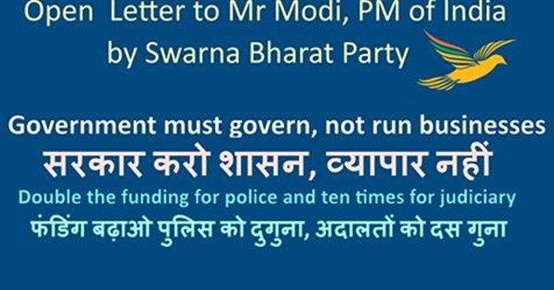
Narendra Modi: Additional funding for Police and Judiciary in India
Some comments in support of SBP's Open Letter to Mr Modi. Sign this petition: https://www.change.org/p/narendra-modi-additional-funding-for-police-and-judiciary-in-india/c
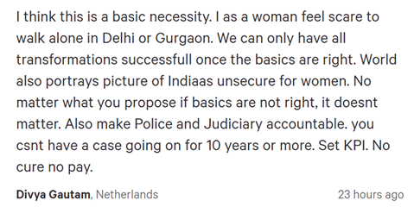
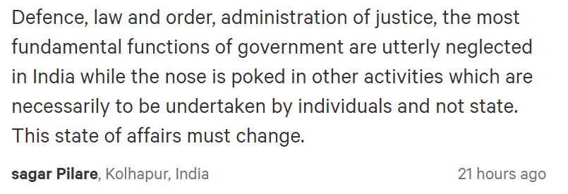

Media Coverage of Swarna Bharat Party

News published in Freedom First 6 September 2016
Swarna Bharat Party Emulates Swatantra Party
September 6, 2016
Freedom First, Digital Politics
Aas Mohammad
The Swarna Bharat Party (SBP), India’s only Liberal Party, registered in 2014, held the annual conference of its National Executive at Delhi on July 30, 31 and August 1, 2016.
SBP is committed to defending liberty and promoting prosperity.
Mr. Sanjeev Sabhlok (I.A.S. – resigned), currently economist with the Government of Victoria, Australia, is one of the founders and driving force of SBP. He, along with Mr. Anil Sharma, a consultant residing in London participated in the conference with other National Executive members from Delhi and various parts of India.
The National Executive discussed, in depth, the current political situation in India and concurred that India urgently needs a strong national liberal political party to steer the country. All existing political parties are different shades of communism and socialism.
The Swatantra Party, founded in 1959 by C. Rajagopalachari, Minoo Masani and N. G. Ranga was the last liberal party in India. In 1967, it won 44 seats in Parliament (incidentally the Congress also wins 44 seats in the general elections of 2014) and Masani was elected as the acting Leader of the Opposition. Unfortunately, the Swatantra Party voted to dissolve itself in 1974. However, Masani, S. V. Raju and others kept the Swatantra flag flying by keeping the Maharashtra unit of the Swatantra Party which exists on paper to this day.
The Swarna Bharat Party has rightly voted for Mr. Naozer Aga, one of the two surviving members of the Swatantra Party (Maharashtra) to be the first National Mentor of SBP. Mr. Aga actively participated in the Conference sharing his views and experiences from the past.
SBP is now taking the Swatantra Party’s efforts further and wishes to emulate the Swatantra Party.
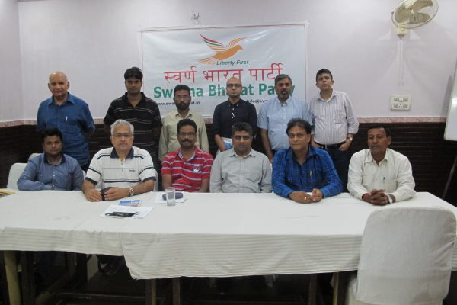
SBP NE Standing L-R : Naozer Aga, Mumbai; Rabikant Bharti, Bhadohi; Bansidhar Maurya, Bhadohi; Vidyut Jain, Darjeeling; Anil Sharma, London; Supratim Basu, Mumbai Sitting L-R : Rahul Pandit, Hyderabad; Sanjeev Sabhlok, Melbourne; Sureshan P., Delhi; Loknath Rao, Pune; Sanjay Garg, Jaipur; Satish Chand Pal, Bhadohi
SBP believes:
a) in State funding of elections, so that competent candidates can contest elections without entering into any quid pro quo arrangements with their financiers or using black money, as is currently the case.
b) that as the Government should be for, and is the Servant of the people, and not their Master, all appointments of senior government officials should be done on performance contract basis only. Article 311 of the Constitution, which protects tenured public servants, needs to be amended.
c) that the Government must not interfere in the freedom of ownership, occupation and speech of the people. Government should handle and focus only on the key functions of defence, law and order, justice and infrastructure. It must ensure equality of opportunity, including need-based direct support to the poor. SBP supports social justice.
SBP will contest elections wherever possible. Efforts are under way in Uttar Pradesh, Maharashtra and Rajasthan and will soon spread to other parts of the country.
SBP also decided to embark on leadership; membership and fund raising drives and appeals to all Indian liberals to support its effort in bringing about a total rapid change (not slow, incremental reform) needed for India to reach its potential.
Ancient India was a liberal high flying “Sone Ki Chidiya”.* Socialism in India has brought the vulnerable sections of the people of India to their knees, in comparison with other similarly placed nations in 1950s, which took to the path of liberty, decades ago.
Liberalism is the long overdue need of the hour for India. For more details, please visit SBP website www.swarnabharat.in
Mr. Aas Mohammad, an IT engineer based in Delhi was invited as an observer at the National Executive Conference of SBP. E-mail: aasmuhammad@gmail.com
*Freedom First issue of March 2015 carried the Executive Summary of Sone Ki Chidiya’s Total Reform Agenda. Please refer to Freedom First archives on its website www.freedomfirst.in

Daily Punyanagari, Pune edition
September 9, 2016
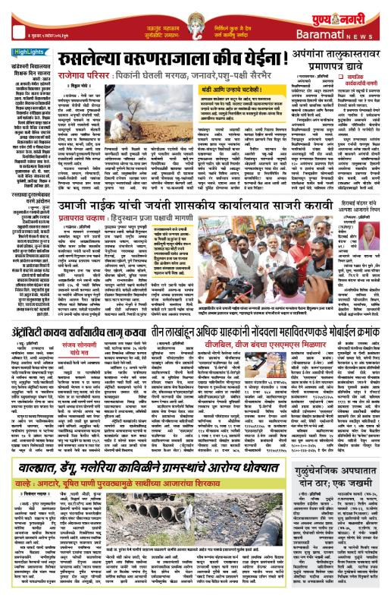

News in Daily Punyanagari, Amravati edition

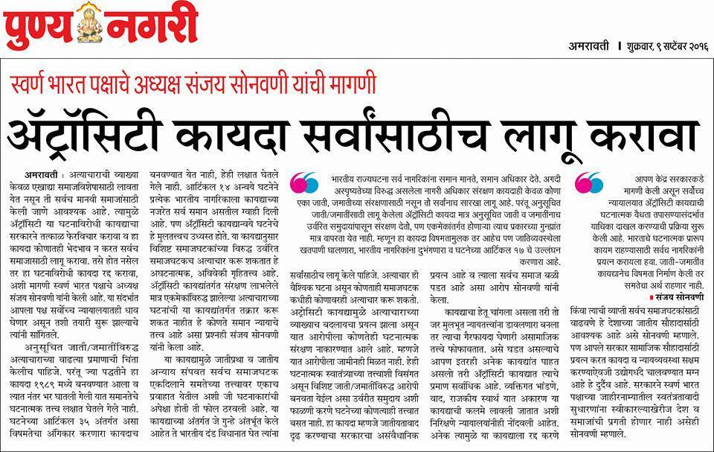

Ground Report India
http://groundreportindia.org/monthly/2016/09/08/the-law-should-punish-all-atrocities-not-just-against-sc-and-st-communities-says-swarna-bharat-party-president-sanjay-sonawani/

Chaprak (page 1 and 8)
September 18, 2016
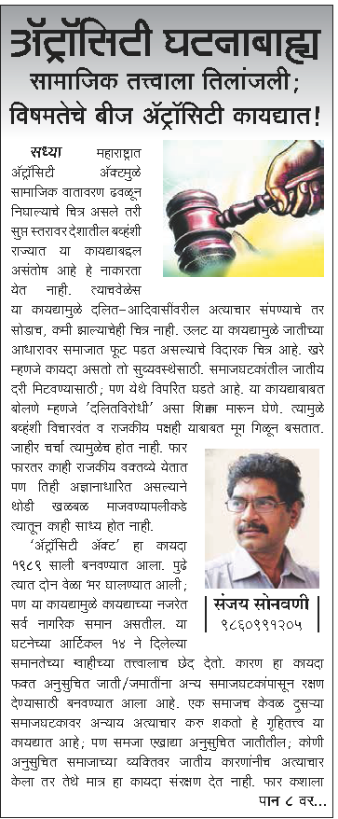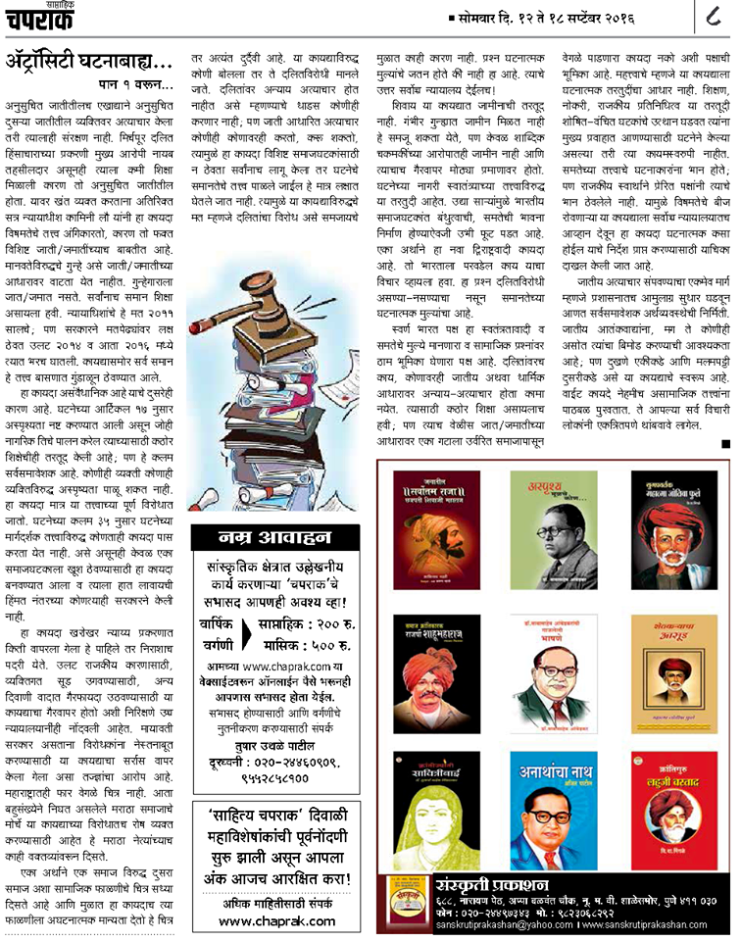

Maharashtra Times, Ahmednagar edition.
September 14, 2016
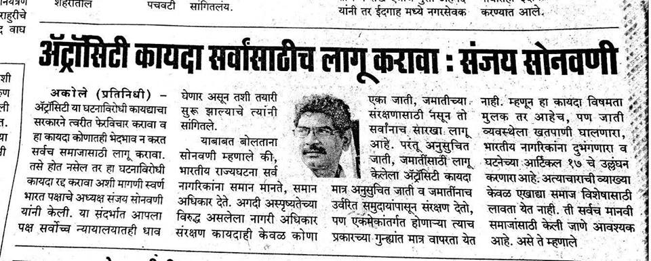

Daily Pudhari, Ahmednagar
September 14, 2016
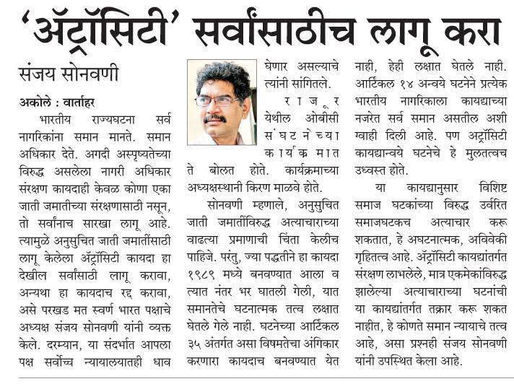

Article discussing SBP's position re: Atrocities Act
September 15, 2016
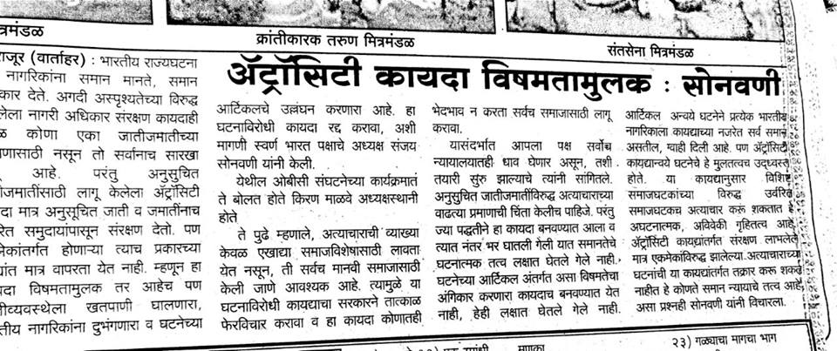

Daily Prahar, Mumbai
September 16, 2016
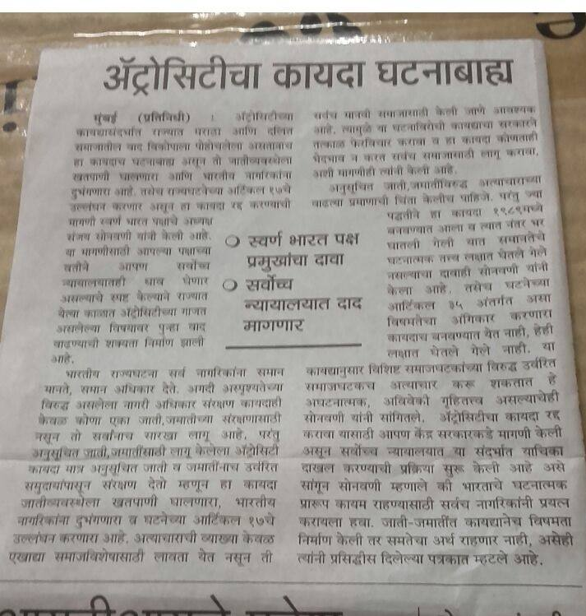

Ground Report India Coverage – Sugarcane Farmers’ Rally
September 22, 2016
http://groundreportindia.org/monthly/indian-states/2016/09/governments-should-stop-looting-sugarcane-farmers-says-swarna-bharat-party-vice-president-alok-kumar/
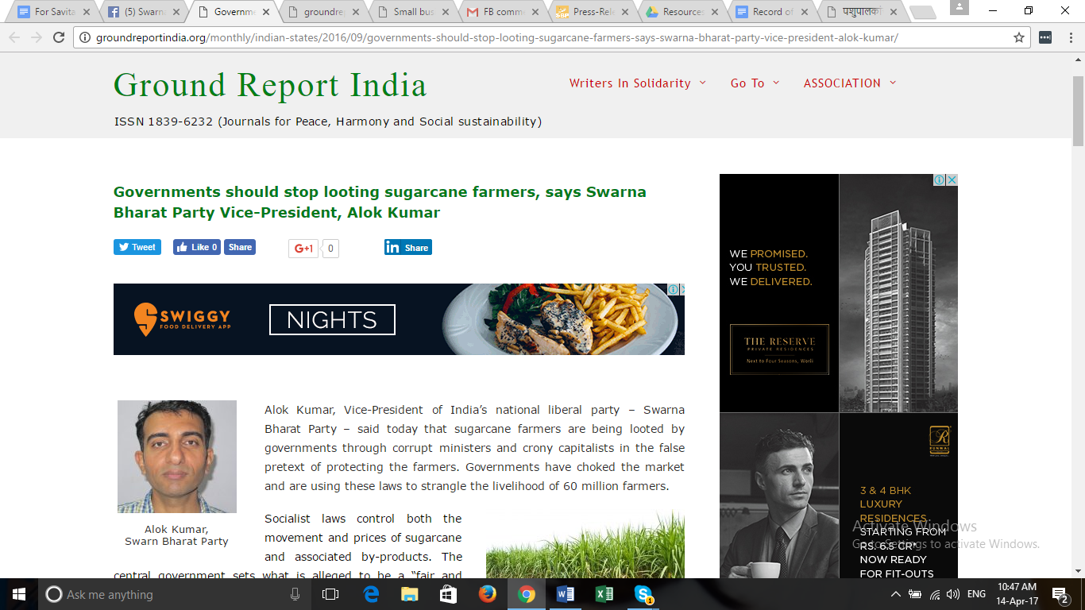

Ground Report India coverage – Small Businessses need Good Governance
September 22, 2016
http://groundreportindia.org/monthly/indian-states/2016/09/small-businesses-need-good-governance-not-sops-or-protection-says-sbp-president-sanjay-sonawani/
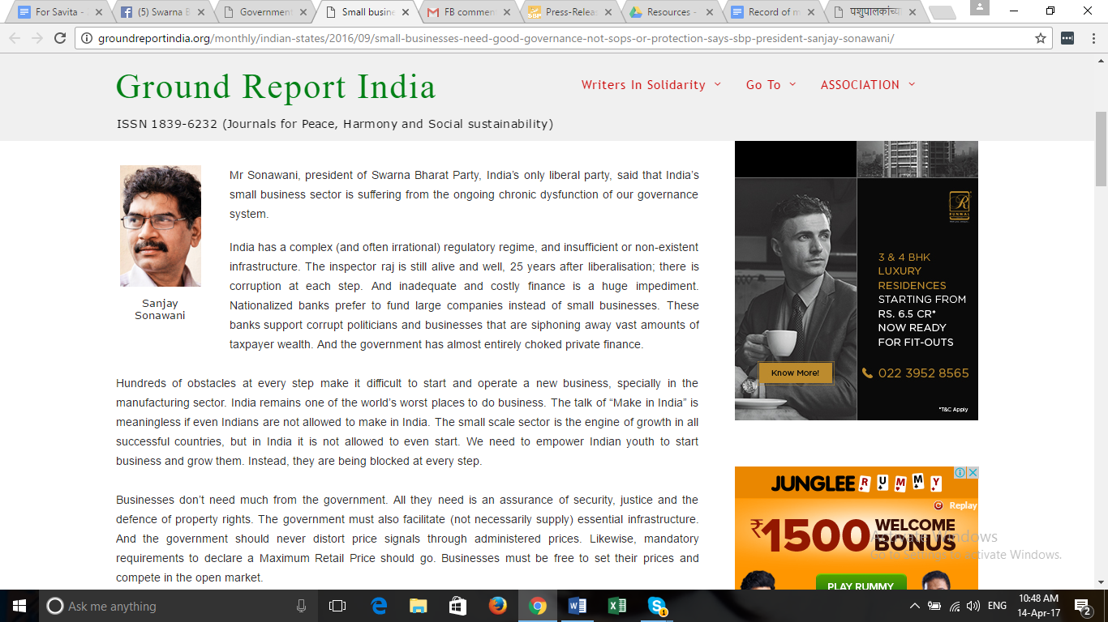

Ground Report India coverage – Caste system
September 16, 2016
http://groundreportindia.org/monthly/2016/09/16/let-us-work-together-hand-in-hand-we-cant-end-the-caste-system-by-making-different-laws-for-different-castes-sanjeev-sabhlok/

Rajasthan Patrika
September 23, 2016
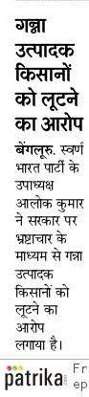

Daily Pudhari, Pune, about SBP's demands on Small Scale Industries
September 25, 2016
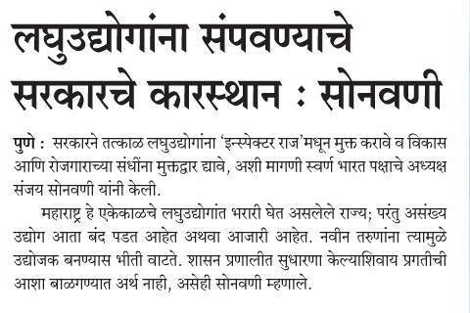

Maharashtra Times
September 25, 2016
News appeared in Daily Maharashtra Times, Ahmednagar edition.
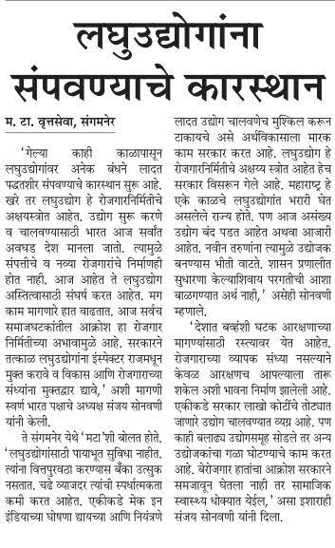

Punyanagari
September 27, 2016
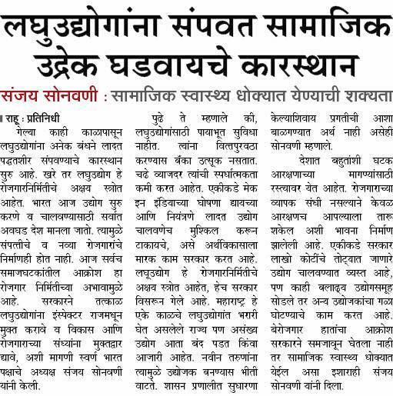

Parsiana
September 21, 2016
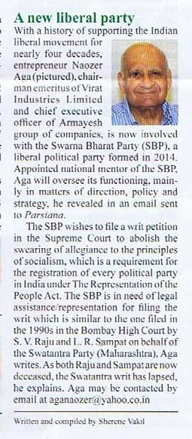

The Public World
September 22, 2016
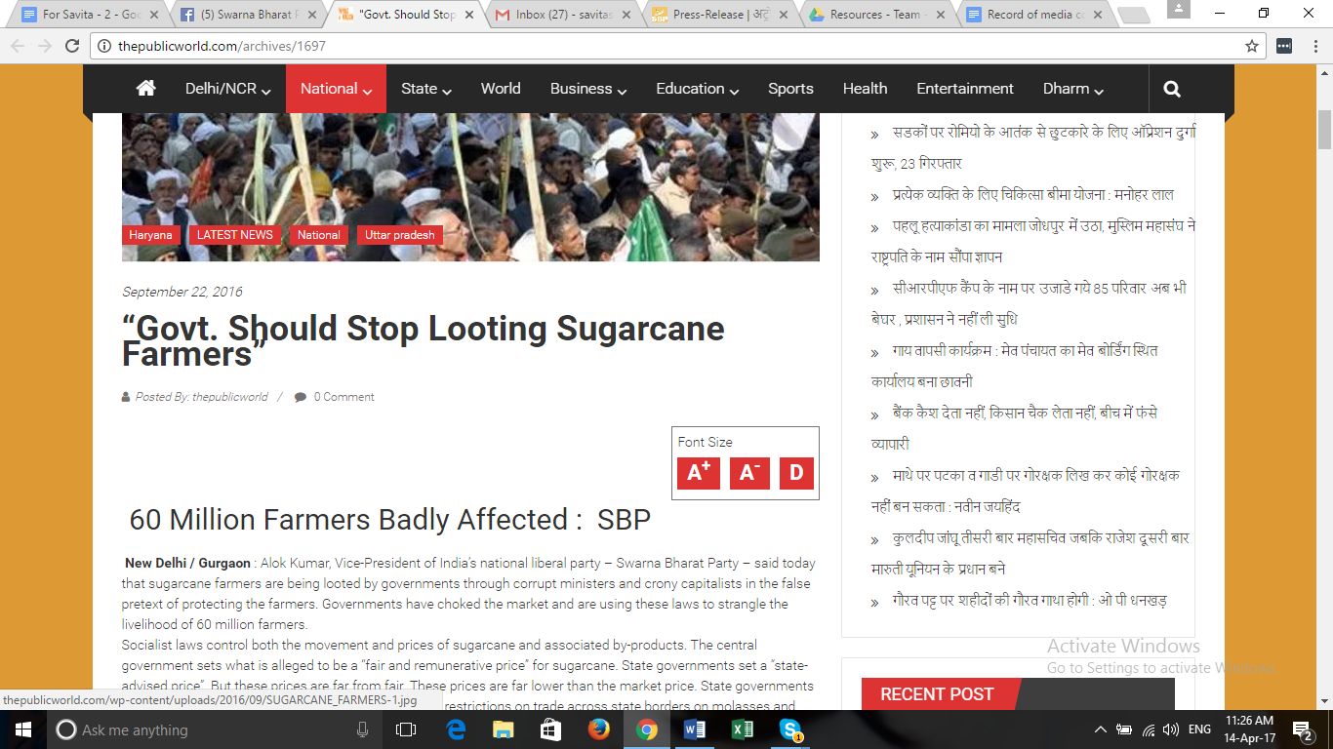

MyMarathi - Coverage of SBP 2 October Rally

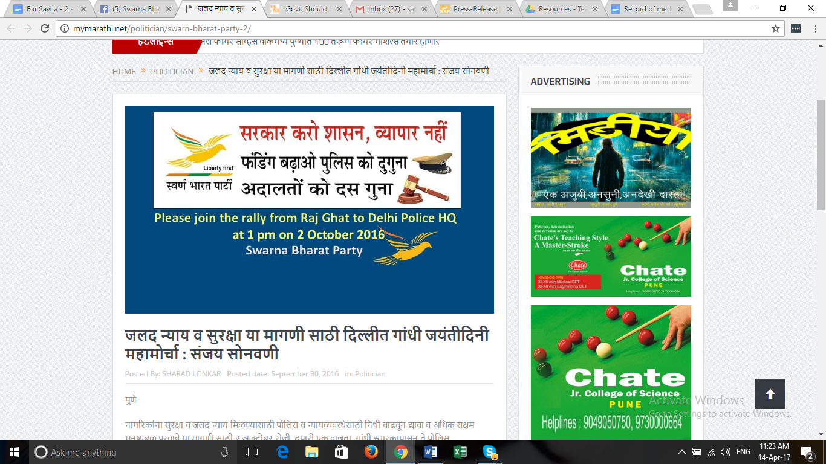

Jagran - Coverage of SBP 2 October Rally
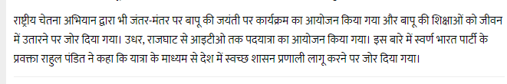

Divya Marathi, Solapur
October 5, 2016
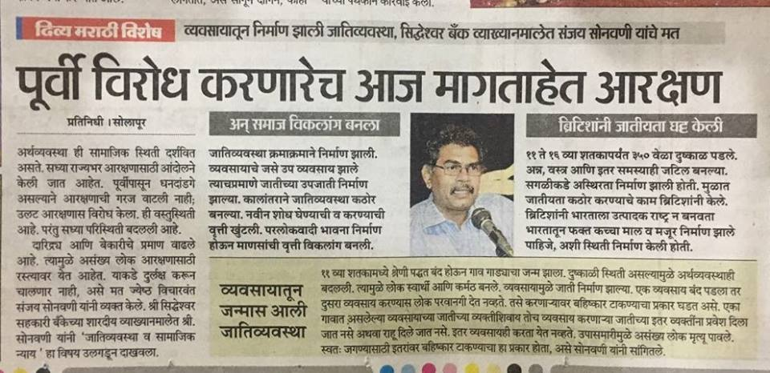

Daily Sanchar, Solapur
October 5, 2016
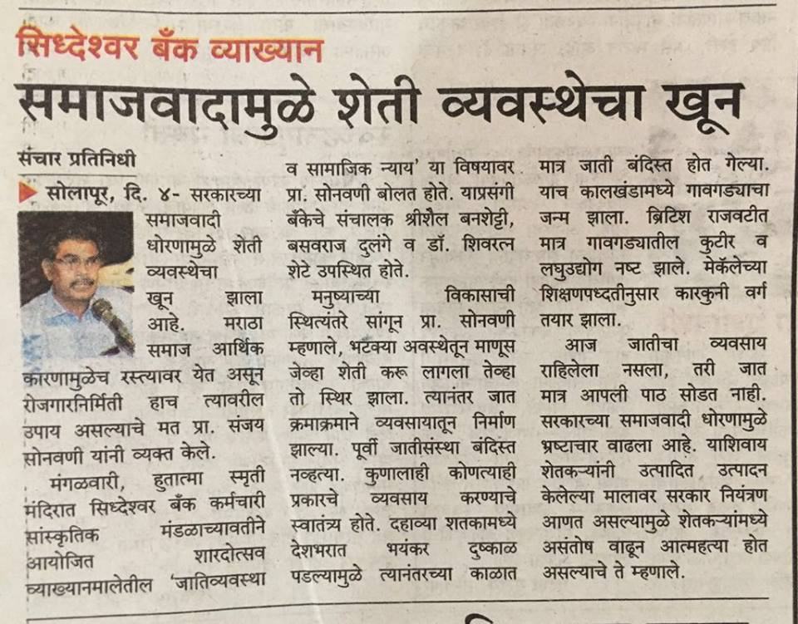

Lokmat - SBP President, Sanjay Sonawani's public talk in Sholapur
October 5, 2016
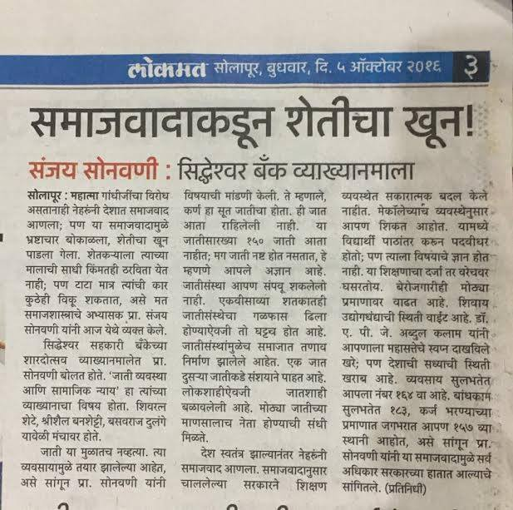

News on Mymarathi
October 14, 2016
SBP views reported on Mymarathi on the serious issue of ever diminishing grazing lands and its impact on the economy, employment and the environment.
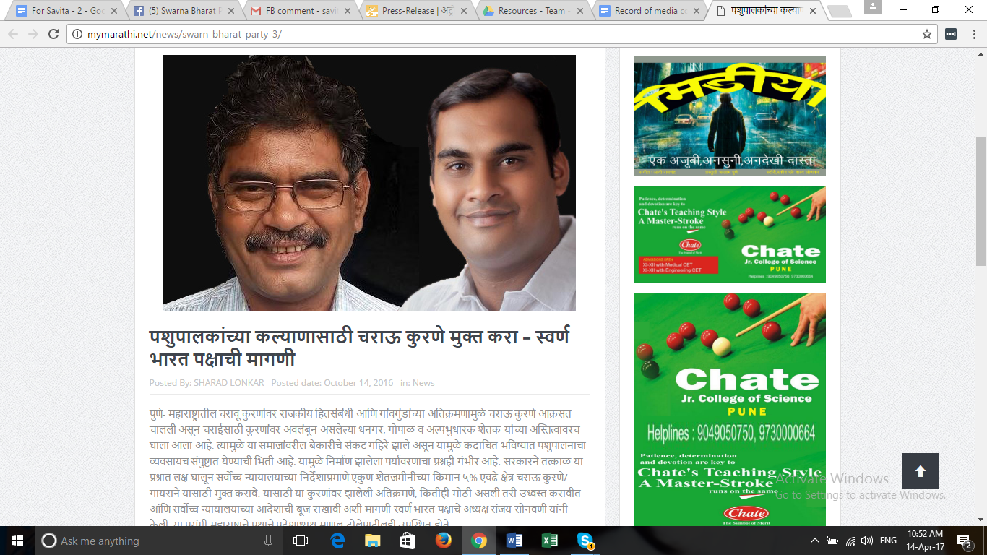

Daily Samachar Post, New Delhi
October 15, 2016
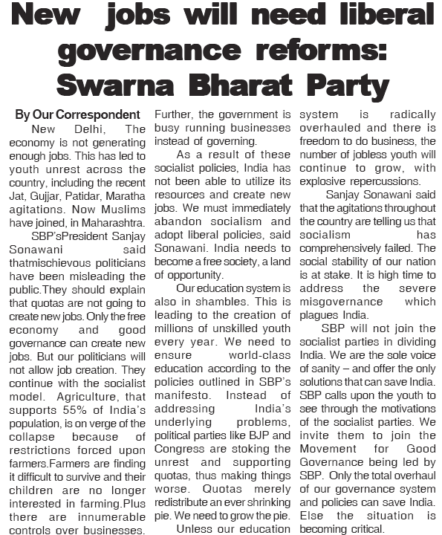

Punyanagari, (page 17, Pune edition)
October 15 2016,
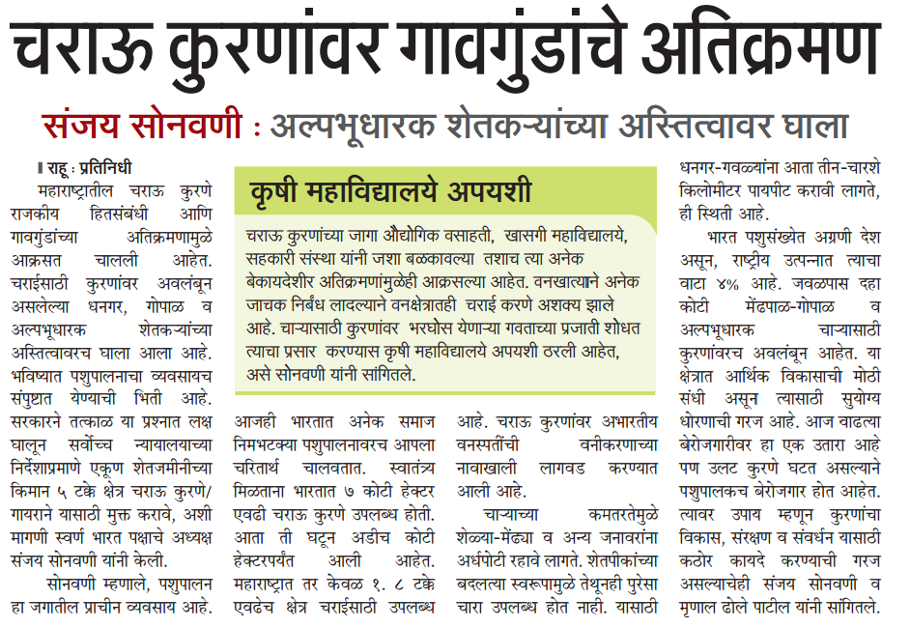

Pune Darpan
October 16, 2016
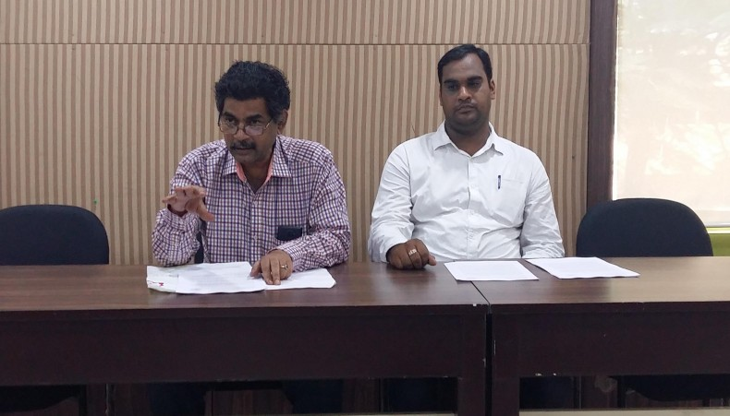

Tennews
October 16, 2016
Swarna Bharat Party demands that public grazing lands be protected from encroachment: President Sanjay Sonawani by tennews.in
Swarna Bharat Party demands that public grazing lands be protected from encroachment: President Sanjay Sonawani
Mr Sanjay Sonawani, President of Swarna Bharat Party demanded that the encroachment of public grazing landsacross the country by corrupt forces in league with local politicians be immediately brought to an end. This encroachment has grievously harmed farmers and the environment.
Livestock rearing contributes around 4% of India’s GDP and sustains over 10 crore people (8.8% of India’s population). A good proportion of these people are landless nomadic pastoralists or marginal farmers who depend on pasture lands for survival. Pasture lands have reduced by around 70% since independence. Nomadic shepherds now trudge three to four hundred miles to feed their herds. Many of them are forced into unemployment each year.
These lands play another critical role. In states where cow slaughter is forbidden, farmers unable to buy fodder for old cows, let them out in the pastures. Where pastures have been encroached, such old cows are discarded in the towns, where they eat plastic. The number of such cows has dramatically multiplied.
In its 28 January 2011 judgement in the case of Jagpal Singh vs. Panjab Government, the Supreme Court of India directed that all encroachments be demolished. Unfortunately, most encroachments still remain. And while many States have amended grazing land laws to stop further allocation of such land they continue to allow Gram Panchayats to allot such lands where no other land is available for an intended (non-grazing) purpose. Grazing land is still being taken away by corrupt forces. This is entirely unacceptable.
There are also grim consequences of this disappearance of grazing lands on the environment and eco-system. Many species of plants and wildlife are being endangered. Further, forest departments often plant incompatible species on these lands, further damaging the eco-system. And forest laws impose draconian restrictions on traditional livestock farmers. They prevent sheep from grazing in forests on such lands, even where the sheep cannot damage big trees.
Mr Sonawani said the country needs the right balance between development, protection of pastures and protection of the environment. We urgently need a law on the lines of the Taylor Grazing Act of USA. Under such a law, permits would be issued (at cost) for grazing and for making improvements to grazing land by pastoralists, such as temporary fencing. Such permits can be revoked under severe drought or other natural disaster conditions. Further, a separate authority would manage all such lands and demolish all encroachments. There is also an urgent need to promote high output grass species. The livestock industry has vast potential, given huge demand for cattle and cattle products from China.
Mr Sonawani demanded that the Modi government immediately draw up a clear policy on this issue, failing which Swarna Bharat Party will consider launching a movement to regain control of the nation’s common public lands.

Saptahik Chaprak,(page 8)
October 24, 2016
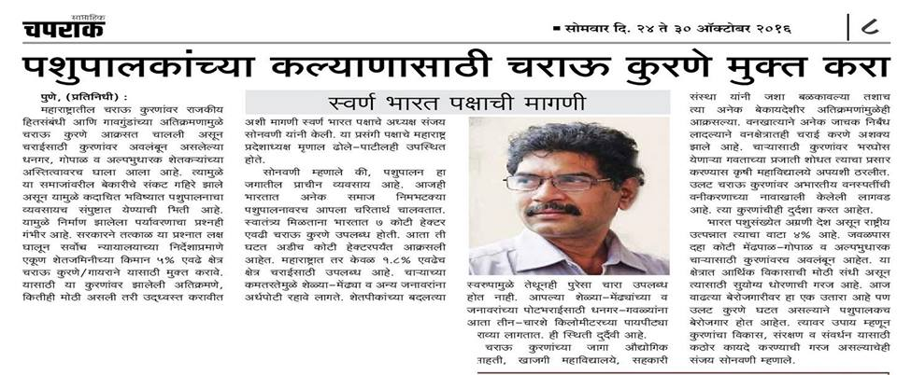

Daily Pudhari
November 16, 2016
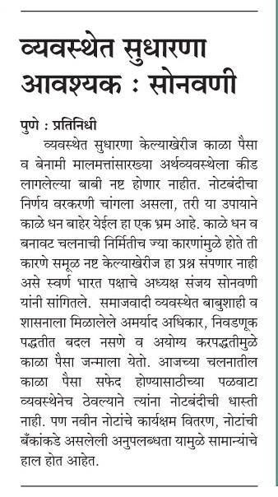

Tarun Bharat
November 16, 2016
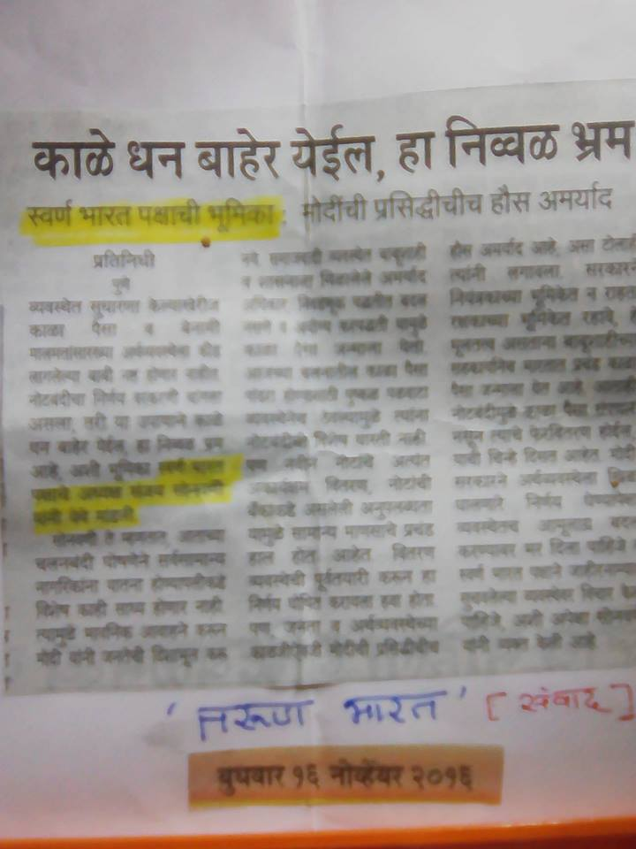

Saptahik Chaprak
November 28, 2016
Recently SBP President Sanjay Sonawani addressed around 1,500 farmers. He lashed out at the evils that socialist governments have brought in to the life of the farmers. The speech is covered in detail by the weekly newspaper Chaprak. Sanjay pitched for liberty and referred to Swarna Bharat Party at appropriate places.

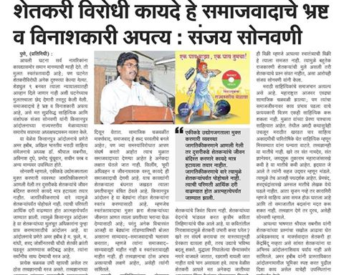

NewsGram
December 16, 2016
Article covered by NewsGram (www.NewsGram.com), a US-based public funded nonprofit media organization whose aim is to bring a perspective in various issues that the mainstream media misses out or covers in a measly manner.
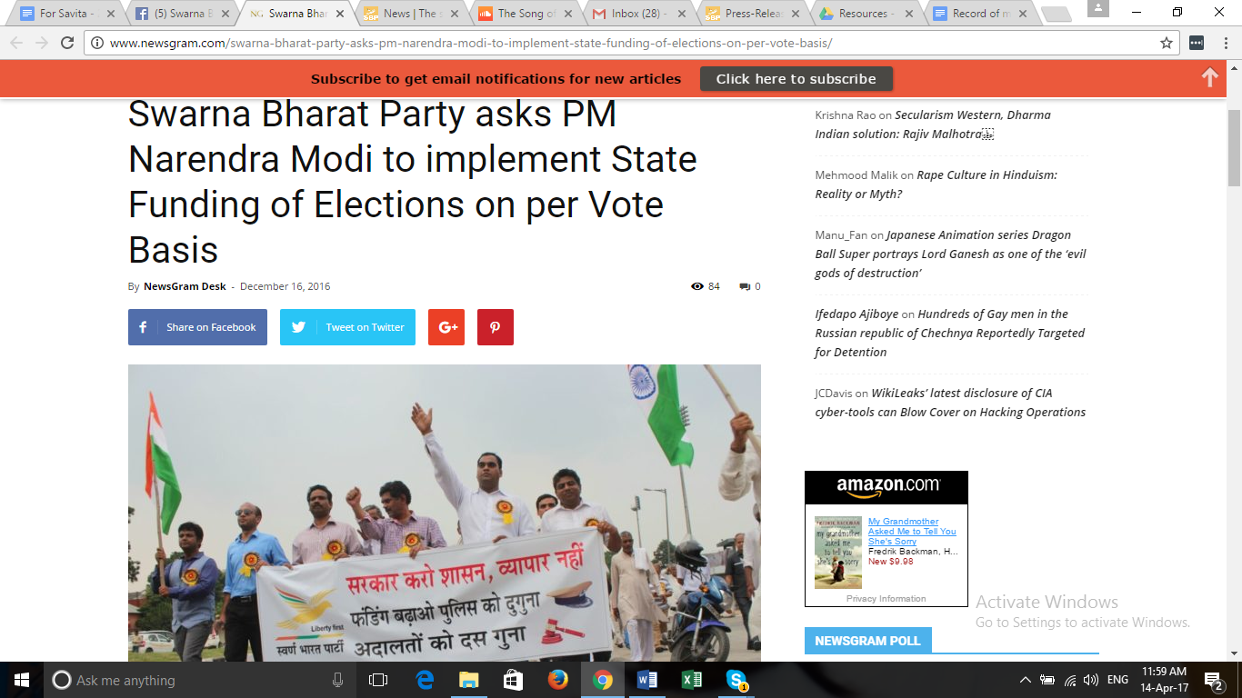

Write-up by Sanjeev Sabhlok in the The Wire- The urgent necessity for state funding of elections.
The Case for State Funding of Elections on a Per Vote Basis
BY SANJEEV SABHLOK ON 10/01/2017
Contesting elections in India is a costly affair, forcing honest persons to avoid it as they risk losing their hard-earned money. State funding on a per vote basis is a simple solution to encourage more competent people to join politics.
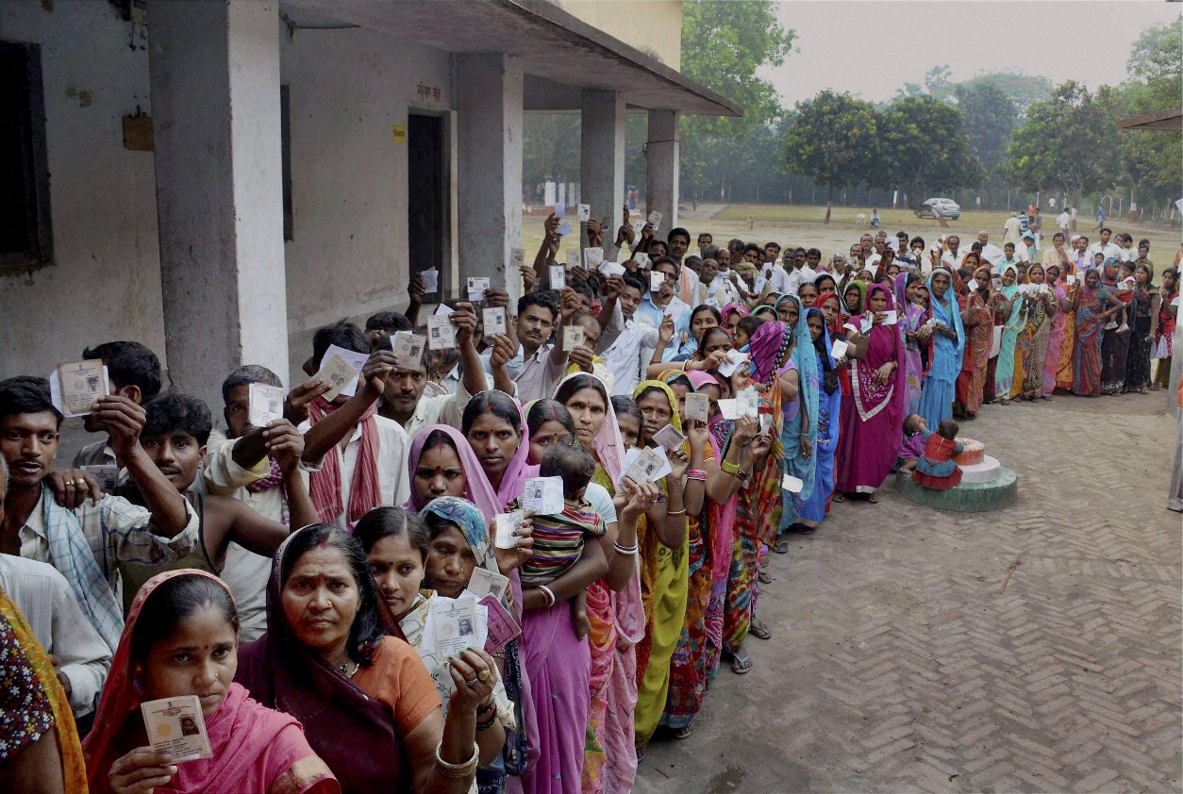
Voters queue to exercise their franchise. Credit: PTI
I joined the IAS in 1982. It didn’t take me long to figure out that all ministers were corrupt. Even Assam Gana Parishad (AGP) – which came to power on the momentum of an anti-illegal immigration movement by the All Assam Students Union – soon deteriorated. Everyone knew that AGP ministers had become corrupt.
Hiteswar Saikia from the Congress was, of course, absolutely brazen. None before him had dared ask me to support their corruption but he personally asked me to award a large tender for cement supply to a company that wasn’t the lowest bidder. I awarded the contract to the lowest bidder (the Cement Corporation of India) and was shunted overnight to a nondescript role in a run-down building without a proper road.
In science, if something happens with regularity, we look for a physical cause. Whether it is gravity or genetics, there is always a physical cause for all regular events. In economics, when something happens with regularity, we look for the underlying incentive.
Everyone in India knows the cause – that candidates must necessarily spend vast amounts of money (whether white or black) in contesting elections. That then creates the incentive for corruption. Everyone who comes to power is guaranteed to become corrupt.
We know this but then we sit tight and twiddle our thumbs. Sometimes we offer “solutions”, such as asking that the amount that people are “allowed” to spend in elections be further reduced. But not all the “limits” in the world can stop the force of incentives. The laws of economics are cast in iron; they can never be violated. We need an incentive-compatible solution.
Prime Minister Narendra Modi has asked political parties to debate the state funding of elections. The last time such a debate occurred was in 1998 with the Indrajit Gupta inquiry, but his report proved to be farcical since he did not consider the most important option – per vote funding of candidates. This time I hope there is genuine intent for reform. No jumlas, please.
It is in our interest to ensure that honest and competent candidates contest elections. Worthy candidates are a public good, more important than any other public good. We, the people, must be willing to incentivise such candidates to contest. As a founder of the Swarna Bharat Party, India’s only liberal political party, I want to persuade you that state funding on a per vote basis is the only sure way to attract honest and competent people into politics.
While the level of electoral expenditure is never the only determinant of electoral success, good candidates are defeated in our system even before they start. Honest competent middle class or poor persons refuse to contest elections since they stand to lose their hard-earned savings if they lose the election. To add to the conundrum honest people face, honest political parties – which do not sell their soul to corrupt businesses – receive almost no funding.
State funding on a per vote basis is a simple solution. It is transparent and it is incentive-compatible. It has been successfully implemented in many countries. The Swarna Bharat Party suggests a reimbursement of Rs20 per valid vote cast to the relevant candidate up to a maximum of Rs70 lakhs per parliamentary constituency. This calculation can be refined.
Along with this, the security deposit will need to be increased significantly to ensure that only serious candidates contest elections. MP and MLA salaries will need to be significantly raised, while eliminating all perks and pensions.
Some people object to state funding, arguing that politics is a social service. It is preposterous to suggest that those who serve us as electoral representatives should be required to lose their lifetime’s savings “for the country’s sake”.
In the reformed system, even though corrupt candidates will probably still outspend honest candidates, good candidates will start participating since their risk of bankruptcy is reduced. That is enough to start changing the system.
Such a payment by taxpayers is excellent value to them, for the opportunity cost of corruption and incompetence is in the tens of trillions of dollars – more than ten times India’s GDP. We have been short-changed by corrupt and incompetent representatives for 70 years. Let’s give the honest people of India a chance.
The Swarna Bharat Party strongly supports Modi’s suggestion for state funding – but only on a per vote funding basis. It is important, however, to emphasise that it is not sufficient to implement only this reform. A range of fundamental reforms, as detailed in our party’s manifesto, are needed in order to make the country a sone ki chidiya once again.
Sanjeev Sabhlok is a founder of the Swarna Bharat Party

Newsgram
February 11, 2017
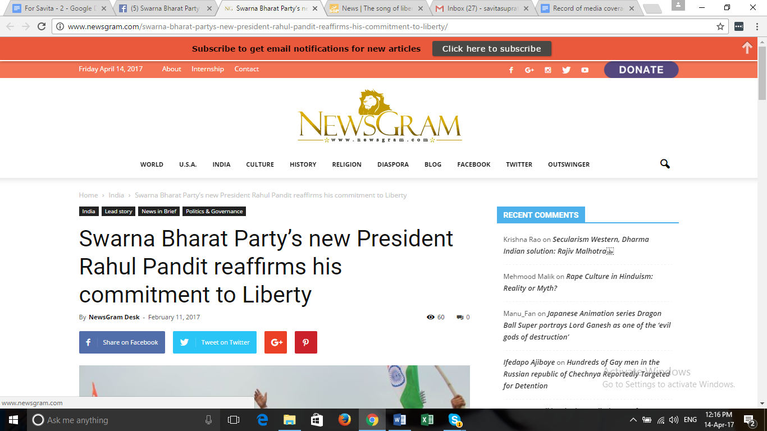

Dainik Bhaskar
March 1, 2017
http://epaper.bhaskar.com/detail/858502/3111223953/cph/map/tabs-1/03-01-2017/356/1/image/
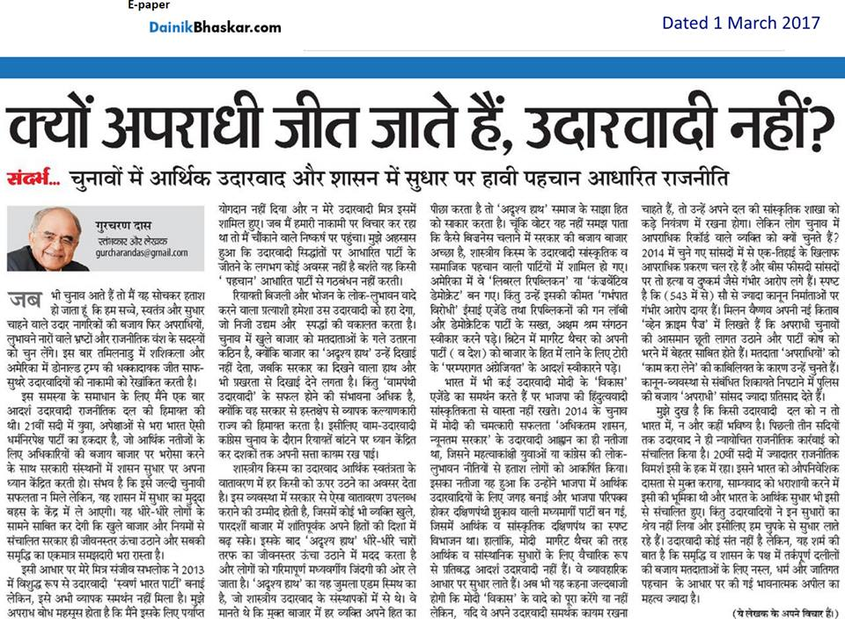

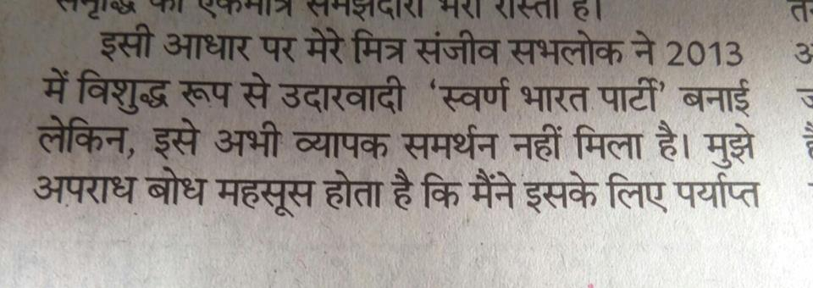

Lokmat epaper
March 11, 2017
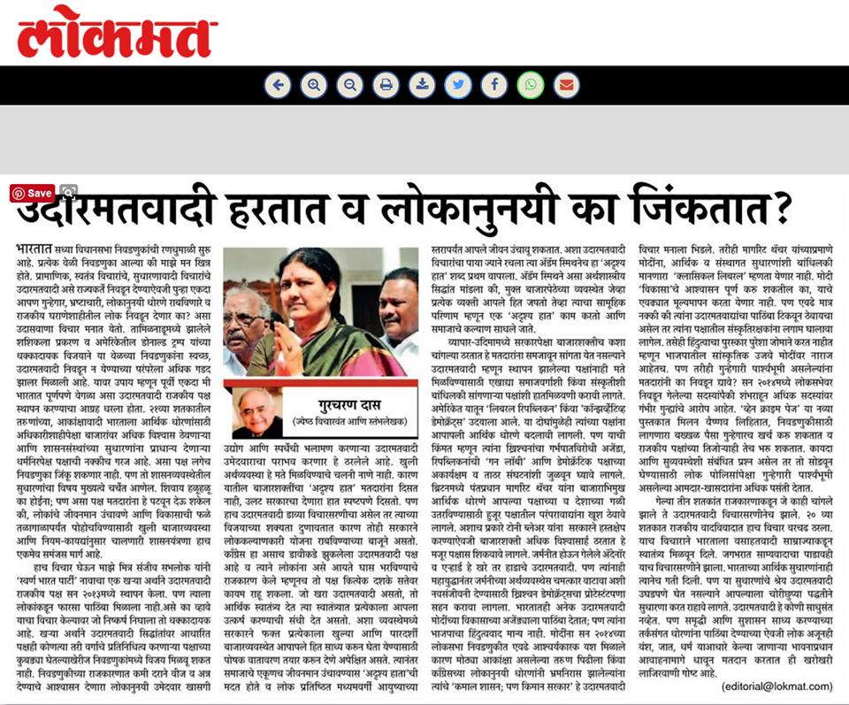

Op-ed in the Times of India by SBP leader Sanjeev
April 1, 2017 – by Sanjeev Sabhlok – see the first page of this report

Sirf News Coverage
April 3, 2017
The Libertarian Has Arrived, But…
India’s largest circulated newspaper, The Times of India, today published an article by Sanjeev Sabhlok. The man had voluntarily retired from the IAS, frustrated by successive Indian governments’ socialistic policies, and migrated to Australia purportedly to study better governance models. Living in the Victoria province, Sabhlok but stayed in touch with India, scouting for people who supported the ideals of individual liberty and free markets, physically visiting the country once in a while and establishing contacts with people online. In due course, the Freedom Team of India was formed; it comprised sporadic people from across the country, mostly employed in the corporate sector, who advocate capitalism unabashedly on social networking sites. A section of the FTI went on to form the Swarna Bharat Party, named after the Hindi appellation for ancient India — Sone ki Chidiya.
On a recent Sunday, columnist Gurcharan Das had informed the readers of the same newspaper that he had joined the SBP. One recalls he was one-half of the duo (the other half being writer Chetan Bhagat) that had visited Arvind Kejriwal in 2012-13 to urge the Aam Aadmi Party to appreciate market economics and returned empty handed. At a subsequent point of time after the Narendra Modi government was formed at the Centre, Das had also lamented the fact that the political heads in India did not get the difference between being pro-business and being pro-market (the truism became all the more evident when, days after the formation of the BJP-led NDA government, Finance Minister Arun Jaitley said there was no mutual opposition between pro-business and pro-poor policies). It was no surprise that Das would like the SBP. What is curious is that he believes this party can make its mark in elections, if not win them. Else, no senior intellectual wastes his time in real-life activism. On seeing Sabhlok’s article on the edit page of the ToI, some political friends of this journalist inquired whether Das had pressed the newspaper to accommodate the piece or Sabhlok had to buy that space. Answering this question would distract my readers from the focus of this article while I cannot be assured that my answer will convince the people. That the SBP has made it to the edit page of ToI is important; how it made it up there is not.
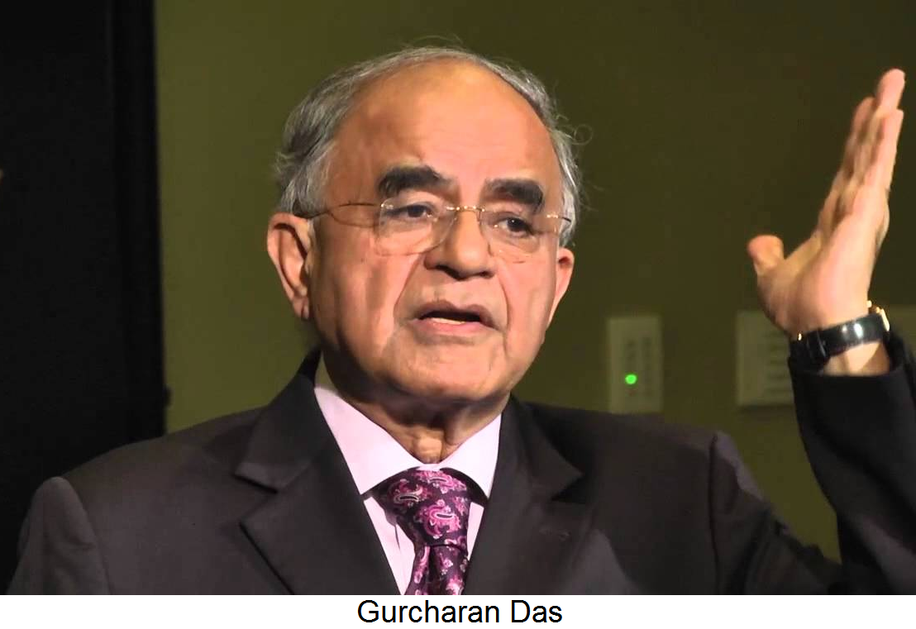
The probability of the SBP’s victory or even a grand show falling short of a win is, honestly, low. It is not because the party’s ideas make no sense to the people. It is because Indians have been fed — rather brainwashed — with the misleading idea of a messianic state and the misplaced ideals that (a) rights are of communities rather than citizens and (b) the leader of an acceptable party or political movement must move around barely or poorly dressed. The SBP cannot win at the moment not because it cannot convince the people that its philosophy is right. It is because it does not have volunteers like socialists who are conditioned [sometimes paid like the cadre of the CPI(M)] to live for days, months and years on end in remote villages and urban slums — where the maximum votes come from — for the act of persuasion. When one talks of the Congress vice-president, for example, Rahul Gandhi is dismissed or blamed for his party’s poor show due to what appears his superficiality in dealing with issues. In contrast, the SBP’s chances are bleak as of now despite the profundity with which it has dwelt upon every issue of governance. This is where the ‘X factor’ kicks in. Notwithstanding his frivolity (which the learned alone can see through), Kejriwal saw overnight success in politics due to his natural talent for histrionics. The corporate culture that SBP members are, by and large, bred in brings with it a restraint from going over the top. This is besides a hint of snobbery and impatience they betray, which makes them consider their audience a bunch of fools if the latter is not convinced about the arguments of the former easily. In the middle of a debate, you are more likely to hear from an SBP ideologue, “If Indians do not understand what is good for them, we are wasting our time,” rather than “if Indians do not understand what is good for them, we shall try harder”.
This lack of appreciation of the Indian mindset is also evident in the manner in which they profess atheism. They insult the people who believe in the divine. It goes without saying that an overtly irreligious (not a covertly atheistic) party cannot succeed in Indian politics. If the communists have ruled Bengal for 34 years, after struggling to come to power anywhere in the country for 57 years, it was because the people of that province had had a 300-year-old history of agnosticism, iconoclasm and reform movements that militated against societal norms. I am discounting Kerala here because the Left Front loses power in that State in alternate elections, thereby showing that the people are not bowled over by the idea of communism. As for Tripura, that State is again dominated by Bengalis rather than its native population. In the whole of the rest of India, you cannot hope to make it big in politics if you feel the itch to lampoon their faith in gods every other day. Here again, if you point this out, you will be told, “If Indians do not understand what is good for them, we are wasting our time!”
But then, I must clarify that the SBP is not made of people who follow pseudo-secularism of the kind the Indian National Congress, Samajwadi Party or any communist party does. To them, secularism can only have its original, unadulterated definition: separation of the Church from the state; in the case of India, it translates to no religion being permitted to dictate state policies.
Nevertheless, the party has attracted the criticism of being “anti-Hindu” in the recent past. It was because a member of the FTI was constantly making atrocious statements about Muslims on his Facebook wall. When he was removed as a result, he went about the town branding the party. But even while keeping that incident at bay, I would prescribe a course correction by some personalities the SBP is associated with. Whereas their criticism of certain Hindu practices surfaces spontaneously, they need to be prodded to find some fault in the belief systems of Muslims and Christians. It’s like writing a 1,000-word article slamming the hardly practised Sati, and concluding it with an epilogue of 100 words critiquing triple talaq so that the piece looks ‘balanced’. This implicit yet evident bias against the majority must go. While the SBP places itself diametrically opposite of communism in economic policy, they may well take a leaf out of the life of an atheist called Jyoti Basu. In the heydays of the CPI(M) in Bengal, it used to favour no community in particular [appeasement politics sneaked in much later]. Those days, Basu would patiently wait for the second and third rung leaders of his party to finish their puja or namaz outside the places of worship — demonstrating to the believers that he did not share their belief — before they would together leave for a programme of the party, but never utter a word against any religion.
The SBP must also revise its position on polygamy. It says that if the Muslims cannot be persuaded to do away with this practice legalised by the Shari’ah, the Hindus must be freed of the law to stay monogamous as no Hindu text mandates, advocates or necessitates monogamy. This is a male perspective and an insensitive one at that. Not only is it sick of a man to demand if his neighbour has four wives, he must have at least as many wives, the very idea of sharing one’s spouse with someone is terrible for a man and a woman alike. The policy makers of the SBP must spare a thought to the trauma a man puts his wife through when he brings home another wife.
As for economics — the reason why India must embrace the SBP — there is just a minor shortcoming it must work on. Unlike hardcore libertarians, its leaders are not averse to the idea of income tax. A typical libertarian government, like those of Alaska, Florida, Nevada, South Dakota, Texas, Washington and Wyoming of the United States, and to some extent those of Hampshire and Tennessee, believe it is a sin on the part of the government to snatch away a part of a citizen’s income. Sabhlok, in the course of a conversation with me, had said that the replacement of income tax with consumption taxes would increase the cost of living of the poor. I do not agree with this assessment, as the taxes on expenditure can be calibrated in a range beginning with a decimal percentage for essential goods like salt and ending with a huge percentage for, say, one’s stay in a luxury hotel. This policy is important not because an inconsequential person like me believes in it. An announcement of abolition of the income tax will be significant for the middle class — it has a shock value — the first potential class of people who would rally around the SBP and turn into its core supporters. In politics, a section of your support base must be core, and you must promise them at least one thing that is big. Nothing is bigger for the salaried people than an assurance that a grossly unfair regime, which forces honesty down their throats in the form of TDS — while letting the filthy rich hide their real incomes and stay under-taxed — will go.
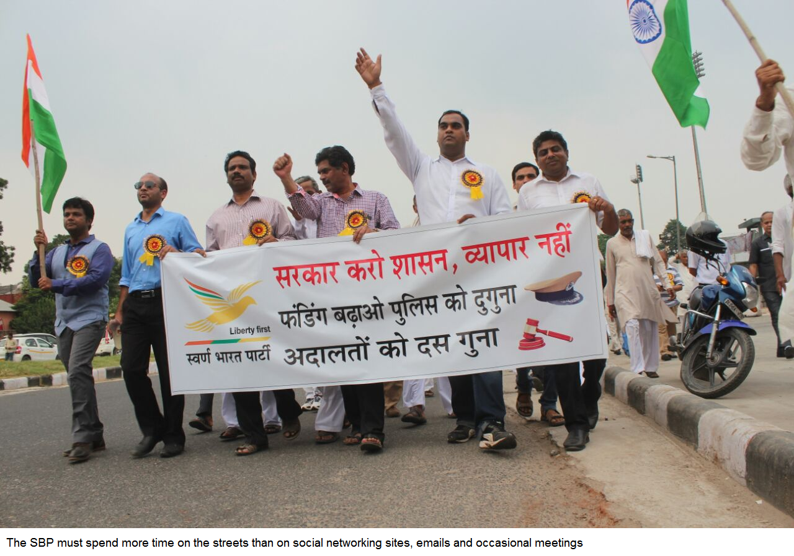
Having taken care of its policy papers, the SBP must enter mainstream politics with a bang. Being inhibited against dramatics will not help. The well-dressed company executives, consultants, lawyers, retired soldiers, etc that constitute the party must contemplate processions, rallies, demonstrations, picketing and gherao, all for the right reason of demanding an end to socialism so that the SBP makes news headlines. The news, in turn, will attract membership though many of the wannabes would be subconsciously socialists. These ‘kids’ must be oriented through workshops on economics to drive away their soft corner for subsidies, freebies and doles.
A revolution does not happen in India. Once in a decade or two, there can be an eyeball-grabbing movement — JP’s anti-Indira movement in the 1970s, LK Advani’s Ram Janmabhoomi movement in 1988-92 and Anna Hazare’s Lokpal movement in 2011 — when the generation that knows how their last ‘hero’ had failed them turns old and a new, gullible, unassuming generation replaces them. That opportunity has been seized by Kejriwal. Therefore, the SBP’s growth will be slow. Nevertheless, there are still many in their 20s who are ready to render service for free if urged with all conviction at your disposal: “Do it for your country!” Groomed, they can spread out to neighbourhoods, telling people how the idea of a maai-baap sarkaar has kept them in a state of penury and under-achievement for 70 years and how their individual liberties alone could uplift their lot.
Why am I issuing sermons? Frankly speaking, my generation cannot do this for free. For six years, beginning two years before the India against Corruption movement, I roamed the streets of Delhi, lanes of the outskirts of the city, the alleys of all its slums and the rows of seats in seminars across community centres, trying to make people see sense in freedom. All this while, I had a few tentative sources of fluctuating income and no regular job. My wife and son suffered due to the absence of money in the wallet and me at home. At the same time, your politics cannot succeed if it keeps you occupied only part-time. This is the unexceptionable stage of building an organisation brick by brick. So, when I am teaching Milton Friedman or Ludwig von Mises to a vegetable vendor in a slum of Bawana or a motor mechanic in a shanty of Shastri Nagar, who fends for my family?
When the issue of funding the cadre has been addressed, the SBP must choose the target right. In a revenge movie where the ‘villain’ is a half-hearted devil, no part of the audience whistles when the ‘hero’ enters the scene. For the audience to burst into applause, the antagonist should be as cruel as one can imagine. Socialism has been the cruellest in the BIMARU States, but the SBP is arguably the strongest in Mumbai and Delhi! In better economic centres of the country, at worst a capitalistic society is dragged down by a semi-socialist government. On the worst spots, the citizen does not even know what freedom he must demand from the government. Therefore, while it can be proved that Modi and Devendra Fadnavis are socialists, such a discourse will get you at best a lukewarm response. Begin getting people on your side in the Seohar district of Bihar, the Sunderbans of West Bengal and Kalahandi of Odisha, for example. Don’t abandon Delhi and Mumbai, by the way. They are useful for the nuisance value the media creates for you.
Undoubtedly, the Indian economy is better off today than in the last three years under the UPA rule. However, the listlessness of the opposition and media, where the menu of restaurants in Lucknow or the palate of a community is debated day after day, spells doom for our democracy. Indians will soon look for serious opposition — some leader raising a question, for example, as to why the taxes of a poor country like India are being wasted in running luxury hotels and airlines, as Sabhlok has mentioned in his article.
Modi is apparently working on a plan of empowerment of the poor followed by a further liberalisation of the economy in his second term, which he seems to be sure of. He can be challenged only till the time he is more socialist and status-quo-ist than a capitalist and reformist. Filmmaker Mayank Jain wrote on his Facebook wall recently that this was the first leader in Indian political history who hogged all the three slots — left, right and centre — simultaneously. So, how do you challenge him? If you question his funding for the Congress’s schemes, he will show you the money that is coming in from an improved market condition. If you accuse him of leftism today, he will say he will turn rightist tomorrow. And, like a centrist, he will steer clear of controversies even as the loony fringe comprising the ilk of Sakshi Maharaj and Sadhvi Niranjan Jyoti go bonkers.
So, how will the SBP sink its teeth in? Influence the States not ruled by the BJP first. There will be a huge void in Indian politics in 2024 when Modi retires. No second-rung leader of the ruling party from Shivrajsingh Chouhan to Fadnavis to Yogi Adityanath can fill the space that a peculiar leftist-centrist-rightist combo alone, which only Modi is, can occupy. By then, the SBP’s cadre-building exercise should acquire a critical mass. Only then it stands a chance.

SBP was the only party other than BJP and SBP invited by Horasis or the India Meeting 2017
See observations and photos on the first few pages of this report.

Outline strategic plan and budget, 2017-18

Outline of the party’s strategic plan for 2017-18

The party is ready to take off. It needs to focus on the following key objectives:

Key objectives:
• Increasing the number of full time leaders
• Increasing the number of registered members
• Organising strategic activities both at the national and international level, and at the state and grassroots levels
• Developing a very strong social media presence
These strategies need to be supported with funds.
A minimum of Rs 15 lakhs is needed for the 2017-18 year. Anything more than that will obviously help expand the effort proportionately.
Supporters of liberty are invited to chip in monthly (amounts that they can reasonably afford) to support the party in this critical second year of its development.
Donors can either use online payment system or make out cheques to “Swarna Bharat Party” and send them to the party head office at G-249 Palam Vihar, Gurgaon-122017.
If you have any questions, please write to info@swarnabharat.in

Financial statement – FY2016-17

Scanned copies of financial statements

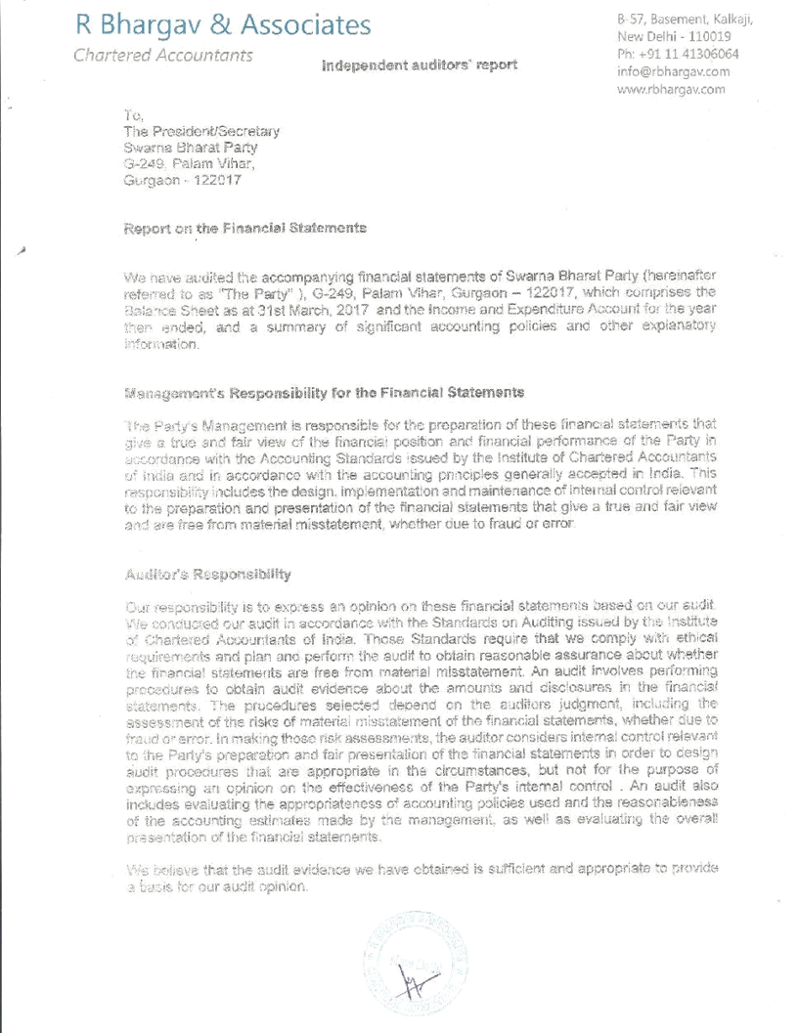
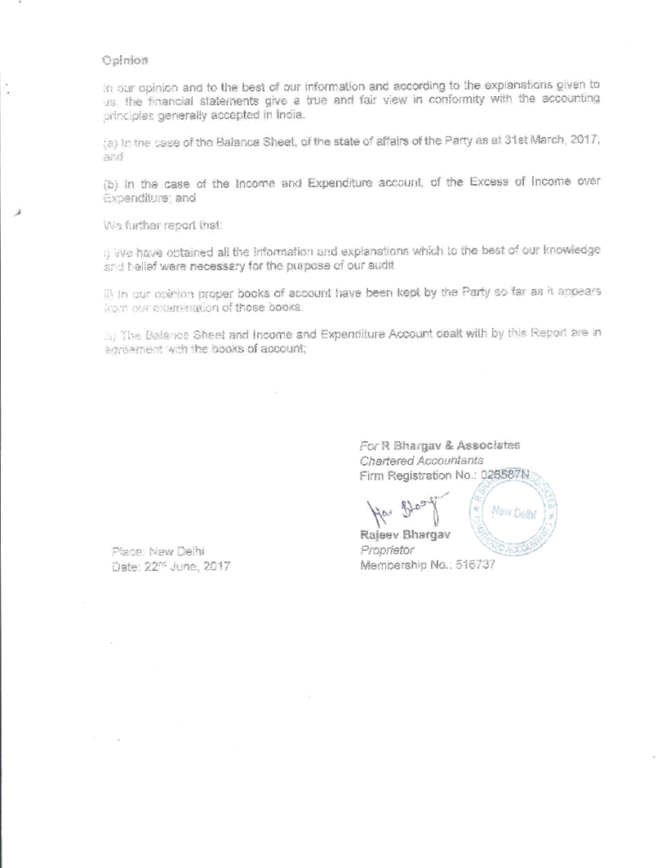

Financial statement – FY2016-17

Scanned copies of financial statements
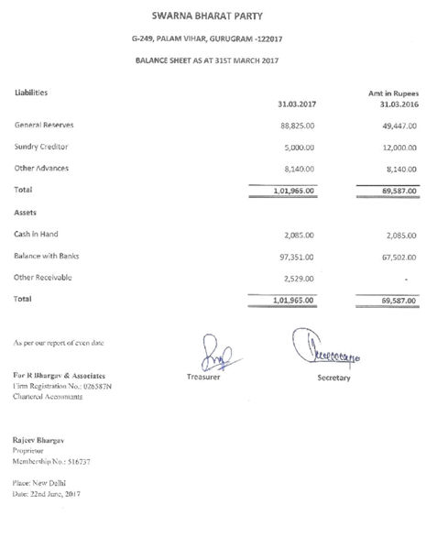

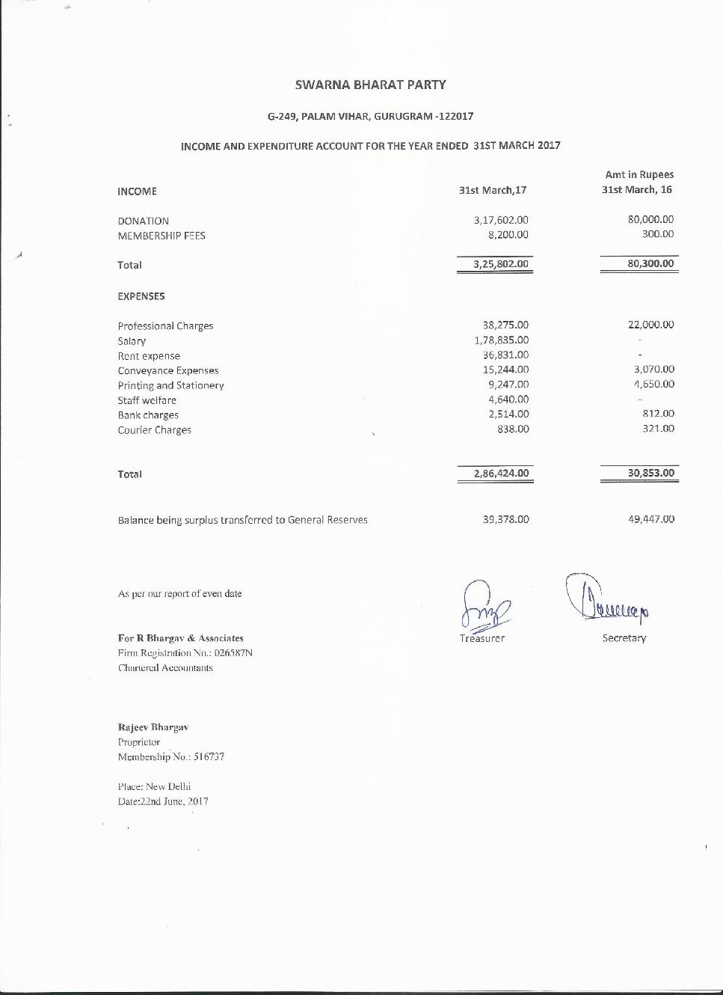

Copy of report on donations sent to Election Commission
Scanned copy, duly receipted by Election Commission on 23 June 2017 [Note: the date of issue of the letter is accidentally written as 23/06/2016. It is actually 23/06/2017]

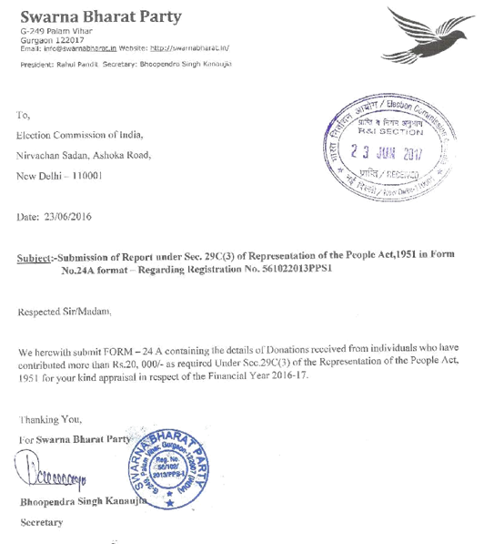
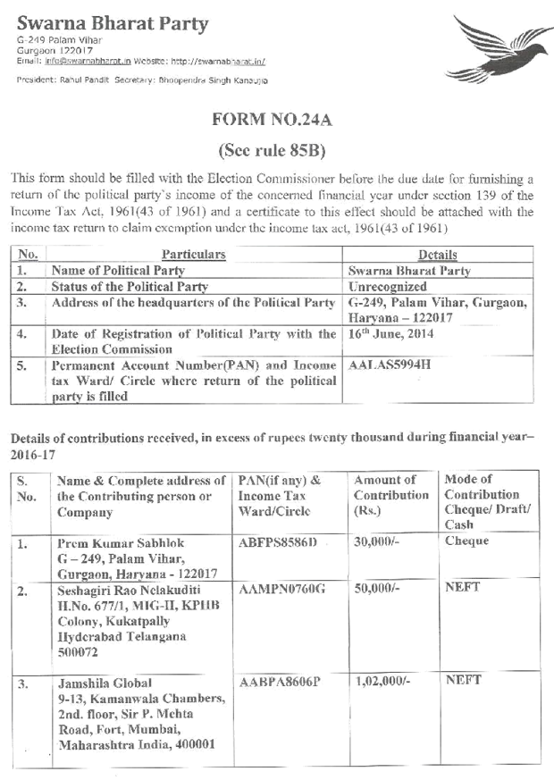

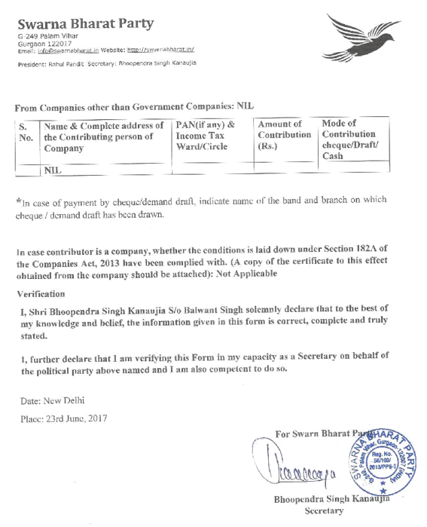

Copy of Income Tax return of the party, 2016-17

Scanned copy of the income tax return

