Should the government be our master or our servant? You decide.

Swarna Bharat Party is India’s only liberal party. We are committed to your life, liberty, property rights and to your right to pursue happiness. Only a market economy, supported by a strong but limited government, in which the government remains our servant at all times, can make India a truly great country.

Our policies will ensure:
- Security and law and order: a core function of government
- Speedy and cost-effective justice, another core function of government
- Facilitation of high quality infrastructure, including power, water, transport, sanitation and broadband
- Equal opportunity for all, through access of high quality school education for the poorest and the government stepping out of direct management of schools
- Low taxes, as an SBP government will not undertake unnecessary roles
- Total elimination of corruption and extreme poverty within three years – if all key aspects of SBP's manifesto are implemented
- Better prices for farmers through phased deregulation, without increasing food costs
- Access to healthcare for the poorest of the poor
- Ease of doing business and a highly competitive economy
- Jobs for all by facilitating opportunities in the private sector.

We will achieve these by:
- electoral reforms – such as state funding of elections – to motivate good people to join public life;
- transforming the bureaucracy to ensure accountability, with removal of tenure at senior levels;
- separation of state and religion; and
- removal of all unnecessary barriers to liberty, such as any unnecessary restrictions on freedom of speech or of occupation.

Read our manifesto at : https://swarnabharat.in/manifesto

Join us to build a bright future for the country. Let’s take back our liberty!
Please visit: http://swarnabharat.in/registerto join as member or volunteer. Lifetime membership fee is currently only Rs.100. Donations to the party are exempt from income tax under sections 80GGB & 80GGC of the Income Tax Act. Please write to info@swarnabharat.in for questions. Twitter: @SwarnaBharatIN ; Facebook: @SwarnaBharatParty
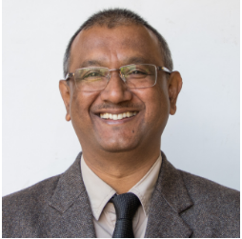  Pankaj Das  National President  From 1 March 2020 – current  +91 97060 49270  daspankaj01@gmail.com | 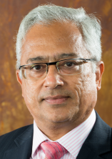  Sanjeev Sabhlok  Overseas Coordinator  sabhlok@gmail.com

