 | Swarna Bharat Party
 | Liberty first
2015-16 | Annual Report

Fighting for your freedom and prosperity
Lifetime membership fee: Rs.100. Please donate liberally.
G-249 Palam Vihar, Gurgaon-122017
www.swarnabharat.in email: info@swarnabharat.in
Registration No. No. 56/102/2013/PPS-1
Contents
president’s MESSAGE 3
Introduction to the Swarna Bharat Party 4
Outline strategic plan and funds needed for 2016-17 5
Outline of the party’s strategic plan for 2016-17 5
An outline of the party’s budget/ fund requirement for 2016-17 5
Current office bearers 6
National office bearers 6
State office bearers 8
OPEN LETTER TO PRIME MINISTER MODI RE: MAXIMUM GOVERNANCE 10
Key activities in 2015-16 and up to END-August 2016 12
SBP's manifesto launched on 5 December 2015 12
Inaugural meeting of the Maharashtra chapter of SBP at Pune on 27 December 2015 12
SBP's new website was launched on Republic Day, 26th January 2016 12
SBP started accepting funds from 26 January 2016 13
SBP’s Bhadohi unit meeting on 16 March 2016 13
SBP’s press conference in Pune on 12 April 2016 14
SBP’s payment gateway operational from 14 April 2016 14
SBP’s second press conference in Pune on 25 June 2016 in a build up to the local municipal elections 14
Swarna Bharat Party’s Youtube channel activated on 21 July 2016 15
Coverage of the party by Liberty Viral in July 2016 16
Meeting with activists in Jaipur, 28 July 2016 16
National Conference of SBP, 30 and 31 July, and 1 August 2016 17
Public meeting at Bhadohi on 2 August 2016 18
Public meeting at Mirzapur on 3 August 2016 20
Public meeting at Pune on 6 August 2016 21
Press Conference in Bengaluru on 8 August 2016 22
Meeting in Jaipur on 8 August 2016 24
Swarna Bharat Kisaan app launched by party members on 8 August 2016 25
Party workers meeting at Hyderabad on 9 August 2016 25
Press Conference in Hyderabad on 9 August 2016 26
Press Conference in Mumbai on 26 August 2016 27
Press Conference in Pune on 30 August 2016 30
Press Releases 32
Press Release - 1 February 2016: Prohibition is no solution to alcohol abuse, says SBP President 32
Press Release - 4 February 2016: SBP commends Supreme Court’s initiative to re-examine same-sex relationship 32
Press Release - 15 February 2016: India must urgently replace its outdated bureaucracy, says SBP President 33
Press Release - 26 February 2016: SBP President says that to attract honest people into politics, India needs urgent electoral system reforms 34
Press Release - 4 March 2016: Liberate India’s mining industry from shackles to create lakhs of jobs, says SBP President Vishal Singh 34
Press Release - 14 March 2016: Replace Censor Board with rating agencies, says Swarna Bharat Party President, Vishal Singh 35
Press Release - 21 March 2016: Mr Modi should first make India makeable, says SBP President, Vishal Singh 36
Press Release - 28 March 2016: Agriculture must be liberated so our farmers can flourish, says SBP President, Vishal Singh 37
Press Release - 4 April 2016: We must support Constitutional, not sectarian nationalism, says SBP President, Vishal Singh 38
Press Release - 3 June 2016: Modi government has failed to create the conditions for new jobs, says SBP President, Vishal Singh 38
Press Release - 7 July 2016: The mantra of Swachh Bharat cannot deliver results. Only governance reforms can, says SBP President, Vishal Singh 39
Local Press Releases - 8 and 9 August 2016: Swarna Bharat Party, India’s only liberal party, has arrived 40
Press Release – 15 August 2016: New President of Swarna Bharat Party, Sanjay Sonawani, wishes India a very happy independence day 41
Press Release – 26 August 2016: President of Swarna Bharat Party, Sanjay Sonawani, asks Mr Modi to substantially increase funding for the police and judiciary 42
Financial statement and signed audit report 44
fORM 24a PROVIDED TO THE Election Commission 50
Record of donations above Rs.20,000 50
Income Tax return of the party for the assessment year 2016-17 53
Income tax return 53

president’s MESSAGE

Sanjay Sonawani  President, Swarna Bharat Party | 1 September 2016  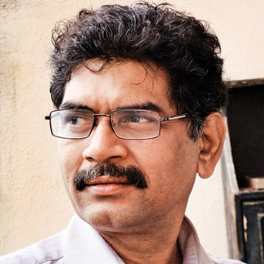
Dear Citizen
A national liberal party for India is long overdue. Since 1974, when the Swatantra Party decided to merge with other political forces, the voice of liberalism has only sporadically been heard in the Indian political scene. Perhaps the last such voice was that of Sh. Sharad Joshi, who passed away on12 December 2015 after having contributed immensely through his long career as farmer’s leader and one time Member of the Rajya Sabha.
On 1 June 2013, some liberals from a group known as the Freedom Team of India, concerned about the deplorable state of liberty in India, and having become convinced over the course of many years that there was no alternative but to start a new liberal party, floated Swarna Bharat Party, which was registered by the Election Commission in June 2014.
With extraordinarily limited resources but with determination to keep moving forward, the party finally launched a new website on 26 January 2016, and has been taking a number of steps to grow the party and take the message of liberty to the people.
Recently, on 26 August 2016 I wrote an open letter to the Prime Minister of India, demanding that he stop wasting resources and energy on running hotels and, instead, start funding the police and judiciary. I also demanded that he implement all the reforms detailed in our party’s manifesto.
I am hoping that within a month he will implement these reforms, consistent with his slogan of “Minimum Government, Maximum Governance”. If not, I will need your support to take this movement forward on behalf of the people of India.
In liberty
Sanjay Sonawani

Introduction to the Swarna Bharat Party
india’s only liberal party
An unpleasant truth stares at us today: the absence of freedom and opportunity in India, and our injustice, lack of security, and high levels of crime and corruption. Life itself is not secure and it is virtually impossible to run a business without constantly bribing someone or another. India is by all international benchmarks almost a banana republic. All political parties have failed to defend our liberties.
India became an independent nation in 1947, but never became free. Despite its broadly liberal Constitution, India remains one of the least free countries in the world on all indicators of freedom, including freedom of speech.

Without liberty we cannot truly become what we are capable of becoming
But here's the issue: A nation means nothing if oppression in one form or other is allowed to continue. Feudalism, aristocracy, religious bigotry - these have destroyed human lives and human progress for thousands of years across the world. To be independent is no big deal. Without being free of oppression and man-made limitations to our freedom of expression, we are stunted as human beings; it is pointless to live a life as a pygmy when one could be a giant.
SBP is designed from scratch as a liberal party which advocates the philosophy of liberty and truth. It is not dependent on any individual, and aims to provide the sole national platform for all Indian liberals for all times to come.
India’s governance is in shambles. India’s governance failure is systemic, and comprehensive. But our major parties refuse to implement any reforms, pandering, instead, to caste and religion - and to the lowest common denominator. Claiming socialist goals, they subsidise the rich and are hands-in-glove with corrupt business. Crony capitalism is rife. The voice of the people is blocked through numerous anti-free speech laws. There is no one in the elected assemblies of India to speak for our freedoms.
In this domain of total under-performance, China is rushing ahead in many fields and poses an increasing strategic threat to India. India needs to get its act together to become a major power. That can only happen if India is committed to human liberty and truth. India needs to launch a frontal attack against illiberal and poverty-creating ideas.
That's why Swarna Bharat Party exists - to speak and fight - for our freedoms and our future. SBP fills a deeply felt void in India's political landscape, which is populated by corrupt, socialist parties. None of these parties can possibly provide India with corruption-free governance to deliver freedom, equality of opportunity, rule of law, and justice to every citizen.
SBP is the only party in India that supports and defends all your freedoms.

Outline strategic plan and funds needed for 2016-17

Outline of the party’s strategic plan for 2016-17
The party’s national conference of July-August 2016 identified strategies to develop the party as India’s national alternative.

Key strategic objectives:
- Increasing the number of full time leaders from three to at least ten by mid-2017
- Increasing the number of registered members to well over 3000 by mid-2017
- Organising a strategic national movement to create a special niche for SBP, and starting party branches across most states of India by mid-2017
- Developing social media outreach to capture the energy of the youth
- Building party cadres at grassroots level in selected pockets where the party is currently strong enough to branch out, with a view to contesting as many elections as possible during the year
- Developing and activating systems for internal party elections in a phased manner within the year.
The party is working on the details of these and similar strategic objectives. Of course, most such activities will need to go hand in hand with fund raising.

An outline of the party’s budget/ fund requirement for 2016-17
The party’s national conference of July-August 2016 worked out a broad outline of the funds required to achieve key party goals for 2016-17. Funds requirement includes:
No. | Item Description | Amounts (Rs Lacs)
1 | Support for full time leaders in the field:  For Sanjay Garg, Sanjay Sonawani and Alok Kumar @Rs.1.50 lacs each | 4.50
2 | Organising a professional social media support cell | 2.00
3 | Organising grassroots petitions/ protests, etc | 3.00
4 | Flyers, brochures, translation of manifesto, etc. | 1.00
5 | Office space in states where membership so supports | 2.00
6 | Full time and part time staff, logistics, printing and contingencies | 4.50
 | Total estimated: | 17.00
It is expected that around Rs.2.0 lacs could be raised from membership fee, and another Rs.2.0 lacs from ongoing donations by national executive members. This leaves a funding shortfall of Rs.11.0 lacs.
Supporters of liberty are invited to contribute monthly amounts that they can reasonably afford to support the party in this critical year of development. You can use either use the party’s online payment gateway system or make out cheques payable to “Swarna Bharat Party” and send them to the party head office at G-249 Palam Vihar, Gurgaon-122017, along with details of PAN number if the amount is greater than Rs.20,000 in a financial year.

Current office bearers

National office bearers
The party's National Office Bearers as at the date of publishing this report are listed below:
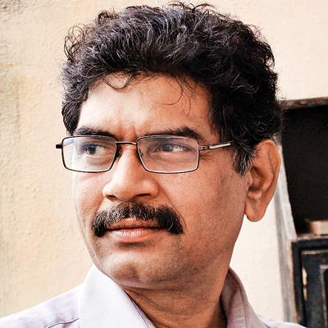 | Sanjay Sonawani, President  Renowned Marathi and English author with 85 books in a variety of genres to his credit. He was a businessman in IT, engineering, publishing and powder metallurgy. He is a dedicated libertarian social worker and researcher, has participated in hundreds of debates on various channels and has delivered over 500 lectures on social issues. He has successfully led many social agitations in Maharashtra.
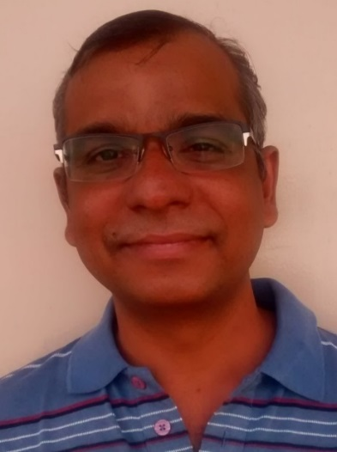 | Vishal Singh, Vice-President  Vishal Singh has worked in various capacities to advise IT companies, more recently in the health sector. He is also co-owner of LiveHospital, a startup in healthcare including electronic medical records, appointment solution, accounting and analytics. Vishal joined the Freedom Team of India in 2010 and over the years his commitment to liberty has increased significantly. He is active on social media and holds strong opinions regarding people and policies that have failed India.
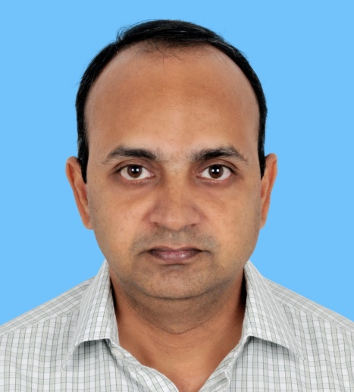 | Madhusudhan Kolachina (Hyderabad), Joint Secretary  Madhusudhan K. has worked in the financial sector for over 15 years. Presently he is an independent consultant to the SME sector and founder of few startups in health and technology. He has been keen over the past few years to work on building a liberal party in India.
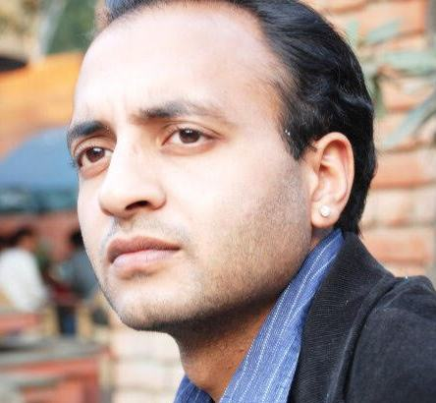 | Vidyut Jain (Darjeeling), Joint Secretary  Vidyut is a graduate of St.Stephens College, Delhi where he studied philosophy, Vidyut was thereafter awarded the Naveen Jindal Scholarship while studying at the Jindal School of government and public policy. Vidyut has been with the Freedom Team of India for a number of years. Barely out of his formal education, he is keen to help India become a free country.
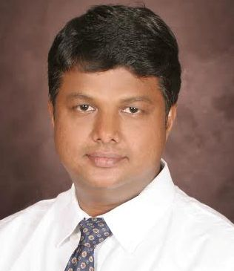 | Rahul Pandit (Hyderabad), Spokesperson  Rahul comes from an international business development background and currently serves as a C level corporate leader. It is his dream to see India as a developed nation. He believes India and Indians have the potential to be a world leader. He believes SBP is the much needed liberal political platform for India that can restore its lost glory. Rahul currently volunteers significant amount of his time for developing youth in India.
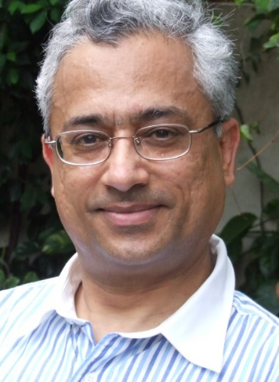 | Sanjeev Sabhlok (Melbourne), Overseas Coordinator  Sanjeev worked in the IAS from 1982 to January 2001, when he resigned to focus on providing India with a liberal political alternative. He works in the Department of Treasury and Finance in the Victorian Government in Australia as an economist, providing public policy advice on a range of issues. He is author of Breaking Free of Nehru (Anthem Press, 2008) and Discovery of Freedom (manuscript). He floated the Freedom Team of India (FTI) in December 2007. Swarna Bharat Party is an offshoot of this effort.

State office bearers
The party's State office bearers are listed below, in no particular order.
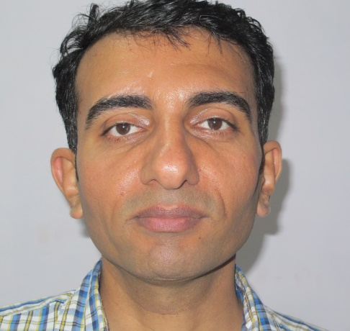 | UTTAR PRADESH STATE UNIT  Alok Kumar Singh, (Ghaziabad), President  Alok Kumar Singh is an IT professional having worked with a number of multinational corporates and extensive experience of working abroad (London) for many years. He returned to India in 2009 with a dream to work for transformation of India into a modern nation. After years of field work at grass roots and considerable evaluation of the organisational structure, processes and manifesto, Alok Kumar is convinced that Swarna Bharat Party is the most appropriate political platform for India.
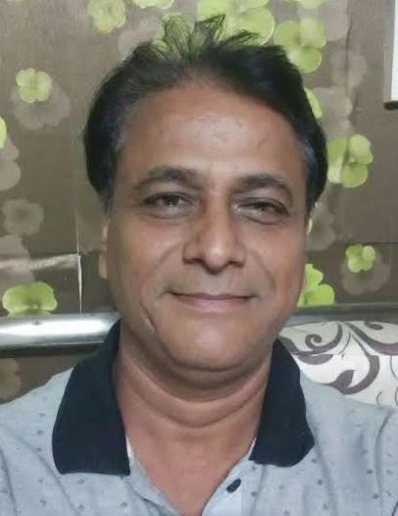 | RAJASTHAN STATE UNIT  Sanjay Garg, (Jaipur), President  Sanjay Garg is a former mechanical engineer who came to value liberty through his own thinking and experience. He came across Swarna Bharat Party and decided to join it, given its determination to fight for Indians' liberty. He decided in mid-2016 to devote his entire time and energy to the development of the party in Rajasthan. Sanjay Garg runs the Centre for Policy Solutions and is active in RTI related matters.
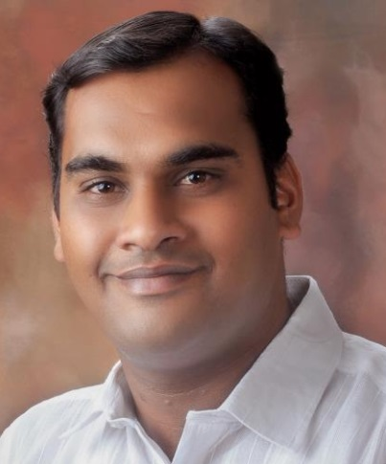 | MAHARASHTRA STATE UNIT  Mrunal Dhole Patil, (Pune), President  Mr Patil has a Master's degree in political science. He is a businessman and social activist.
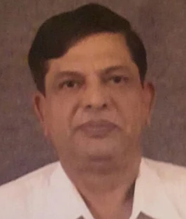 | KARNATAKA STATE UNIT  Commander Bhirappa Bhimappa Khilari (retd.), (Bengaluru), President  Commander BB Khilari was commissioned in the Indian Navy in the engineering branch on 1 January 1976. He served the Indian Navy until February 2003 as engineer and quality assurance officer.  After retirement he contested Assembly Elections from Sarvagnya Nagar Constituency, Bengaluru in May 2008 from Lok Paritran Party. He also undertook social service, educating farmers and employment generation projects in Jath Taluka of Sangli District and Yavatmal District, Vidharbha, Maharashtra. He contested the Assembly elections as an independent candidate from Indi Constituency in 2013. He is native of Kuruba community in Indi Taluka of Bijapur District, Karnataka.
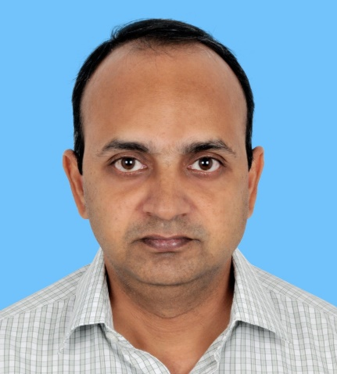 | TELANGANA STATE UNIT  Madhusudhan Kolachina, (Hyderabad), President  Madhusudhan K. has worked in the financial sector for over 15 years. Presently he is an independent consultant to the SME sector and founder of few startups in health and technology. He has been keen over the past few years to work on building a liberal party in India.
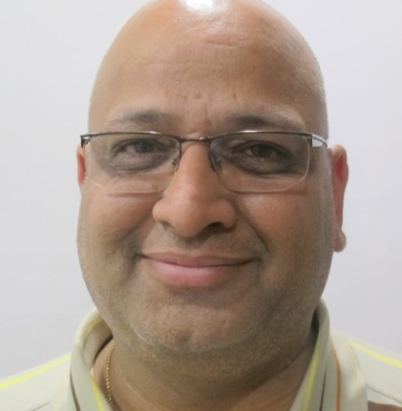 | JHARKHAND STATE UNIT  Atul Agarwal, (Ranchi), President,  Atul Agarwal holds a B.Tech in Construction and a M. Tech in Urban and regional planning. He has extensive experience in the building industry.
The party is in the process of establishing State units in West Bengal and Delhi.
The party invites liberal leaders to join the party and start State Units across the length and breadth of India.

OPEN LETTER TO PRIME MINISTER MODI RE: MAXIMUM GOVERNANCE
The full contents of the open letter (including attachments) are available at: http://swarnabharat.in/openletter-26August2016. The contents of the main letter are provided below:
OPEN LETTER
TO MR. NARENDRA MODI, PRIME MINISTER OF INDIA
Friday 26 August 2016
Dear Prime Minister
Subject: MINIMUM GOVERNMENT MAXIMUM GOVERNANCE
Swarna Bharat Party, the only liberal party of India seeks the liberty and prosperity of all Indians. We believe that a government must focus on security, law and order and justice. It is not the job of a government to run hotels and public enterprises.
Our ancestors firmly believed in this basic rule: जहाँ का राजा हो व्यापारी वहां की प्रजा हो भिखारी.
You have often used the words “Minimum Government, Maximum Governance”, which presumably mean the same thing, but the country has not seen any evidence of implementation.
The country is crying out for basic services like security and justice – which the people cannot provide for themselves; but your government is busy running hotels and airlines – which the people can manage themselves. Does running businesses constitute “Minimum Government”. Does making the Chief Justice of India cry and beg for recruiting more judges form part of “Maximum Governance”?
Please see the data attached, which clearly reveal that a vast amount of public resources are being squandered on running government businesses. At the same time, the government refuses to fund police and justice. It is not an acceptable excuse to suggest that some of these issues are State subjects. Central government resources must be provided to the States for basic governance.
I appeal to you to implement four simple things:
- Your government must immediately get out of running businesses. This will save the country well over Rs. 40,000 crore in losses from loss-making PSEs and banks. Even profitable PSEs should be divested since it is not the job of government to do what the people can do for themselves. All nationalised banks should be immediately divested. Present jobs should not be lost in this process, and the government should continue to regulate all businesses, as appropriate.
- Your government should deploy the funds so saved/raised to immediately increase the funding for core government functions, as specified below:
- Increase nation-wide police funding by at least two times from Rs.74,258 crore to Rs.1,50,000 crore per year, i.e. from around 0.6 per cent of GDP presently to around 1.2 per cent of GDP. Increase the number of policemen from 147 per lakh persons to 222 per lakh persons.
- Increase funding for the judiciary by at least ten times from around 0.02 per cent of GDP presently to around 0.2 per cent of GDP. Increase the number of judges from 1.3 per lakh persons to at least 5 per lakh persons.
- As a condition for increased funding, you must make State governments divest their businesses. In funding any branch of government, you must ensure accountability measures (including for all municipalities). The people of India want results. They want to pay policemen, judges, bureaucrats, teachers, only for results.
- Your government must immediately start implementing all reforms listed in our party’s manifesto (http://swarnabharat.in/manifesto), including critically needed reforms of the electoral system and significant strengthening of the defence forces. It should be clear to anyone who reads our manifesto: that only these reforms can take India from its miserable Third World performance to the top of the world.
In a country where rule of law is supreme, the numerous communal riots and state-supported pogroms would never have happened. In a country where the police and judiciary are functional, people would never be targeted and killed for belonging to a particular religion, neither would caste massacres occur. Even the sensitive areas of the country, the Northeast, Jammu & Kashmir, and the Red Corridor would never be ravaged by insurgencies, as people would be free and secure, and would have no reason to revolt and pick up arms.
I therefore request you to agree to all our demands by Monday 26 September 2016. If you do so, my party commits to working with you to make India a Sone ki Chidiya – which is the logo of our party.
Should you choose not to implement these demands, we will infer that you have no intention to implement governance reforms and that you do not care about India’s development.
This open letter is also available in HTML, PDF and Word document format at: http://swarnabharat.in/openletter-26August2016.
Yours sincerely
(Sanjay Sonawani)
President, Swarna Bharat Party
info@swarnabharat.in

Copy to: Ministers, Chief Ministers, media and many others.

Key activities in 2015-16 and up to END-August 2016
This section of the annual report provides an update on all key party activities during 2015-16 and up to the end of August 2016. Future annual reports will report from September 2016 onwards.
SBP's manifesto launched on 5 December 2015
In December 2015, Swarna Bharat Party adopted the total reform agenda prepared by the Sone Ki Chidiya Federation (http://sonekichidiya.in). The manifesto contains detailed positions on various topics, all based on the foundation of liberty. These positions are published here: http://swarnabharat.in/sbp-ideology, http://swarnabharat.in/role-of-government. The manifesto is published here http://swarnabharat.in/sbp-manifesto.
The party is committed to further improving and customising the manifesto, in consultation with the people of India.
Inaugural meeting of the Maharashtra chapter of SBP at Pune on 27 December 2015
On Sunday, 27 Dec 2015, the inaugural meeting of SBP (Maharashtra Chapter) was held at Pune. The meeting was presided by Mr. Loknath Rao. Main attendees were Sanjay Sonawani, Mrunal Dholepatil, Prakash Khade, Dhananjay Zurange and others. This meet discussed the party’s policies and created a local action plan to take SBP to the people.
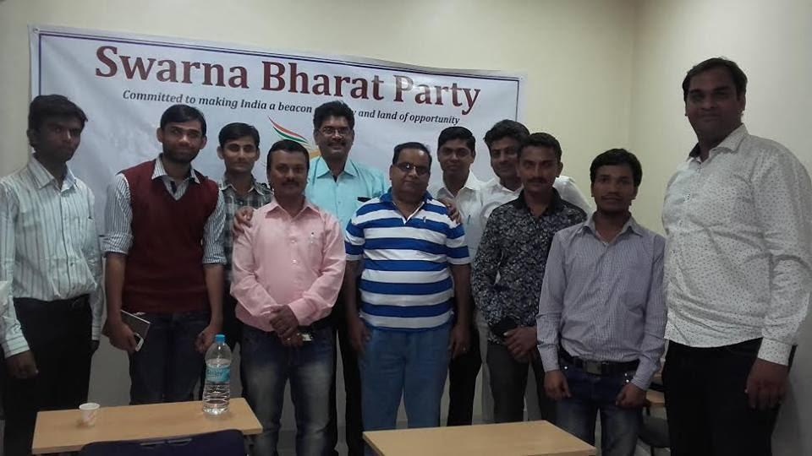
SBP's new website was launched on Republic Day, 26th January 2016
SBP was registered by the Election Commission as a political party in mid-2014. We launched our new website on the occasion of the Republic Day 2016. You can find the website here: http://www.swarnabharat.in

SBP started accepting funds from 26 January 2016
SBP opened its bank account in early 2015 but decided that unless its internal systems were up to scratch, it would not accept any funds. After establishing strong systems at every level, SBP announced on 26 January 2016 that it is ready to receive funds.
Donations to SBP are eligible for tax deduction. For contributions of Rs.20,000 or more in a given financial year, PAN number of donor is essential. SBP is committed to publishing all donations received. These are available on its website (http://swarnabharat.in/sbp-donor-list).
SBP’s Bhadohi unit meeting on 16 March 2016
SBP set up a district unit in Bhadohi in March 2016, its first in the state of Uttar Pradesh.
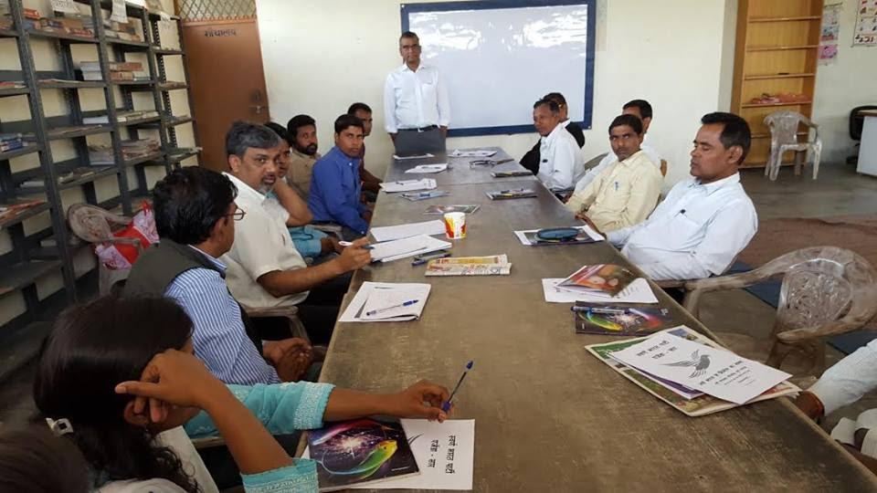
At the inaugural meeting, Vishal Singh reiterated the need to take the message of liberty to the people of India, who have been fed the ‘mai-baap’ culture since independence.

SBP’s press conference in Pune on 12 April 2016
Swarna Bharat Party held a press conference in Pune on 12 April 2016, its first press conference in the state of Maharashtra.
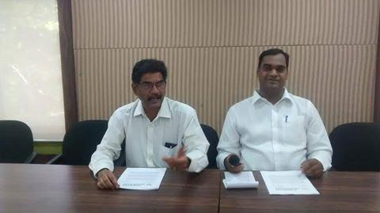
SBP State President Mr. Mrunal Dhole-Patil and the (then) Party Spokesperson Sanjay Sonawani addressing the press in Pune.

SBP’s payment gateway operational from 14 April 2016
A portal for payments through credit card and internet banking was operationalised on SBP’s website from 14 April 2016. With this, SBP has finished creating a comprehensive platform to bring liberty to India.
SBP’s second press conference in Pune on 25 June 2016 in a build up to the local municipal elections
SBP’s second press conference was focused on preparing for the forthcoming Pune municipal elections. The conference was attended by about 13 journalists and an electronic media person. Major local and state level social organizations, such as the Samta Parishad, Vasundhara Mitra Parivar, OBC Sangharsh Samiti and OBC Mahasanghatana also supported this effort.
SBP was represented by the State President Mrunal Dholepatil and the Party’s spokesperson, Sanjay Sonawani.
Many parties are contesting reserved seats on the basis of fraudulently obtained false certificates. It is understood that false OBC caste certificates can be obtained by paying a sum of 20 lakh rupees to corrupt officials. In particular, SBP noted that in the Pune and Pimpri- Chinchwad areas, around half the seats meant for the reserved OBC class are being held by people who belong to the Maratha caste but have obtained false Kunbi caste certificates. Similar malpractices are occurring in elections to Gram Panchayats, Zilla Parishads and municipal corporations all over Maharashtra.
Legal recourse is not an option due to the time consumed by courts. By the time a court verdict is issued against such persons, their term may well be over, hence this route becomes pointless.
Data gathered under RTI shows that this is happening not only in elections, but is observed in education and employment reservations.
SBP stands for liberty and the rule of law. While we are committed to policies of equal opportunity which will make the need for reservations redundant, the immediate need is to ensure that the law of the land is followed.
SBP called upon all political parties to thoroughly scrutinize caste certificates before issuing tickets to contest elections. SBP also believes that the Election Commission should ban political parties that have issued tickets to candidates with false certificates. Also, officials who take bribes to issue false certificates should be prosecuted, to avoid making a mockery of the law.
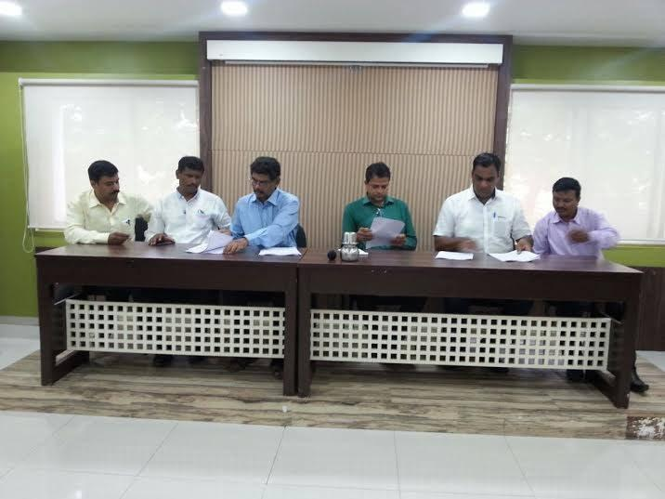
Coverage on TV: https://www.youtube.com/watch?v=E-Y9Oglgqu8
Swarna Bharat Party’s Youtube channel activated on 21 July 2016
The party uploaded two video posts by Sanjay Sonawani on 21 July 2016 on its new youtube video channel https://www.youtube.com/c/SwarnabharatIn

Coverage of the party by Liberty Viral in July 2016
Liberty Viral, an organisation dedicated to liberty identified SBP as a top 10 liberal party of the world.
http://libertyviral.com/the-top-10-international-freedom-fighters-you-didnt-know-about/
“Vishal Singh is the president of the ONLY classically liberal party inside of India. Singh talks about how even though the country was liberated in 1947, it never came to adopt freedom. He rails against the socialist goals of the government, and its perpetuation of crony capitalism. Singh says that his party, the Swarna Bharat Party is the only one in India which looks to protect and defend all Indian people’s freedoms. To that point, he is often critical of India’s Prime Minister Modi, saying things like he came to power “with the slogan of limited government, but all his actions are diametrically opposite to what he was saying during elections.” It’s obvious that Singh has a passion for freedom, and that he is determined to change the hearts and minds of those in India.”

Meeting with activists in Jaipur, 28 July 2016
Nearly 25 key activists and media persons from Jaipur attended a discussion with Sanjeev Sabhlok and Sanjay Garg of SBP on 28 July 2016.
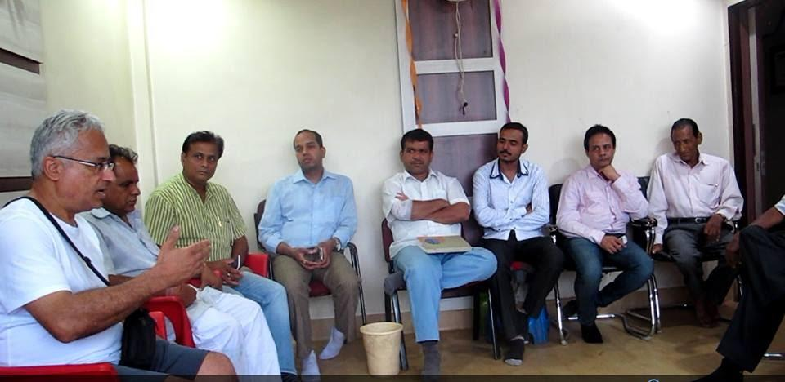
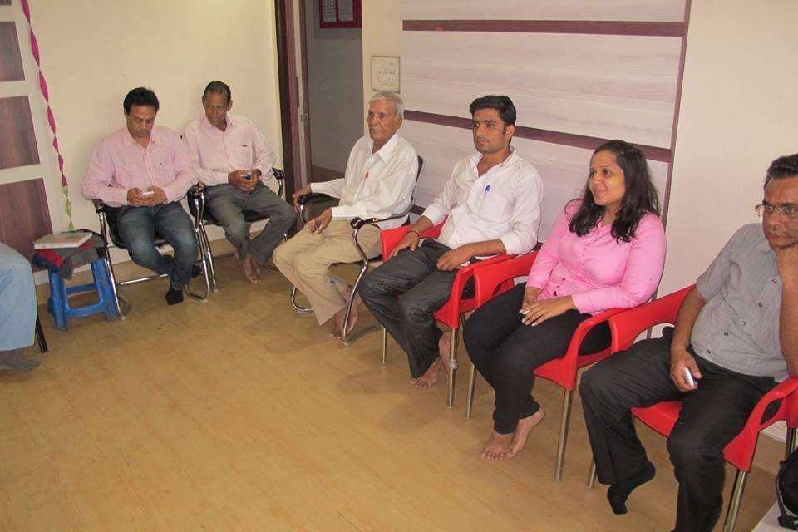 | 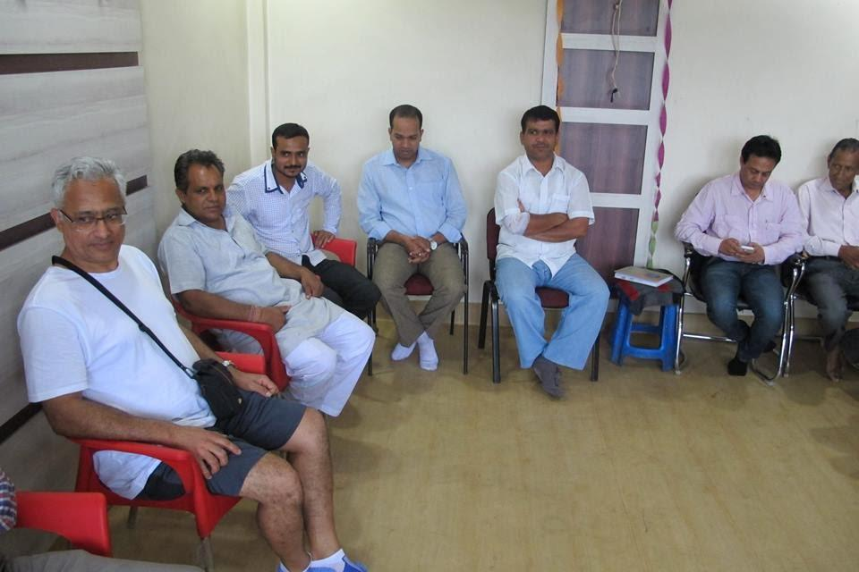
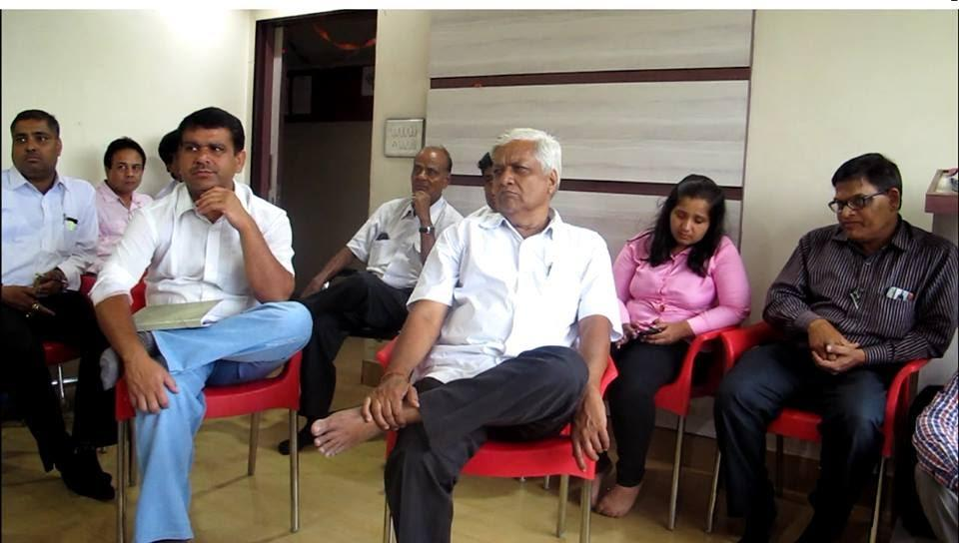
Videos from this meeting are available on SBP’s Youtube channel

National Conference of SBP, 30 and 31 July, and 1 August 2016
The party held its 3-day national conference, with key members of the national executive and a few other participants/ observers. A photo of the participants late in the evening on 30 July 2016 is provided below.
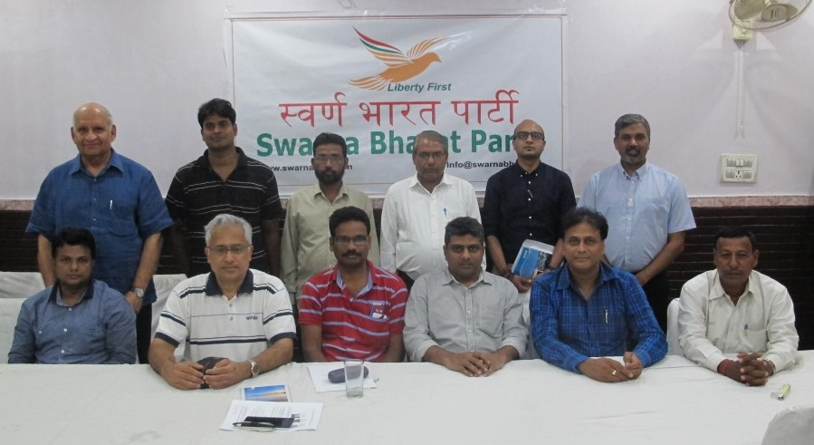
Another photo, below, from earlier on the first day:
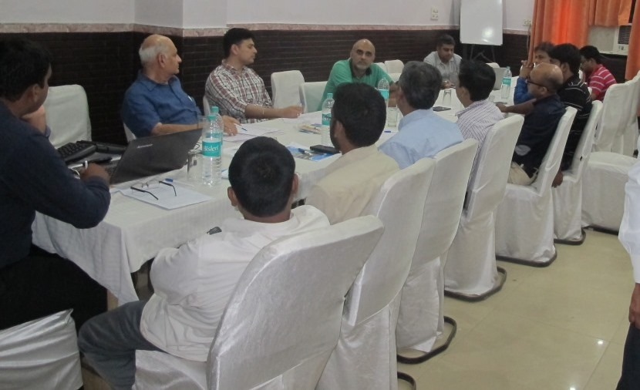

Public meeting at Bhadohi on 2 August 2016
Some photos of the audience at the Bhadohi public meeting organised by the local SBP unit on 2 August 2016 are provided below. Videos from the meeting are available on the party’s Youtube channel. Anil Sharma and the local Bhadohi team organised the event. Deepak Rawat of the party ably compered the event.
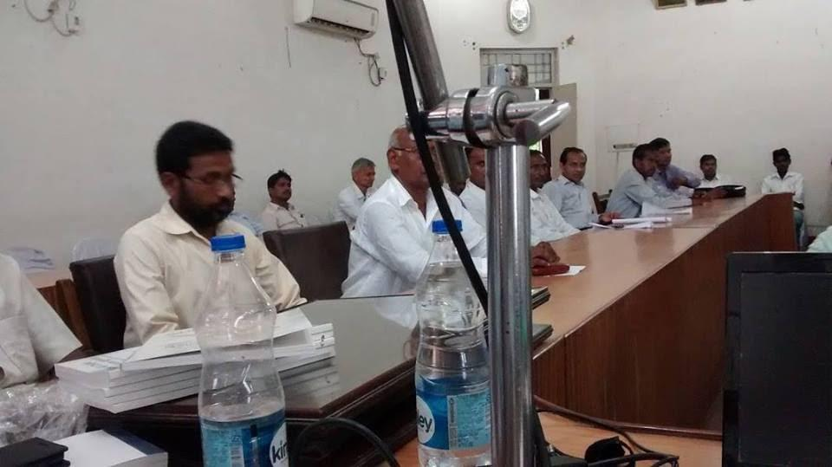
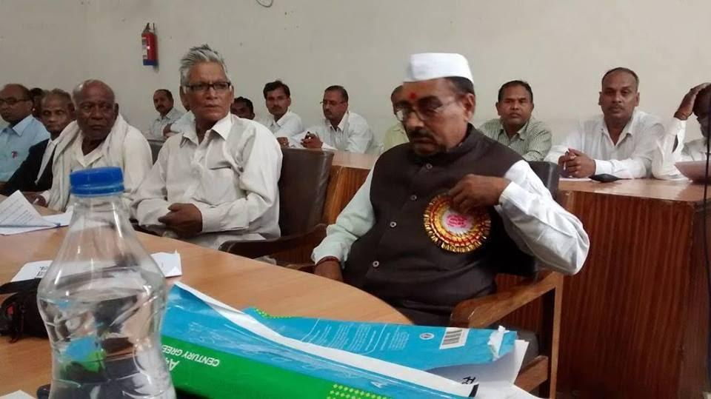
The event received significant press coverage. Some clippings are provided below.
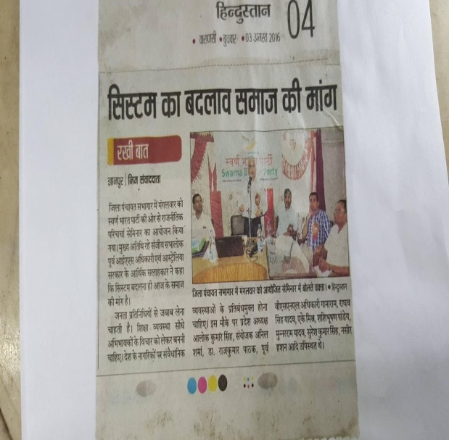 | 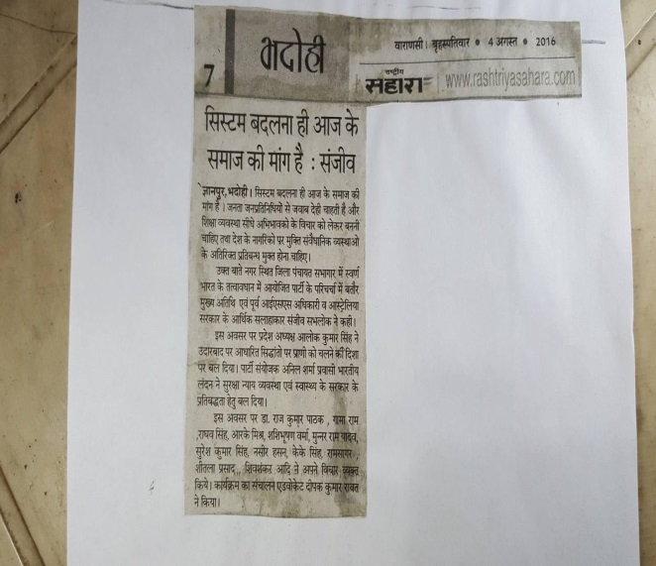
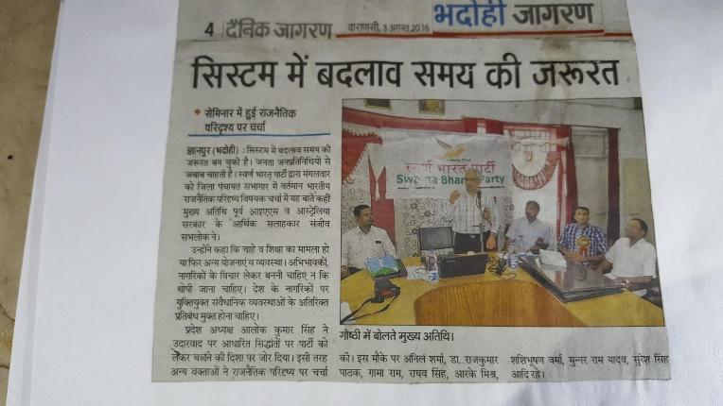

Public meeting at Mirzapur on 3 August 2016
Some photos of the audience at the Mirzapur public meeting organised by the local SBP unit on 3 August 2016 are provided below. Videos from the meeting are available on the party’s Youtube channel.
Mr Anil Sharma and Mr Ghanshyam Sharma organised the event. Mr Ghanshyam Sharma ably compered the event.
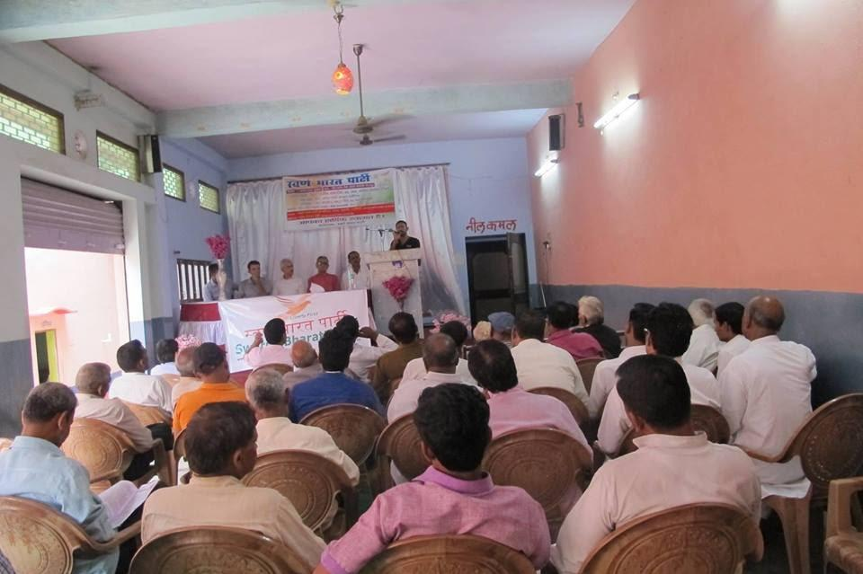
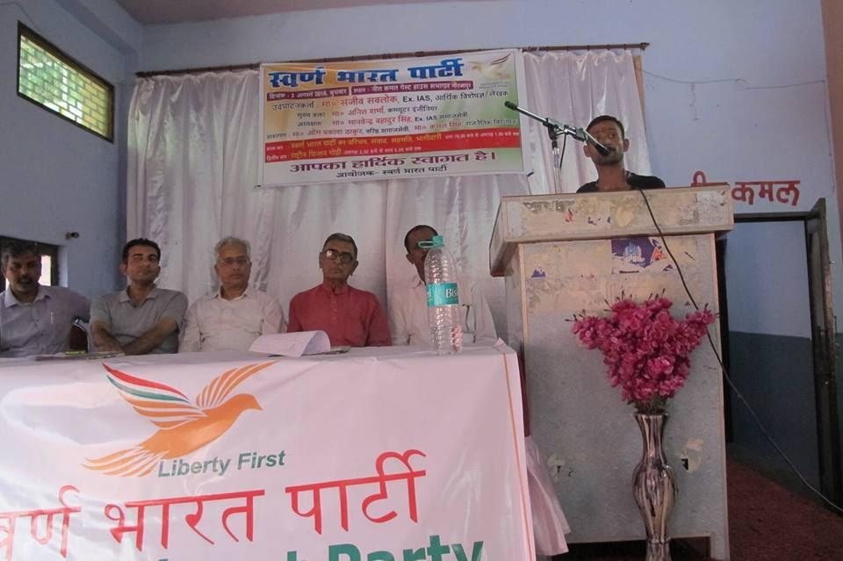 | 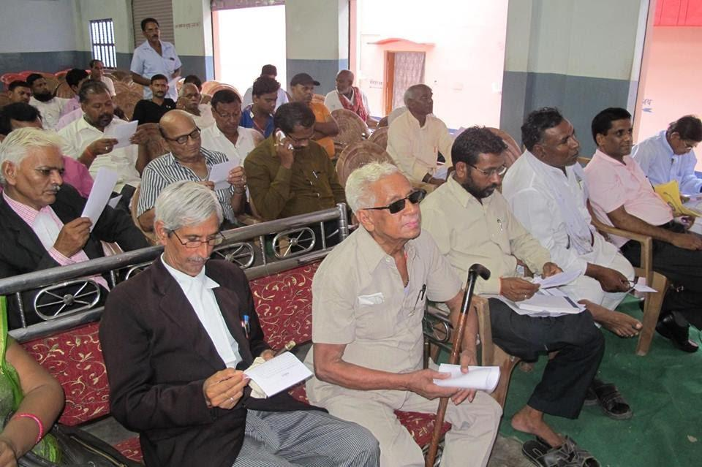
Press coverage of the event in Mirzapur:
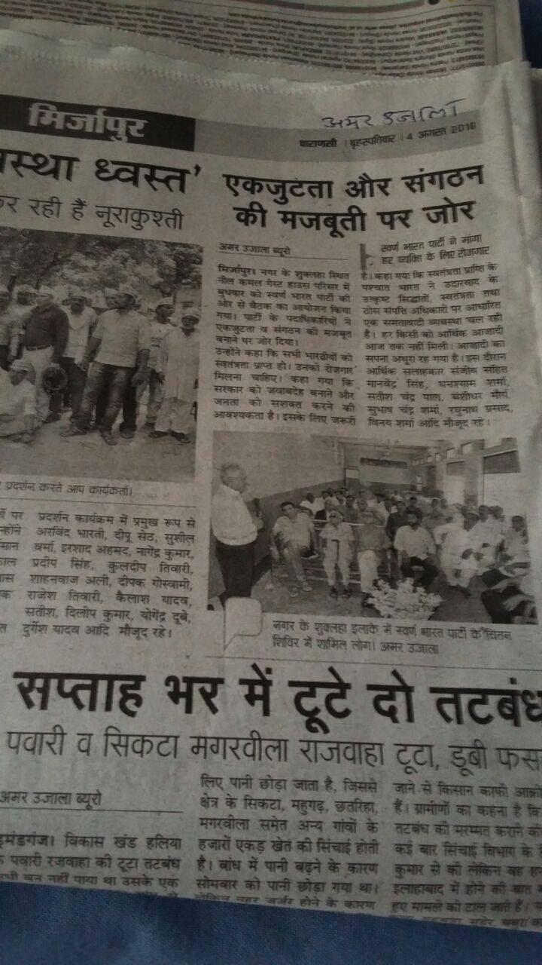

Public meeting at Pune on 6 August 2016
Some photos from the Pune public meeting of 6 August 2016 are provided below. Around 35 people attended. Sanjeev Sabhlok was keynote speaker. The question and answer session showed the high level of interest and understanding from the audience. Sanjay Sonawani, Mrunal DholePatil and Loknath Rao should be commended for their efforts. Videos from the meeting are available on the party’s Youtube channel.
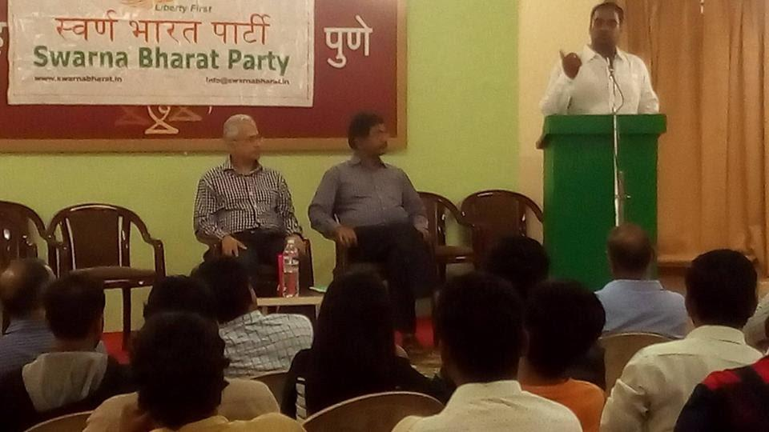
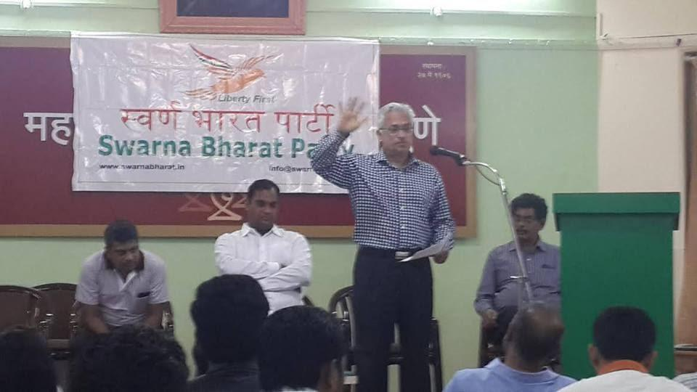

Press Conference in Bengaluru on 8 August 2016
A successful press conference was held in Bangalore on 8 August 2016, coordinated by the local team including Vishal Kumar Singh, Cdr. Bhirappa Khilari (retd.), and Anubhava Srivastava. Videos from the meeting are available on the party’s Youtube channel.
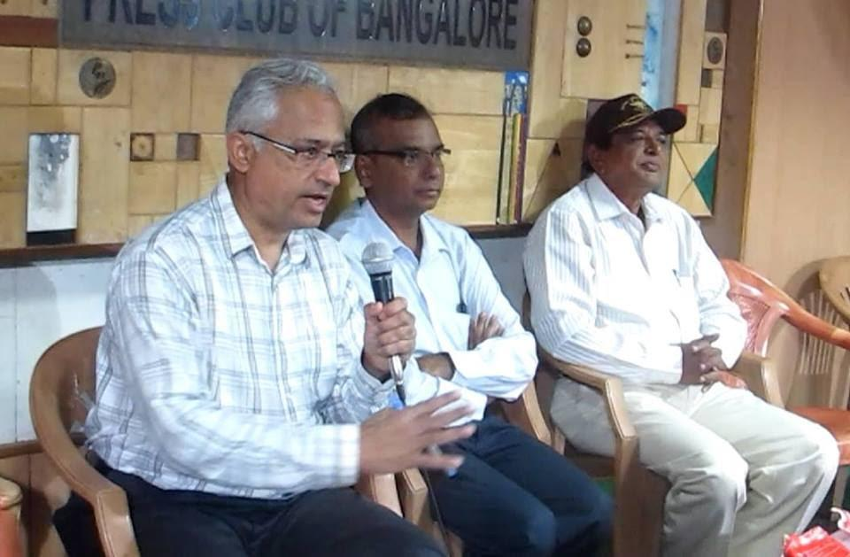
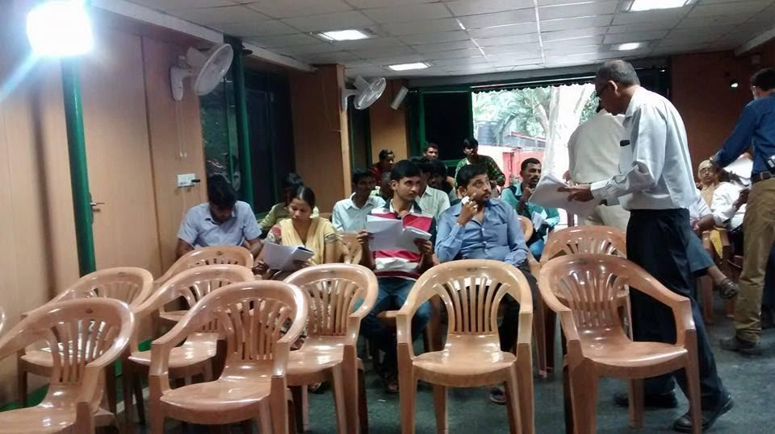
Coverage of our Bangalore press conference, below:
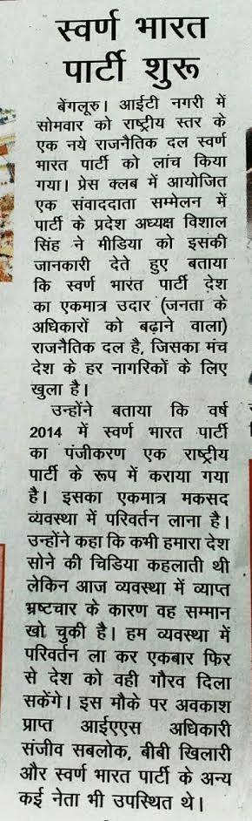

Meeting in Jaipur on 8 August 2016
A Swarna Bharat Party meeting was held on 8 August 2016 at the residence of Mr. Sanjay Garg, State President, Rajasthan State Unit, SBP. The values, policies, manifesto and ideology of the party were discussed in detail.
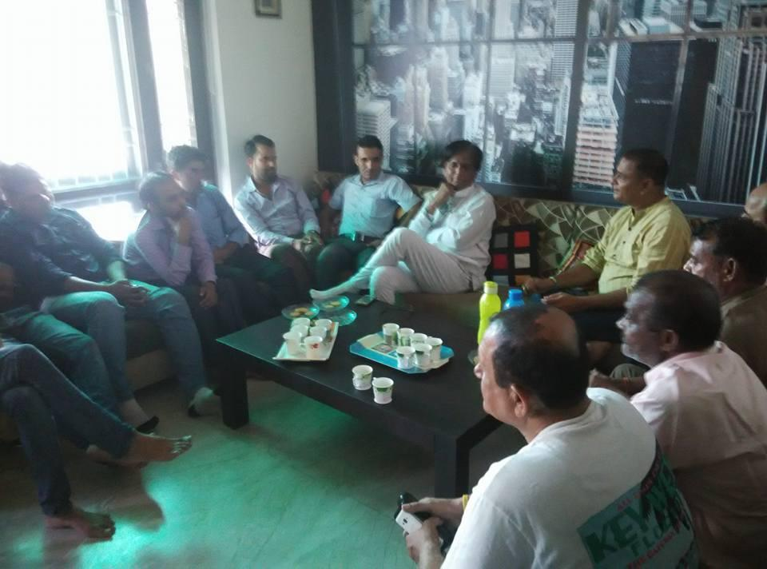 | 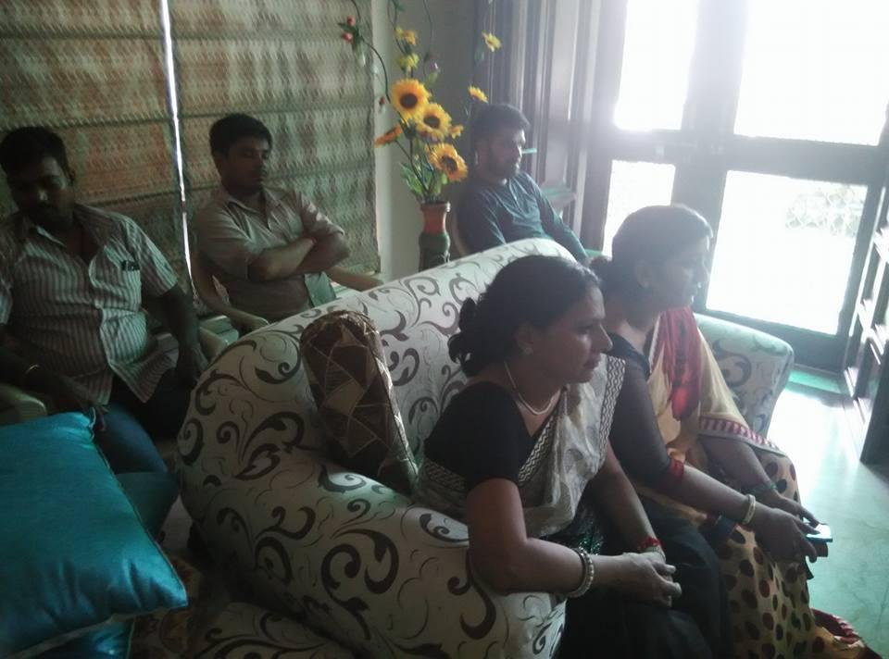
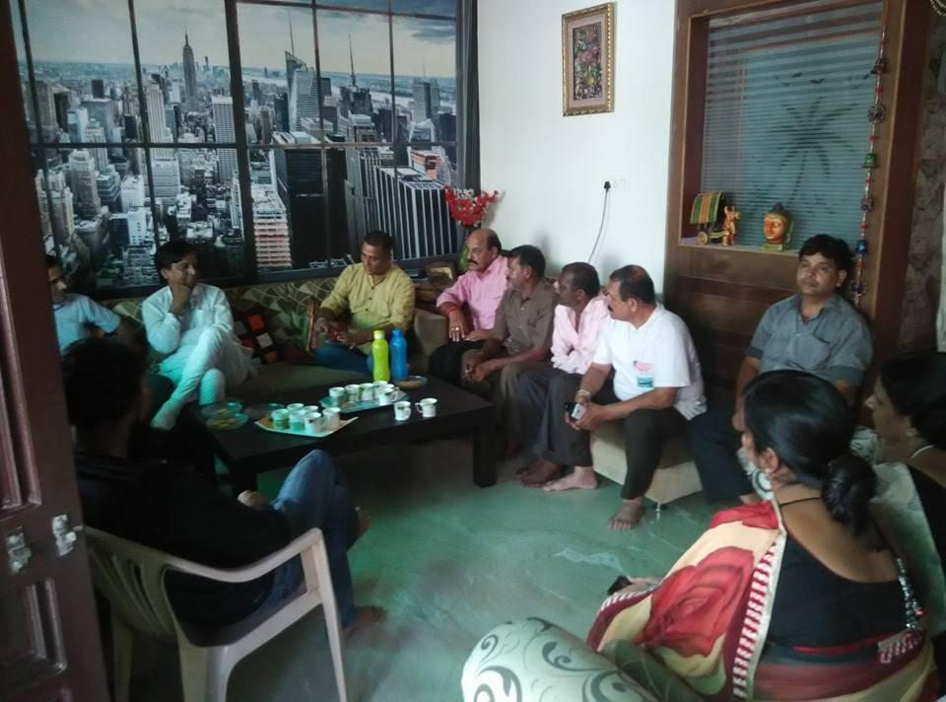 | 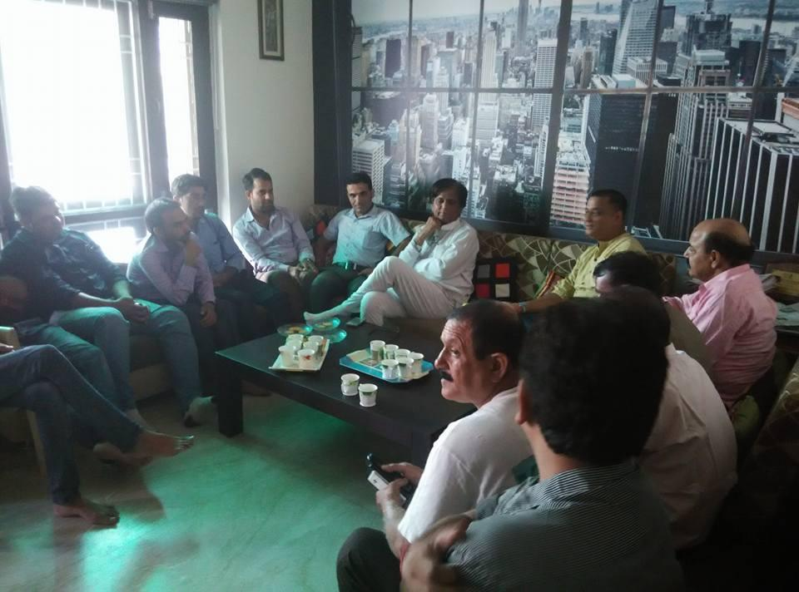

Swarna Bharat Kisaan app launched by party members on 8 August 2016
Mr Loknath Rao of the party released Swarna Bharat Kisaan app on Google Play Store on 8 August 2016. The app was co-developed with Sanjay Sonawani. The app is intended to enable farmers to sell their produce directly to retailers and receive a higher price. The party has no direct affiliation with the app, but notes that the Freedom Team of India has lent its bird logo (which is also the logo of SBP) to the app, to help familiarise the farmers with the concept of sone ki chidiya.
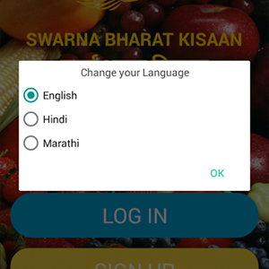

Party workers meeting at Hyderabad on 9 August 2016
A number of people came to Rahul Pandit’s house in Hyderabad on 9 August 2016 to discuss the need for SBP and its unique reform agenda.
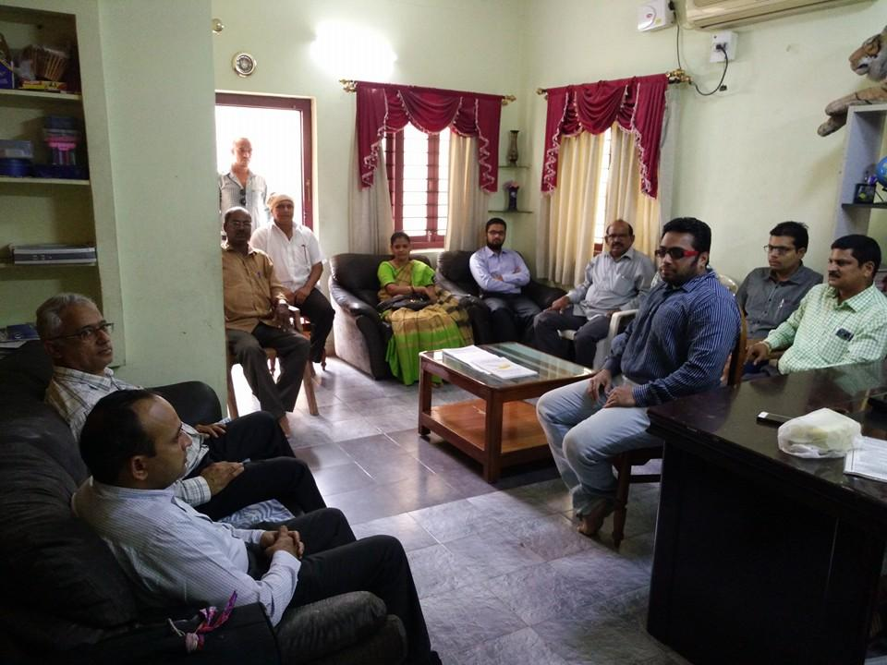

Press Conference in Hyderabad on 9 August 2016
A successful press conference was held in Hyderabad on 9 August 2016, coordinated by the local team including Madhusudhan K and Rahul Pandit. Videos of the meeting are posted on the party’s Youtube channel.
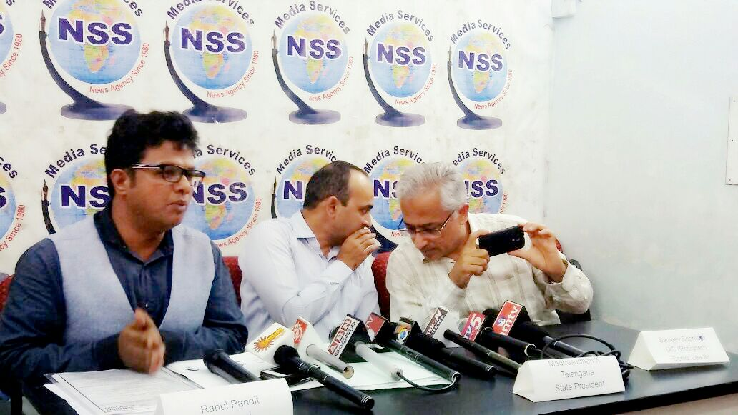
Press coverage in local papers on 10 August 2016, below.
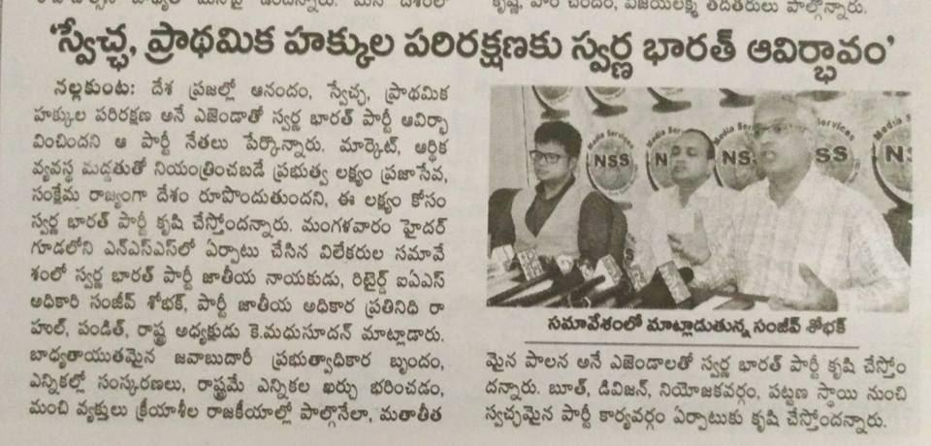  Andhra Jyoti | 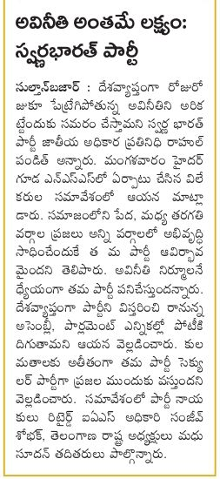  Sakshi
After the press conference, around 15 people went to a nearby restaurant to discuss SBP in greater detail.
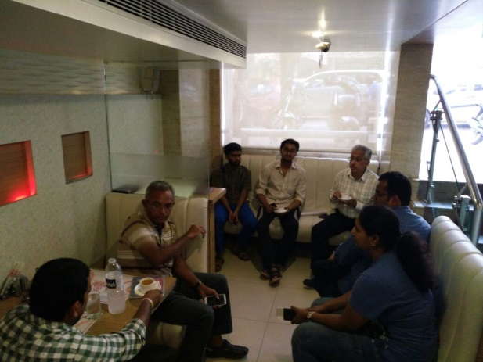

Press Conference in Mumbai on 26 August 2016
The Party President Mr Sonawani held a press conference in Mumbai on 26 August 2016 in which he released the open letter to PM Modi regarding Minimum Government, Maximum Governance. The open letter is available on the party’s website at: http://swarnabharat.in/openletter-26August2016
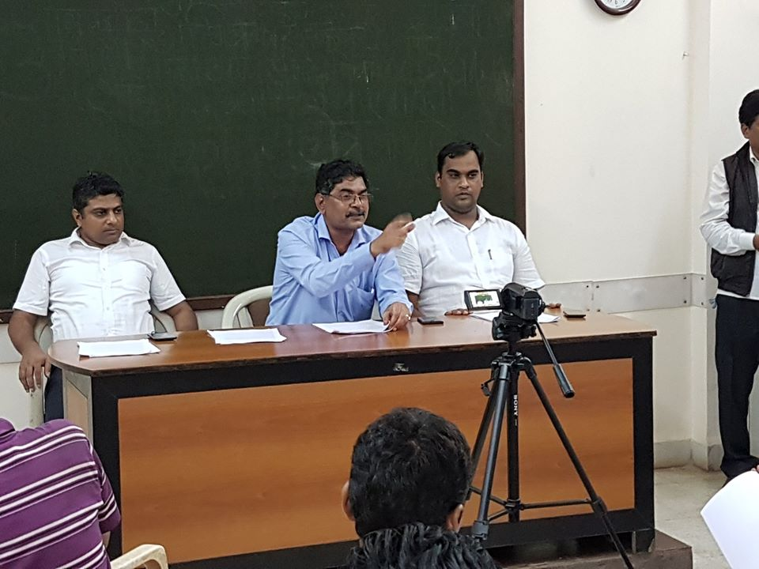
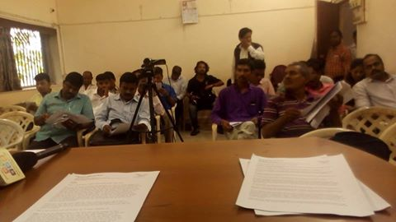
Press coverage of the 26 August 2016 press conference:
President of SBP Sanjay Sonawani, asks PM Modi to substantially increase funding for the police and judiciary, Merinews, 26 August 2016
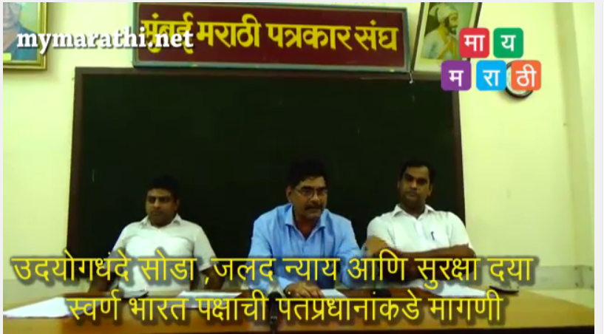
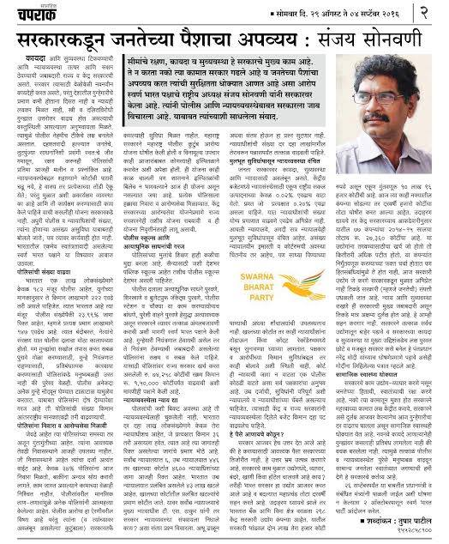

Further, a news report, in Daily Samrat:
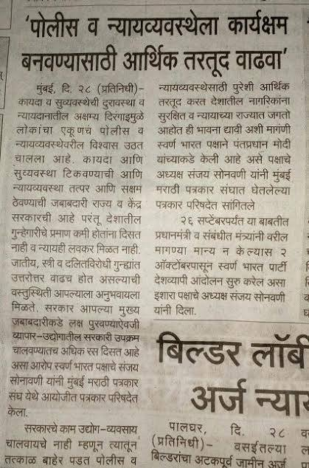
Video of the conference at: https://www.youtube.com/watch?v=bbCP2Cwnv3w

Press Conference in Pune on 30 August 2016
The Party President Mr Sonawani held a press conference in Pune on 30 August 2016 to re-iterate the message which had been released on in the open letter to PM Modi on 26 August 2016.
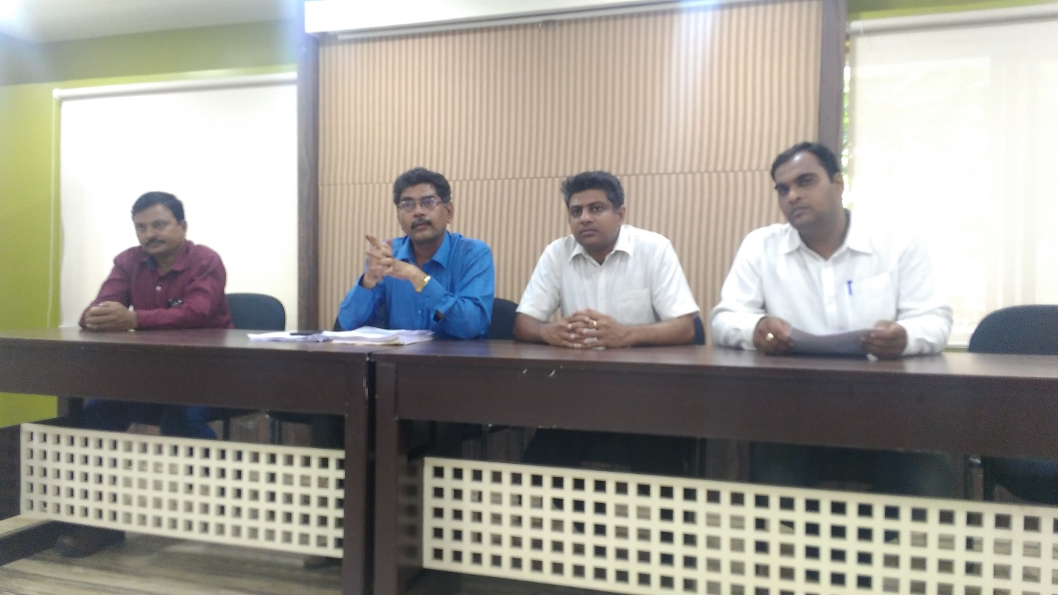
Picture from the party’s press conference on 30 August 2016 in Pune.

Press Releases
These are a few of the Press Releases issued by SBP during the past few months.

Press Release - 1 February 2016: Prohibition is no solution to alcohol abuse, says SBP President
Committed to liberty, Swarna Bharat Party (SBP) denounces prohibition or excessive restrictions on the sale of alcohol by some States. Some of these States treat rich Indians or foreigners differently, with alcohol allowed to be served in five star hotels. Such arbitrary policies imply that some Indian citizens are less responsible than others, that such Indians are fit to vote but unfit to make responsible decisions on the question of alcohol. This two-tier approach harks back to India’s colonial era. It also begs the question why alcohol is allowed to be manufactured in India in the first place.
In a press note issued by the SBP President, Mr. Vishal Singh noted that “Prohibition has been a disaster wherever it has been attempted. The evidence is overwhelming - from across India and the world - that prohibition is never realised in practice. Instead, illicit liquor and crime receives a fillip, including smuggling from nearby non-prohibition States. This causes governments to lose essential tax revenues, even as taxpayers pay more to deal with the consequences of increased crime and corruption.”
Moreover, Mr. Singh pointed out that such restrictions are a direct attack on the promise of liberty assured by the Preamble to India’s Constitution. No doubt, the Directive principles enjoin the State to impose prohibition on the ground that “intoxicating drinks … are injurious to health". However, SBP believes that the merits and demerits of alcohol need to be constantly reviewed in the light of new scientific evidence. A Constitution is not the place to make public policy.
Even if alcohol were proven to be injurious to health, a government would not necessarily have a role. A government’s role must be limited to addressing any harm that people cause others, for example, driving when intoxicated or domestic violence, not harm they may choose to cause themselves.
Chanakya’s Arthashastra details how alcohol can be regulated. But India’s own history and that of other free countries can also provide useful insights. One way is to tax liquor, keeping in mind that if desi liquor is taxed heavily, the poor may switch to illicit, often toxic, liquor. Breath tests of drivers should be regularly undertaken, with revenues generated from fines defraying the cost of these tests. Those who harm others should be made to pay; not those who use alcohol responsibly.
Mr. Singh noted that excessive consumption of alcohol by someone in the privacy of their home can sometimes become a social issue. Social organizations should provide scientific information to the community on the harms of excessive drinking. SBP will also disseminate such information through its social outreach efforts.
Mr. Singh re-iterated that “A government’s job is to defend the liberty of every citizen, while addressing the harm caused by any irresponsible exercise of liberty. SBP’s manifesto outlines mature and well thought-out regulatory approaches on all aspects of public policy. The recent alcohol ban in Kerala, the proposed ban in Bihar, and existing bans or significant restrictions in Gujarat, Maharashtra and other parts of India should be immediately reviewed.”

Press Release - 4 February 2016: SBP commends Supreme Court’s initiative to re-examine same-sex relationship
Swarna Bharat Party, India’s only liberal party, commends the Supreme Court’s decision to re-examine the question of same-sex relationship and hopes the Constitutional Bench will quash Section 377 of the IPC which criminalises homosexuality.
SBP president Vishal Singh said in a press note that this provision violates the principle of equality and liberty guaranteed to every citizen by India’s constitution.
From the scientific perspective, homosexuality has long been proven to have a significant biological (i.e. genetic) component. Criminalising homosexuality is a throwback to the time when ignorant prejudice ruled the world.
In 2013, the Supreme Court upheld this obnoxious section of the IPC. The party believes that was an inappropriate decision. A government can have no role in people’s bedrooms in matters of consensual sex. Section 377 is a direct assault on citizens’ liberty and privacy. Such a perspective on human behaviour is inappropriate in a day and age when India must actively promote the scientific attitude so it can prosper on the foundations of scientific knowledge.
Mr. Singh further said that SBP stands firmly on the side of activists who have fought to decriminalize gay sex. SBP hopes the Supreme Court will soon hear the curative petition and determine to abolish this blight on human dignity and liberty.
Mr. Vishal Singh also outlined the party’s position on an important related issue. Gay couples that wish to live together in a marriage-like relationship, should legally be able to do so. It may be inappropriate, however, to term such a relationship as ‘marriage’, to distinguish it from traditional heterosexual marriage.
Mr. Singh also noted that it may be inappropriate to give such form of cohabitation the right to bring up adopted children. However, the party is committed to an evidence-based approach and believes that a detailed assessment of evidence, with the best interests of children in mind, should inform the country’s final position on this issue.

Press Release - 15 February 2016: India must urgently replace its outdated bureaucracy, says SBP President
Mr Vishal Singh, President of the Swarna Bharat Party, India’s only liberal party, declared that it is of critical importance for India to replace its outdated bureaucracy that was created in colonial times with limited knowledge of governance.
Knowledge over the past fifty years in the field of public choice theory and new public management is available to guide the creation of an entirely new machinery of government. The new bureaucracy would be totally accountable for results, and corruption would be entirely eliminated.
This needs senior officials to be appointed by the relevant next senior person (in the case of a Secretary, the relevant Prime Minister/ Chief Minister would be the appointing authority) on hire-and-fire contracts that ensure total alignment with performance. Such contracts dispense with any unnecessary and dilatory processes that prevent accountability from being ensured under the current system, provided the integrity of the appointing authority is assured.
Such senior officials, to be hired from the open market (mainly amongst the citizens of India), would have to be well paid, comparable to the private sector. This would ensure high quality capability, expertise and demonstrated capability in the bureaucratic system.
Mr Vishal Singh said, “Our party is committed to replacing all tenured civil services such as the IAS, with accountable public servants. This task has been undertaken in many advanced countries without much disruption. All it requires is political will. While we acknowledge that there is considerable talent in the current tenured services, the lack of appropriate incentives has delivered one of the world’s least efficient and accountable bureaucracies.”
The Party’s manifesto has an extensive discussion on this essential governance reform. Mr Vishal Singh pointed out, however, that it will not be sufficient (or even possible) to undertake this reform without associated reforms, particularly state funding of elections and in relation to political incentives and accountability, to allow honest people to enter politics on a regular basis. We need honest and committed political leaders, without which a new machinery of governance will not be practicable.

Press Release - 26 February 2016: SBP President says that to attract honest people into politics, India needs urgent electoral system reforms
Mr Vishal Singh, President of the Swarna Bharat Party, India’s only liberal party, asserted that for India to attract honest and competent people into politics, the electoral system must to be urgently reformed.
The Westminster system, along with a First Past The Post voting methodology that we have adopted, is a proven system that has worked well for many countries. In India, Mr Vishal Singh said, we have distorted the underlying incentives of the electoral process, leading to incentives for corruption among politicians.
No Indian is born corrupt. It is badly designed systems that lead to corruption. In our system, politicians stand to lose a lot of money when they contest elections. Those who get elected therefore seek to recover their costs, with compound interest. On top of this, we pay our politicians relatively poorly. This creates a perfect storm of incentives for corruption.
Simplistic solutions like Jan Lokpal do not address these huge incentive pitfalls. While there must be a system to punish the corrupt, it will not act as preventative with the kinds of incentives we have in India.
The first part of the solution is to reduce opportunities for corruption by focusing on core functions and high quality (but minimal) regulation of the market. The second part of the solution involves minimising politicians’ losses in elections and paying them well.
Mr Vishal Singh said that all candidates should be reimbursed Rs.15 per valid vote cast, up to a maximum of Rs. 70 lakhs. Along with this, the security deposit should be significantly increased to ensure that only serious candidates contest elections. Genuine candidates can, if needed, borrow money for their security deposit, assured of reimbursement for the votes they will receive.
Further, the salaries of elected representatives should be raised significantly, while eliminating all perquisites such as free travel, telephones, furnishings, vehicles or loans.
Mr Vishal Singh assured that such reforms will dramatically enhance the proportion of honest representatives who enter India parliaments. The SBP manifesto details the other essential and associated reforms that the party will implement.

Press Release - 4 March 2016: Liberate India’s mining industry from shackles to create lakhs of jobs, says SBP President Vishal Singh
Swarna Bharat Party’s President, Vishal Singh, said that India’s mining policy needs a total reset. Each mine gives jobs (including unskilled jobs) to hundreds, even thousands of people. Mines boost local service sector jobs, leading to improved nutritional outcomes for the poor within a radius of 50-100 kms from a mine. Exploration and mining on a large scale can also create lakhs of downstream jobs in mineral processing and use.
India’s land mass has much in common with Western Australia, which is rich in a range of minerals. Unfortunately, successive governments have restricted exploration and India’s mineral wealth remains largely unexplored after 65 years of independence. The Modi government also remains oblivious to the vast potential of the mining sector.
India remains close to the bottom of the world on indicators of per capita mineral and energy consumption, key indicators of prosperity. India also has no strategic mineral policy, forcing us to import even basic minerals like coal and iron ore, of which India has some of the largest known reserves.
Mr Vishal Singh said that mineral exploration is an extremely high risk venture and needs incentives, not the kind of disincentives we have imposed on the industry. Royalties should be set at a level that allows profitability and viability. Mineral exploration licences should be given on a first-come-first-served basis, except in the case of mineral deposits which are fully mapped: in such cases auctions can be considered. Of course, all licences should comply with requirements for environmental protection and consultation with the community.
The most urgent policy changes needed are to make exploration and mining licences fully transferable in the open market and to require all mineral exploration companies to be listed on the BSE. The stock market will get rid of any unethical companies. In addition, the government should commission and publish large-scale mapping of mineral resources to reduce uncertainty for potential investors and motivate investment.
Unfortunately, we have such restrictive policies that many Indians and international junior exploration companies are investing in mineral exploration in Africa and South America, and in mining in Australia, but not in India. This is an absurd situation. The government must urgently liberate the industry from government created shackles.
Mr. Singh said that in summary, India needs a modern and investor-friendly Mineral Act, a sensible tax structure for mining and a good regulatory regime that ensures environmental protection even as jobs and growth are given a huge boost. He committed that SBP will liberate the mining sector to enable India to become a Sone Ki Chidiya, once again.

Press Release - 14 March 2016: Replace Censor Board with rating agencies, says Swarna Bharat Party President, Vishal Singh
Swarna Bharat Party (SBP) has called for the abolition of the government owned Central Board of Film Certification (commonly known as the Censor Board).
The party’s President, Mr Vishal Singh, said that a Censor Board undermines freedom of speech. Its existence is an insult to Indians, as implicit in censorship is the idea that ordinary Indians are unfit to think for themselves. Every citizen is an equal of others under our Constitution, and everyone has the right to view any film without an intermediary trimming or otherwise modifying content.
A Censor Board does not prevent depravity or violence. All Indians remain accountable for their actions under the law at all times and cannot attribute any violent or depraved acts of theirs to a movie. The law does not provide for such a defence. A free society functions smoothly because it is in the self-interest of people to be good, not because of a nanny Censor Board. Further, if Censor Board members don’t become depraved or violent by viewing the films they censor, it is preposterous to suggest that Indian voters (who pay their salaries) will. Censor Board members are not a different biological species.
That we have a Censor Board partly explains the lacklustre record Indian films have in winning accolades at global film events, despite our film industry being the largest in the world. We have infantalised the industry and the nation, and curtailed critically needed debate and education. Our film artists have been forced into puerility.
Abolishing the Censor Board will unleash the film industry’s creative force and allow our films to stand on the same pedestal as international films, enhancing India’s global soft power and boosting the economy.
Of course, we must have a classification system for films that provides information to parents to guide their children’s viewing. Light touch co-regulation can ensure the supply of such a system. The film industry will be able to supply internationally compatible rating standards and agencies.
Mr Singh said that in addition to replacing the Censor Board with rating agencies, SBP will abolish prohibitions on other forms of human expression, such as books. The party will also repeal all laws that limit free speech.
The right to speak and express ourselves is an innate, basic human need. Except where such expression involves incitement to immediate violence or constitutes libel that affects someone’s commercial interests and reputation, it should not be restricted.
SBP is committed to taking India to the Heaven of Freedom that Tagore wrote about a hundred years ago.
Let us be free, not just independent.

Press Release - 21 March 2016: Mr Modi should first make India makeable, says SBP President, Vishal Singh
To “Make in India”, India must first be made makeable.
Mr Vishal Singh, President of Swarna Bharat Party, said that India continues to underperform (relative to its GDP) in attracting foreign investment. While investment levels are improving, the inflow is constrained by India being one of the world’s worst governed countries, with chronic inefficiency and corruption (including in the judiciary), unjustified regulatory barriers, delays in land purchase, and substandard infrastructure.
Sixty years of socialism has left India with grinding poverty: Mumbai awash in slums, trains crammed to capacity with hundreds travelling on roofs. Investors see a country trapped in a medieval mind-set, with its khap panchayats that forbid girls under 18 from using cell phones, and people who agitate to be ‘backward’. Investors see turmoil, whether it is people killed for eating beef (or for merely transporting cattle) or jailed for speaking out, or for making caricatures of public figures.
Investing in India comes with very high risks. Leave alone foreign investors, Indians have been putting their money abroad, instead of in India, such as in the mining industry which remains closed to business.
Mr Singh said that “Make in India” cannot succeed till India’s governance is modernised and India’s leadership has the capacity to take the people out of their medieval mindset.
The issue is not just about manufacturing. We need to open up the economy to all forms of trade and investment. Chanakya was the first economist to emphasise the importance of imports. Imports and foreign investment make goods and services cheaper (and better) for consumers and offer competition to businesses, thus forcing them to innovate and become more productive.
For instance, we need far greater foreign investment in retail, infrastructure and service industries. There is no reason for any aspect of Indian markets (including the defence industry) to be sheltered from global competition. Never has any closed country prospered.
But for this to happen, we need reforms of the bureaucracy, electoral system, police and judiciary. And we need policies that make it easy to do business in India. Without these immediate actions, even those who have bravely risked their money in India will leave after their hands are burnt and capital destroyed.
Mr Singh asked the Modi government to implement SBP’s manifesto, which contains world-best policies in all fields of governance. If the Modi government won’t do it, SBP will, said Mr Singh. India can wait no more. SBP is committed to making India a Sone Ki Chidiya, once again.

Press Release - 28 March 2016: Agriculture must be liberated so our farmers can flourish, says SBP President, Vishal Singh
Swarna Bharat Party President, Mr Vishal Singh, said that Indian farmers live in a Kafkaesque world of self-defeating government interventions that are divorced from the imperatives of technology and economics.
Farmers are held back by restrictions on access to technology and on trade, including on the movement, storage and processing of agricultural commodities, and through bans on exports. They are sheltered from global competition, such as through restrictions on imports on grounds of ‘dumping’. And the government sets low and volatile agricultural prices for key commodities, making farm returns even more unpredictable.
Into this obstacle race the government has thrown in the “sweetener” of farm subsidies, but these go largely to fertiliser manufacturers, to corrupt government functionaries and to rich farmers. Subsidised Indian fertiliser is smuggled to neighbouring countries, transferring Indian wealth abroad. Subsidised power has helped deplete groundwater by promoting water-hungry crops, putting India’s future food security at risk. Subsidies also harm poor farmers in another way: through budgetary deficits and inflation.
Mr Singh said that this perfect storm of bad policies has led to an inefficient farm sector stricken with poverty, indebtedness and unemployment. Agriculture has become a losing vocation. Farmers are prematurely abandoning the farm. Most deplorable of all: these policies are part of the reason for India’s high levels of farmer suicide.
But objectively, India has everything going for it on the agricultural front. India has some of the world’s most fertile land and more irrigated land than any other country. By unshackling agriculture, we should be able to supply not only our domestic needs but also meet demand in China and rapidly growing African countries.
Mr Singh said that the solution is two-fold: (a) broad-based governance reforms, and (b) radical liberalisation of agriculture policy. The government should get out of agriculture almost entirely and create markets, instead. All restrictions on the production, movement and pricing of agricultural inputs, as well as restrictions on post-harvest treatment, including on marketing and exports, must go.
In addition, we must streamline environmental regulation (e.g. water table, biodiversity, biosecurity) and the regulation of logistics and crop insurance to create deeper markets in agriculture support services. Market-based reforms will allow vast amount of new investment to flow into the agriculture sector, such as large-scale investments in logistics chains and crop insurance. Businesses (such as mining) should be allowed to operate agricultural subsidiaries. This will give hundreds of millions of farmers a new lease of life.
Mr Singh said that SBP’s manifesto provides details of all policies India needs. He asked the Modi Government to implement these policies. Farmers can wait no longer, said Mr Singh. If the Modi government won’t do it, SBP will. SBP is committed to making India a Sone Ki Chidiya, once again.

Press Release - 4 April 2016: We must support Constitutional, not sectarian nationalism, says SBP President, Vishal Singh
Mr Vishal Singh, President of the Swarna Bharat Party, said that India needs Constitutional nationalism, not sectarian nationalism of the kind that some saffron groups, supported by India’s ruling party, are attempting to forcefully impose on the country.
While a nation needs a narrative, a sense of history, India is perhaps the world’s oldest melting pot and has a multiplicity of such narratives. Expecting everyone to adopt a common shared history is an illusion. “Unity in diversity” is the correct language for a multitudinous nation like India.
Further, India is a constitutional republic, not a theocratic state. Our Constitution does not ask us to imagine the nation in the form of a human being, god or goddess. People are free to chant Vande Mataram or Bharat Mata ki jai if they wish, but no one has the right to mandate such slogans. Mr Singh noted that many SBP members are happy to chant such slogans, but this is a matter of their personal choice.
There is a vast difference between well-considered patriotism and rabid, divisive nationalism. SBP condemns the atmosphere of euphoric sectarian nationalism created by saffron groups in which rowdies are starting to beat up people for not chanting slogans.
In our Constitution, the individual is sovereign. SBP opposes fascist approaches that restrict individual liberty. Compulsion attacks the very basis of nationhood. Attempting to force a particular worldview upon the vast nation of India has already backfired once, leading to India’s partition. Aggressive saffron nationalism is causing new and dangerous fissures.
Mr Singh said that BJP, like all other Indian political parties, has sworn to bear true faith and allegiance to the Constitution of India. How can it justify its support for divisive saffron groups? He also wondered whether the BJP is raising the bogey of sectarian nationalism to draw attention away from its poor performance.
Mr Singh expressed regret that the liberal values underpinning our Constitution are being eroded at a time when India needs them most in order to develop into a modern nation. He noted, for example, how the Delhi High Court made unwarranted comments on nationalism recently in a bail case relating to Kanhaiya Kumar, thus losing sight of its Constitutional obligations.
SBP supports Constitutional nationalism in which patriotism is a well-considered rational response to the nation’s unrelenting commitment to reason and liberty. The intrusion of compulsion into such matters can only take weaken India. Let all flowers bloom in the great garden of India.

Press Release - 3 June 2016: Modi government has failed to create the conditions for new jobs, says SBP President, Vishal Singh
Swarna Bharat Party President, Mr Vishal Singh said that by continuing the failed policies of the past 65 years, the Modi government has prevented the rapid creation of urgently needed new jobs.
Every month, nearly 10 lakh children turn 18 in India, so at least 10 lakh new jobs are needed each month. But only a small fraction of this are being created. Jobs growth in eight labour intensive industry sectors is now the lowest since 2009.
Jobs are not created by governments but by the people. Jobs are created when governments support markets through the rule of law, property rights and essential infrastructure to make it easy to do business. But today, Indians are prevented from working by regulation, corruption and dismal infrastructure. They are forced to spend precious time in navigating a maze of government imposed restrictions.
Jobs also need workers to have the required skills. But the youth are not being imparted the essential skills. According to The Economist, only 60 per cent of ten-year-old students are able to complete work at the level of a five-year-old. More than half cannot subtract. Employers tell us that India graduates millions, but too few are fit to hire.
Unfortunately, the Modi government is neither letting people work, nor giving workers the skills they need.
Mr Singh said that unless India’s anti-business policies are urgently reformed, the youth will increasingly take to the streets. The youth have started agitating for government jobs since the private market is essentially defunct. Worse, many are getting radicalised since they have too much time on their hands.
He said that only Swarna Bharat Party has the policies that can break through this nightmare for the country. Only policies in SBP’s manifesto can fix India’s deep-rooted problems of governance. But the Modi government seems to have no clue about governance, and is continuing the same old failed policies.
India needs leadership with a vision. SBP provides that leadership. Mr Singh asked the youth to read SBP’s manifesto to understand why socialist policies can never work. Mr Singh asked the youth to insist on total reforms. India must reform for their sake.

Press Release - 7 July 2016: The mantra of Swachh Bharat cannot deliver results. Only governance reforms can, says SBP President, Vishal Singh
The President of Swarna Bharat Party, Mr Vishal Singh, said that chanting slogans won’t deliver a Swachh Bharat. A rubbish-free India simply cannot be delivered under the current governance system.
The cause of the vast amounts of filth that litters Indian streets, rivers and lakes has nothing to do with the habits of the people of India but everything to do with the inefficiency and corruption of our unaccountable political system and colonial bureaucracy.
SBP’s manifesto provides the full details of the reforms essential for India’s transformation. We need electoral reforms to ensure that the country gets honest politicians at all levels. We need to get rid of tenure and automatic promotion at all senior levels, including in local governments. Key performance indicators need to be included in municipality CEO contracts, so that if a CEO fail to deliver, he or she can be immediately fired. These CEOs must be empowered to hire and fire their senior officials on the basis of performance. Of course, the contractual CEOs and other contractual senior officials need to be paid very well and rewarded if they perform.
Without all these reforms Swachh Bharat will fail, and funds earmarked for it will be stolen or misused.
Mr Singh said that only highly competent local governments can implement the wide range of policies necessary to deliver a clean India. For example, e-procurement that uses modern auction design must be used to procure professional services to clean streets and public places. The contract design must ensure that successful bidders are held to account. Constructive compliance policies must be implemented. On the one hand, citizens must be educated and given access to waste bins at convenient locations. On the other hand, compliance officials equipped with cameras must to be empowered to impose significant on-the-spot fines.
However, the key is that the buck must stop with the CEO. “Deliver or go” must be our motto.
As part of this process, a vast number of new jobs will be created. India will also attract millions of new foreign tourists and investment. The stink of India puts off almost every person from the developed nations.
Mr Singh noted that the Modi government is unfortunately unable to understand the concept of governance reforms. It believes in chanting slogans. That is a delusion. The Modi government is guaranteed to fail.
Without implementing SBP’s policies , the stink and filth of India streets, rivers and lakes can never be removed.

Local Press Releases - 8 and 9 August 2016: Swarna Bharat Party, India’s only liberal party, has arrived
[Broadly similar press releases were issued in Bangalore on 8 August 2016 and in Hyderabad on 9 August 2016 at press conferences. Only the key contents are being provided below]
The party informed the press that it is India’s only liberal political party. It announced that its platform is now available to the people of Karnataka.
The Party’s President, Mr. Vishal Singh then explained how SBP is entirely different from all other political parties.
To set the context, he recalled that India was the richest country in the world for 12 out of the past 20 centuries and second richest for six out of the remaining eight. Even 65 years ago, India was in as good or better economic condition than many other countries such as South Korea and Singapore.
Then something happened. Our political parties took us down the socialist path, while these other countries chose the path of freedom of occupation and trade. Today, countries that chose the path of freedom are 10 to 20 times richer than us. Moreover, some of these countries have overtaken the richest countries of the West.
Instead, our socialistic political parties created a governance system that is guaranteed to fail. As a result, every public service has failed. Life has become hell in India.
SBP’s manifesto is based on 35 years of experience including 20 years of research and consultation with thousands of Indians. Mr Sanjeev Sabhlok, one of SBP’s key founders, served in the IAS for 18 years, took a doctorate in economics from the USA and after resignation 15 years ago has been advising on economic policy in the Victorian State Government in Australia. His analysis has shown that India’s systems are fundamentally flawed.
For example, Indian politicians spend crores of rupees on elections but there is no system to compensate them for this cost. As a result, only the criminals and the corrupt are able to enter politics today. But this need not be so. Some developed countries fund a pre-determined amount to each candidate for each vote received. We need a similar system of state funding of elections so that good candidates are able to step forward and contest elections.
Further, we give a 35-year tenure to public servants and protection under Article 311 of the Constitution. In many parts of the developed world, senior officials are on a performance based contract. They are paid for delivery of results, else they are dismissed. But in India there is no accountability. Would we ever pay a personal servant for doing nothing? Why should our government servants be paid for doing nothing?
Finally, socialist parties have imposed innumerable obstacles on Indians to stop them from producing, trading, and speaking. And they have taxed those who produce very heavily. So the Indian governance system inevitably leads to corruption.
SBP believes that only a free society can produce the best results. SBP believes that the government – which is our servant – should focus on key functions such as defence, law and order and justice. It must ensure infrastructure and equal opportunity, including direct support for the poor. And the government, as our servant, must not interfere in our freedom of occupation and speech.
Registered in mid-2014, SBP is now ready to transform India. The last such effort was by Rajaji’s Swatantra Party, which was formed in 1959. That party got 44 seats in Parliament in 1967 but unfortunately, dissolved in 1973. SBP is not only taking that effort forward in a big way, it is doing so through what is arguably the best manifesto amongst all political parties in the world.
We invite all Indians to read and understand our platform. As Einstein said, ‘The definition of insanity is doing the same thing over and over again, but expecting different results’. India desperately needs to change its governance system, and only SBP knows how to do so without causing disruption.
SBP is a national party from its very inception. Our agenda is offered to the whole of India. Work has started in Uttar Pradesh, Maharashtra and Rajasthan. Work is starting in Telangana, Karnataka, Jharkhand and Delhi. We will contest elections wherever possible.
We invite everyone to join this platform and lead the India to freedom. SBP is the only party that can make India a sone ki chidiya again, the world’s leader in every possible way.

Press Release – 15 August 2016: New President of Swarna Bharat Party, Sanjay Sonawani, wishes India a very happy independence day
The Swarna Bharat Party’s new President, Mr Sanjay Sonawani of Pune, wishes the people of India a very happy independence day. Mr Vishal Singh, former President, and now the Vice President of the Party, joins him in greeting the people of India.
Mr Sonawani said that this is a day for all Indians to review where we have reached. India became independent in 1947 but has not yet become free. We continue to rank poorly on global indicators of personal, media and economic freedom. Our freedom fighters sacrificed their lives for liberty, but would have been disappointed with what today’s India. Our governance system is now one of the world’s worst. Corruption, injustice, insecurity and filth stalks us at each step. Daily life has become very difficult.
Instead of choosing liberty, our political parties have chosen the path of socialism. Not only have they placed innumerable obstacles on our liberty and violated all principles of good policy, they have institutionalised deep-rooted incentives for corruption within our governance system. As a result, the governments of India can no longer deliver even basic services, such as police and justice.
No political party in India other than Swarna Bharat Party cares for the liberty of Indians. This state of affairs can only be fixed when citizens form a strong commitment to liberty and a total overhaul of India’s governance system.
SBP is dedicated to achieving the dreams of those who fought for India’s independence. Mr Sanjay Sonwani said that he will devote his full time in the coming year to the spread of the message of liberty. He said that he is being joined by at least two other full time senior party leaders, Alok Kumar in Uttar Pradesh and Sanjay Garg in Rajasthan; apart from many other leaders committed to liberty.
Mr Sonawani noted that the party has undertaken a number of events across the length and breadth of the country in recent weeks. He said that only SBP’s policies can create a world-class governance system for India, enabling India to become a land of freedom and opportunity. Details of SBP’s policies are provided in the party’s manifesto which is available on the party’s website.

Press Release – 26 August 2016: President of Swarna Bharat Party, Sanjay Sonawani, asks Mr Modi to substantially increase funding for the police and judiciary
Swarna Bharat Party, India’s only liberal party, held a press conference in Mumbai today. The conference was addressed by Mr Sanjay Sonawani, National President of the party.
He shared with the press a copy of the party’s open letter to Mr Modi, the Prime Minister of India. The letter asks Mr Modi to implement his own slogan of “Minimum Government, Maximum Governance” by doubling the funding for police and increasing by ten times the funding for the judiciary.
The people of India feel very unsafe today. They have also lost all faith in the judicial system. Women and Dalits have become soft targets for criminals. Communal, caste and Naxalite violence constantly erupts across the country.
Mr Sonawani said that the prime responsibility of a government is to ensure the safety of every citizen and ensure timely justice. But the law and order situation across India is bleak.
Mr Sonawani pointed out that that this situation is not the fault of our overworked police and judiciary. Our police and armed forces are for the most part heroes, often sacrificing their lives for the safety and welfare of the people. Indeed, because of their high work-load, exhausting working hours, and almost no holidays, health (including mental health) issues in the police have reached alarming levels. And our judges are doing o their best within the grossly underfunded system in which they work.
The real problem, Mr Sonawani said, is that our governments prefer to do other things than govern. The government likes running businesses and hotels instead of funding the police and judiciary.
The party’s open letter to the Prime Minister of India demands increased funding for the police and judiciary to be announced by 26th September 2016. The letter demands total accountability of all branches of government. The people want results, not money to be thrown into a well.
This will improve safety and justice. Mr Sonawani said that in a country where rule of law is supreme, the numerous communal riots and state-supported pogroms would never have happened. In a country where the police and judiciary are functional, people would never be targeted and killed for belonging to a particular religion, neither would caste massacres occur. Even the sensitive areas of the country, the Northeast, Jammu & Kashmir, and the Red Corridor would never be ravaged by insurgencies, as people would be free and secure, and would have no reason to revolt and pick up arms.
In its open letter, SBP has also demanded that Mr Modi implement all the reforms detailed in the party’s manifesto. Key reforms include the state funding of elections on a per vote basis, abolition of guaranteed tenure at all senior levels, and strong support for the defence forces. Mr Sonawani explained that only through such reforms can India become a great nation.
Mr Sonawani said that SBP will consider starting a nationwide movement for good governance from the 2nd of October 2016, if its demands are not immediately met by the Prime Minister. He invited all well-wishers of India to write to Mr Modi to implement these demands.
From where will the funds come?
Mr Sonawani said that SBP is a fiscally responsible party and does not make such demands lightly. He said that the reality is that while government cries that there are not enough funds, the government finds enough money to operate public sector enterprises. The Modi government perhaps thinks of itself as a business conglomerate. Why else is it running hotels, airlines, ports, mines, banks and insurance companies?
Even considering only the central government’s non-financial companies, the government investment is about ten lakh, ninety six thousand crore rupees, with capital invested being two lakh, thirteen thousand crore rupees. There are 298 such companies out of which about 77 are loss-making and their loss stands Rs. 27,360 crores for the financial year 2014-15. Accrued losses are probably in the lakhs of crores of rupees.
In its letter, SBP has asked Mr Modi that both central and State governments should immediately divest all government enterprises, thus making huge savings in resources – that can then be deployed on core duties. Regulatory approaches can be used for divested PSEs that the government believes need to be more closely monitored. Alternatively, the government can hire a managing firm that ensures all requirements for certain essential PSEs.
Mr Sonawani reminded the Prime Minister that during his election campaign he repeatedly changed the slogan about “Minimum Government, Maximum Governance”. He said he wants a small government with maximum governance. SBP is merely asking the PM to act on his own statements. Unless he meant to lie to the country.
Supporting data
The open letter to Mr Modi contains supporting data. The pathetic ground reality of the police and judiciary can be seen from the following statistics.
Police
India has only 182 sanctioned police personnel per lakh population, against the minimum requirement of 222 per lakh population as per UN standards (most developed countries have double this number). Out of the sanctioned force there are 24 per cent vacancies, thus reducing the actual strength to 147 police per lakh population.
Even this limited force is often deployed in security duties for VIPs and during festivals and agitations. There is not enough manpower left to conduct investigations to ensure convictions for crime, to issue fines for traffic and property offences, or to take preventative actions to curb violent crime. How can we blame the police when they avoid registering cases, given the huge build-up of backlogs? It is clear that the government dramatically increase police manpower and suitably train and equip them.
The police force also faces terrible working and living conditions. The condition of Police stations and chowkies is so bad, it is impossible to function properly. Vast amounts of funding are urgently needed to radically improve the condition of our dilapidated police stations and chowkies and to improve police training. The Police badly needs modern equipment and vehicles, bullet-proof jackets and arms.
Only 27 per cent of the police are provided with a satisfactory place to live. The health of the police is getting from bad to worse. Many have committed suicide because of psychological stress. The Maharashtra Government had declared a cashless health treatment scheme under Police Kutumb Arogya Yojana but the government failed to pay the bills, so most hospitals have closed down the scheme. SBP demands that every policeman should have access to a good, habitable residence, access to health facilities, and access to good education for their children – with immediate effect.
SBP has demanded that the Modi government announce an immediate increase in funding for the Police from Rs. 74, 258 crores per year to a minimum of Rs. 1,50,000 crores per year.
Judiciary
The judiciary is hardly in a better condition. In fact, it needs at least ten times more funding to clear the backlog and bring back a semblance of normalcy to the justice system.
Recently the Chief Justice TS Thakur was literally forced to cry at the impossibility of tackling 3 crore pending cases. This is a great shame for the country. And yet, the Modi government is busy running hotels.
About half a crore cases are pending in the High Courts and over 2 crore cases in the lower courts. Every day the number of cases is mounting. India has a strength of just 13 judges for every million population, whereas the minimum number of the judges for every million should be 50. The vacancies are also very high. Some time ago it was reported that there are 6 vacancies in the Supreme court, 446 in the High Courts and 4600 vacancies in the lower courts.
Presently only funding that is equivalent to around 0.02% of the GDP, is allocated to the judiciary. This should be urgently increased to 0.2% of GDP – i.e. by ten times.
SBP believes it is not enough to increase the number of judges. Proper court premises and workable court rooms are urgently needed. Many court premises are like godowns with bad ventilation and lack basic facilities like drinking water and toilets. Some judges have to sit in record rooms to conduct trials.
SBP’s letter asks the PM to dramatically reprioritise government functions and increase support for police and justice. These are the most essential governance tasks, to which he is simply not paying attention.
Mr Sonawani asked the people of India to send photographs of the deplorable conditions of the Police and judiciary. He also asked them to put pressure on Mr Modi to accept the party’s demands.

Financial statement and signed audit report
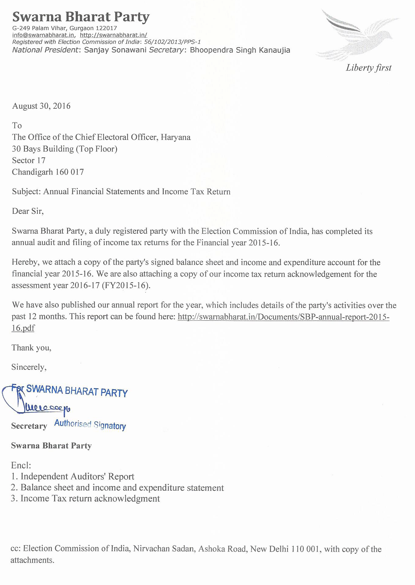
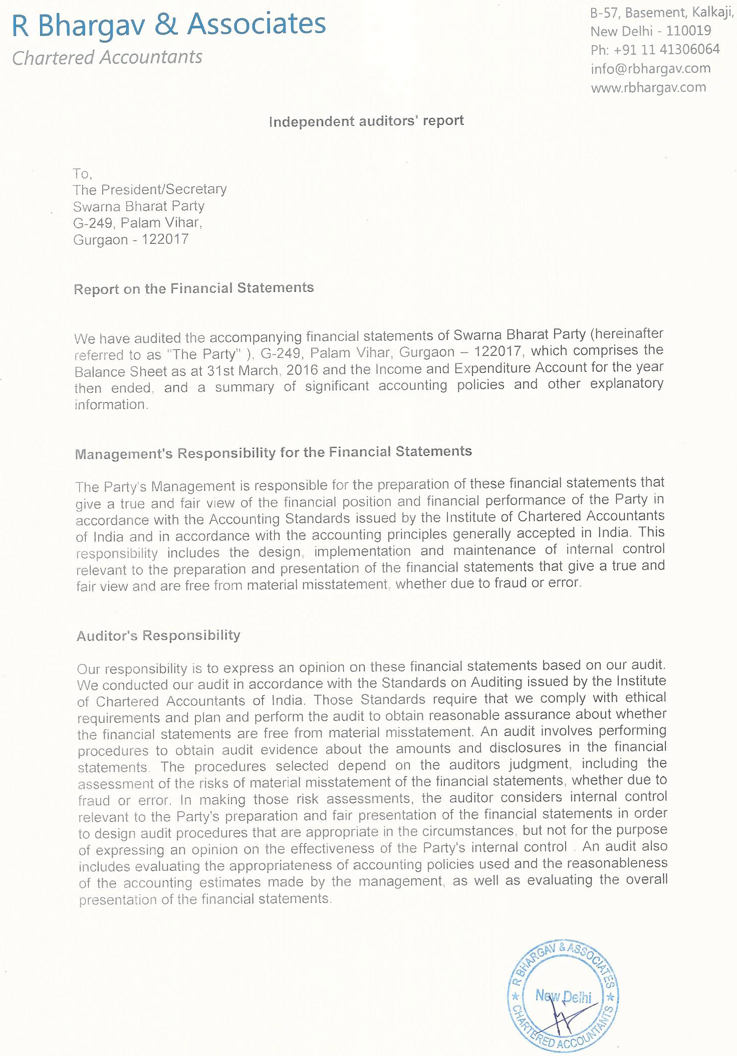
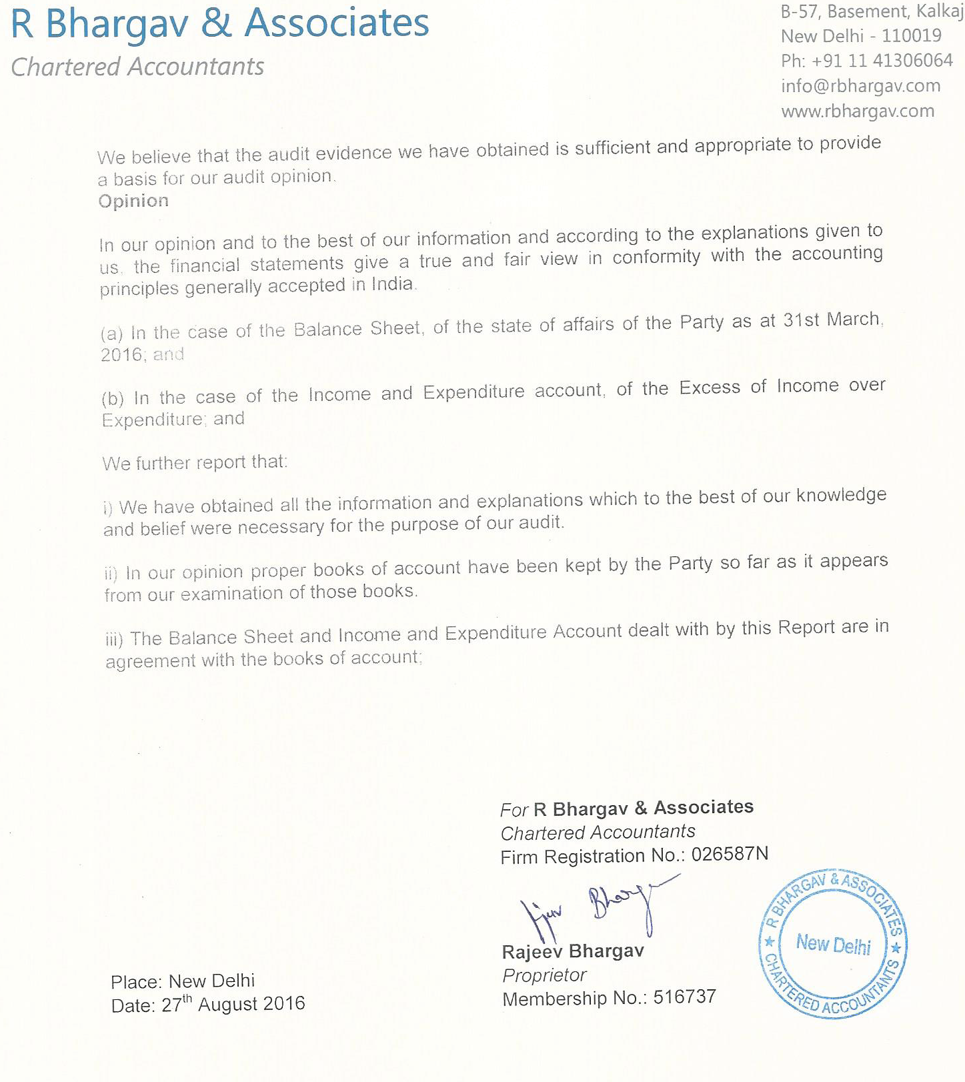

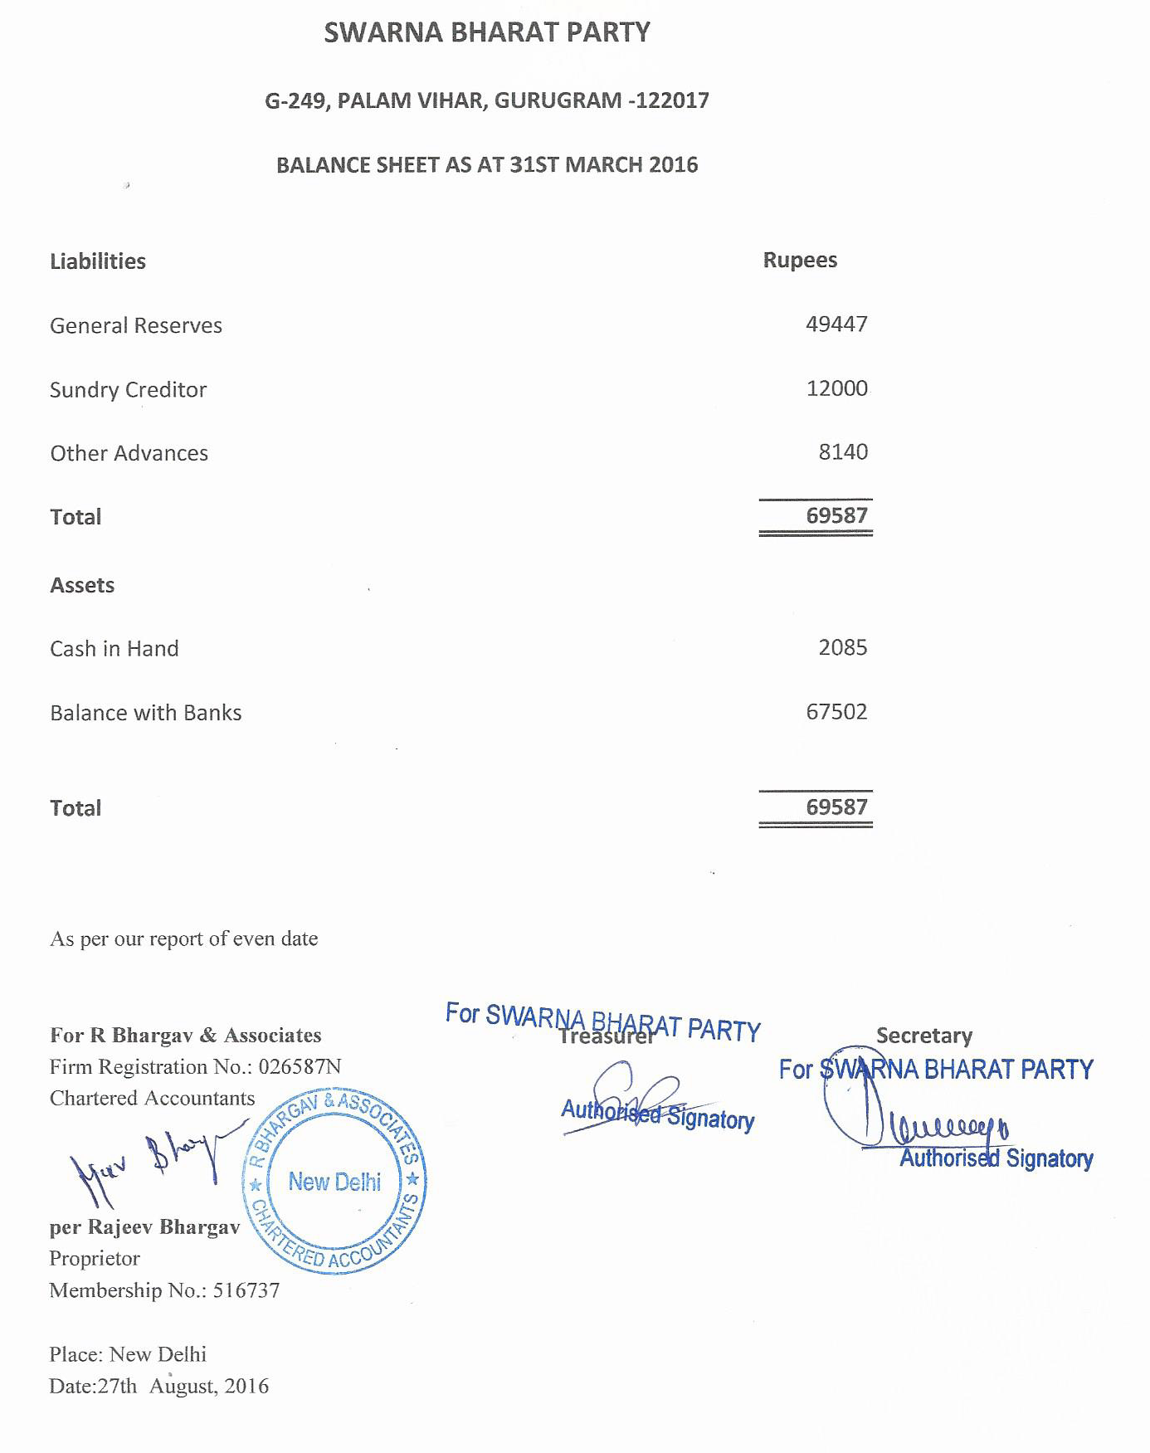
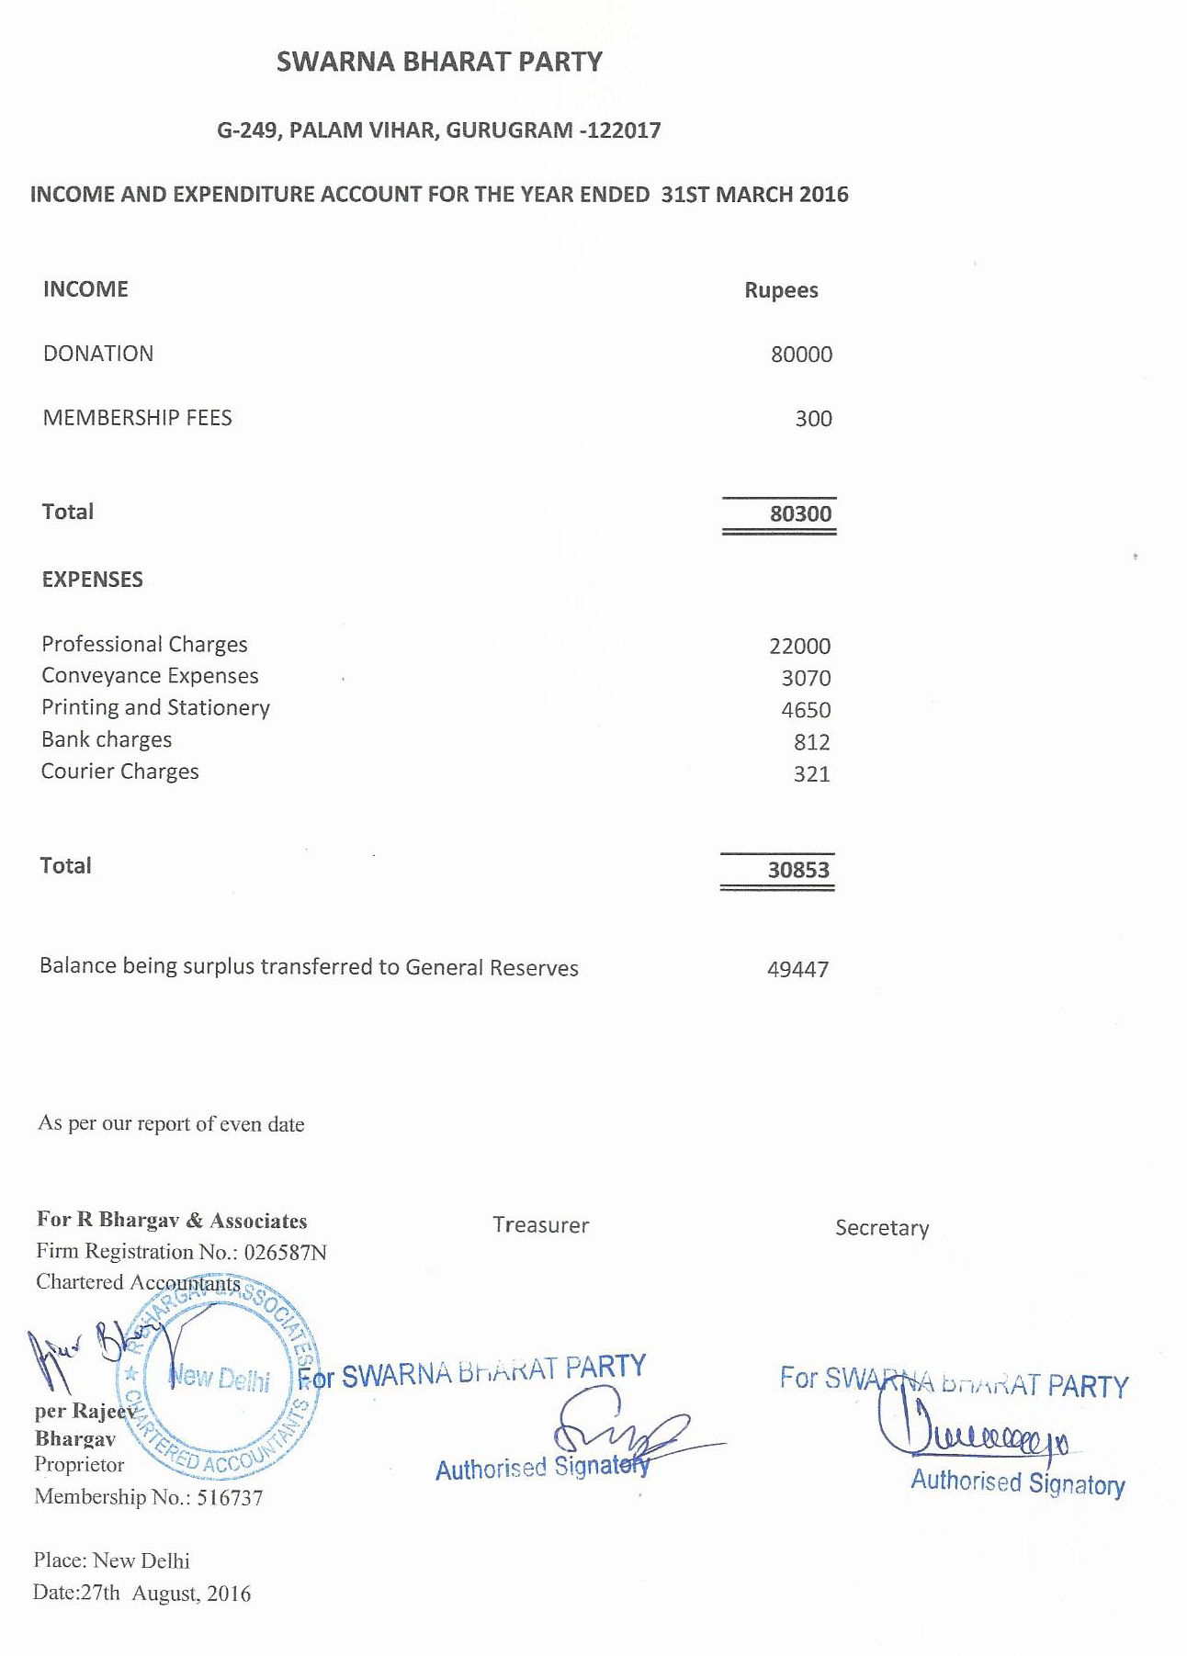

fORM 24a PROVIDED TO THE Election Commission

Record of donations above Rs.20,000
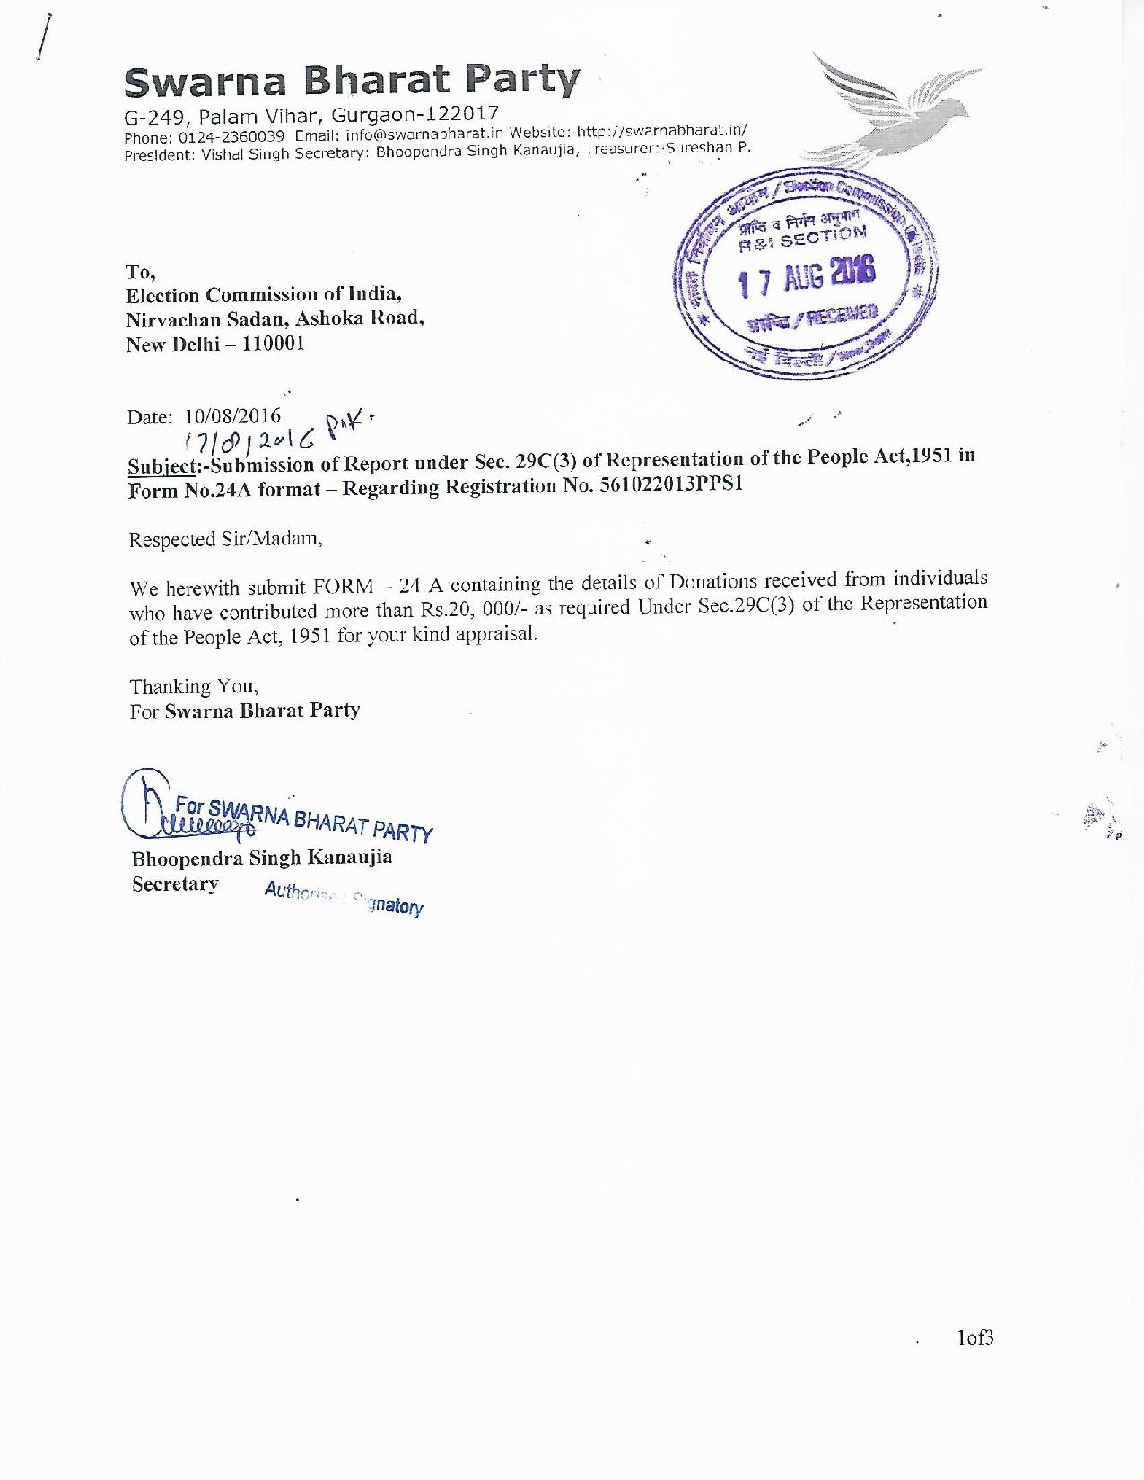
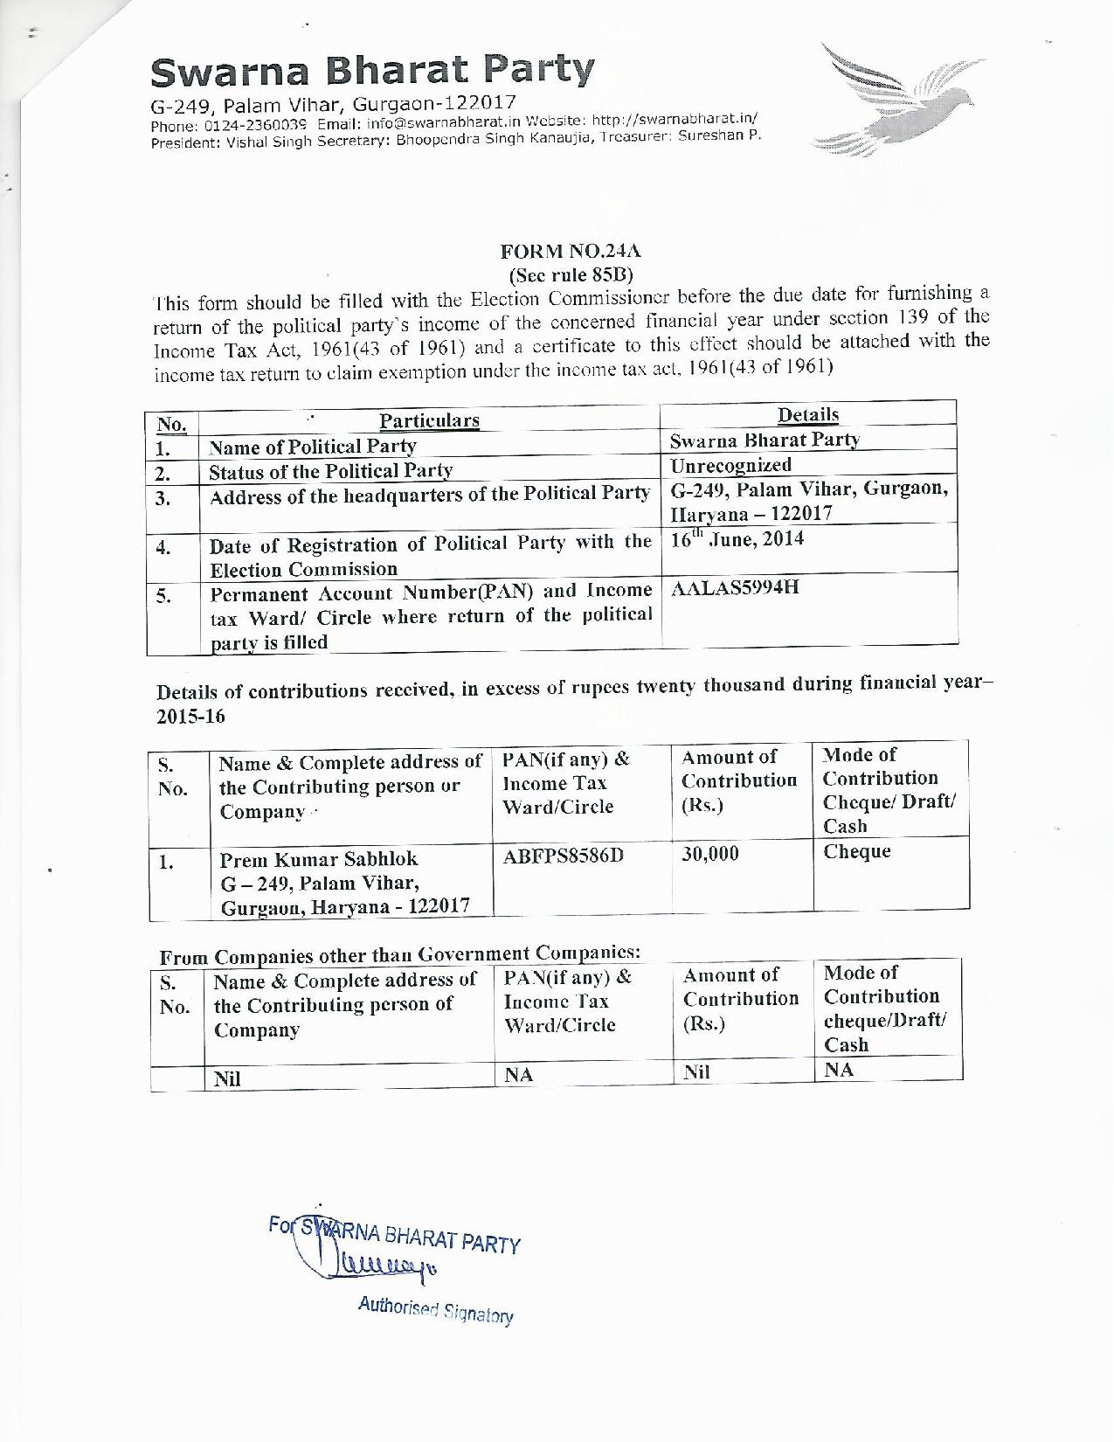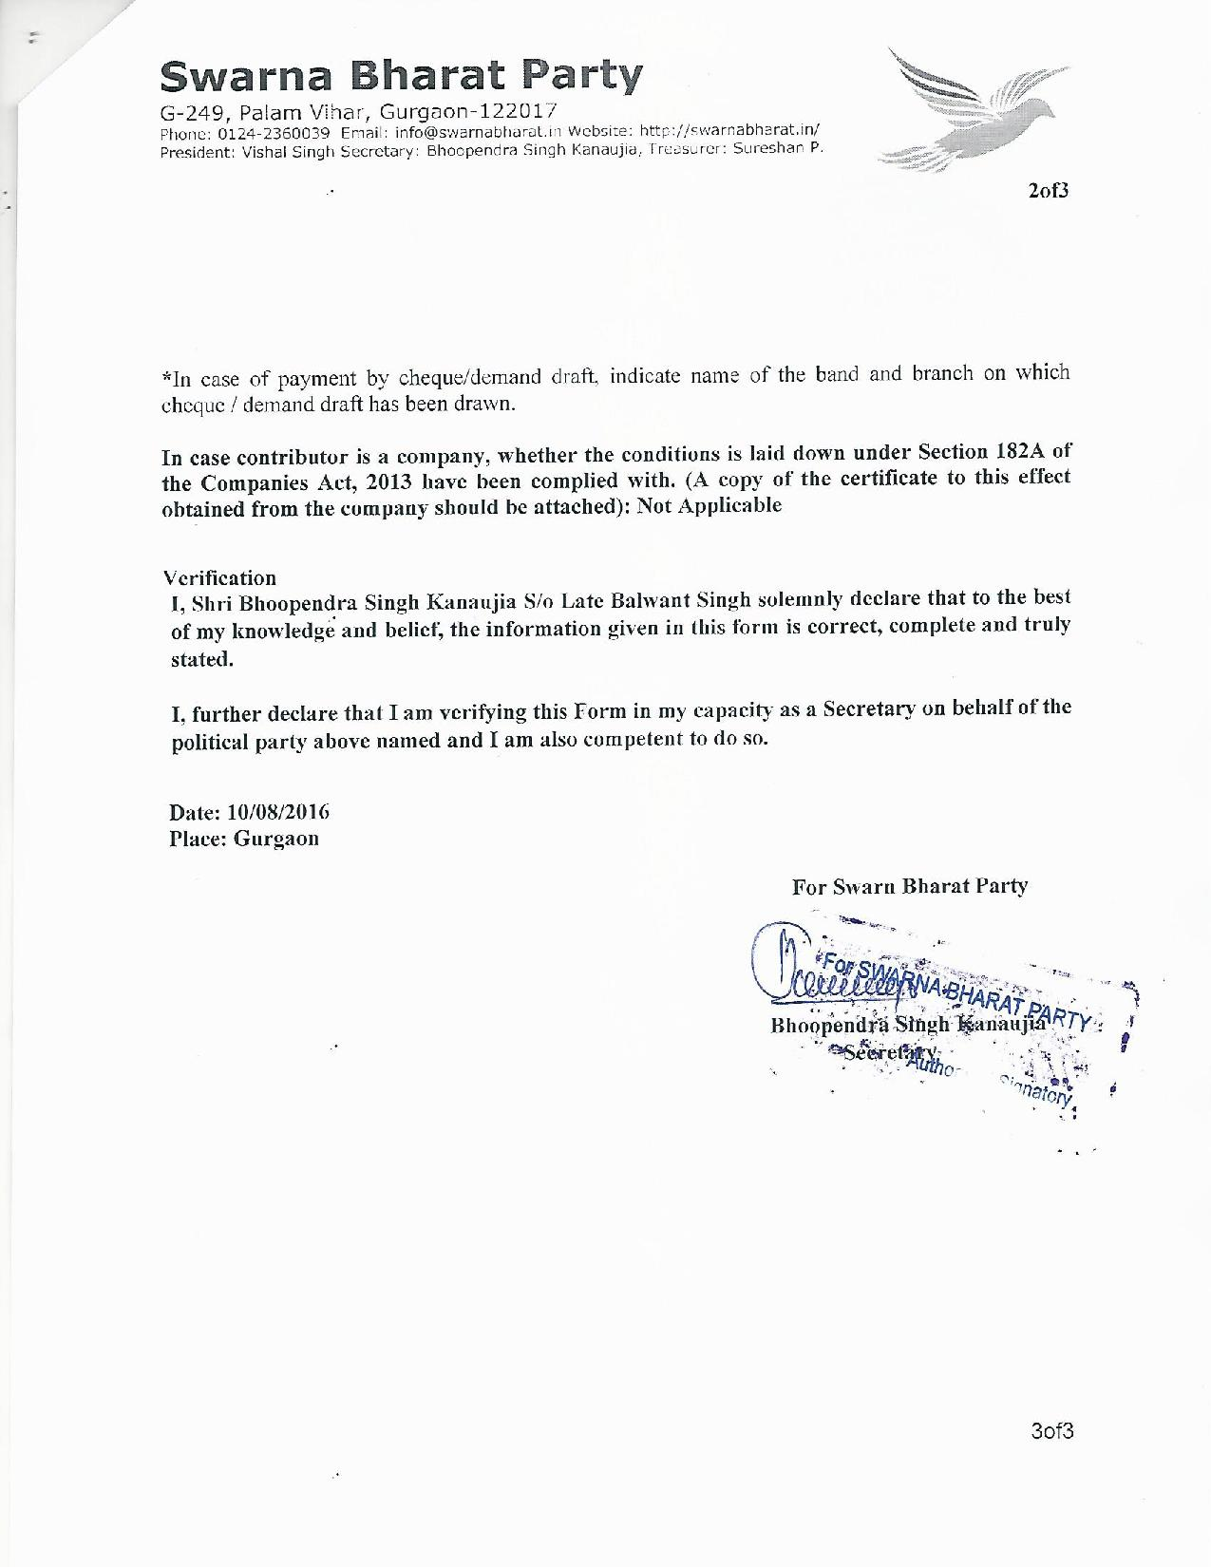

Income Tax return of the party for the assessment year 2016-17

Income tax return
