Why liberalism works and socialism doesn't. Always.
- Abhinav Tyagi
Forcing somebody to care about your morals is immoral.
Who’s to say that your morals are superior to mine?
Who’s to decide that selling my body for money is wrong?
Yet, socialism in all its form preaches exactly that.
And what do you get it in return for accepting this system with hope and applause?
You’re forced to sell your body, for free.
As an ex-Marxist, I am disgusted at my former self.
Marxism says that I should be taken care of just because I breathe.
Whereas American Constitutionalism (classic liberalism/American conservatism/capitalism) says if I don’t add value to your life, I starve.
Marxism in all its forms is the most immoral form of governance.
It tries to defy basic common sense and presumes Marx’s fantasies to be the word of an incorruptible God, defeating the very purpose socialism tries to establish – contempt for the supernatural, as summarised in Marx’s quote, “Religion is the opium of the people”.
In contrast, though an irreligious person himself, Jefferson just said that a priest should not interfere between an individual and his connection with God, thereby establishing a complete separation of Church and state in a way that nobody was offended.
As opposed to the leaders of the rest of world who suppressed individual freedom because “people need to be controlled otherwise they’ll disrupt the whole system”, America’s founding fathers entrusted their people and said: government has no right to interfere with an individual’s freedom to possess firearms.
(This is the message I want to send to all my fellow Indians and politicians. Stop thinking that Indian civilians are bigots who’ll destroy everything after being given such rights.)
Basically, everything Jefferson did was paranormally great if you think about it.
Thank God that the American declaration of independence, though written by him, cannot entirely be attributed to him, otherwise I’d have been forced to think twice about my atheism. Because such perfection can only be endowed by god.
If you don’t believe me, here’s a little challenge for you (a very famous one): find me a state or a society that overthrew socialism and theocracy, and adopted the teachings of the American Constitution, that still remains an underdeveloped country. Go ahead, leave a comment to educate me if you find one.
Meanwhile, let me put down a few socialist states that have failed their people miserably:
- North Korea (in contrast to Allied South Korea)
- Cambodia (Pol Pot’s communist regime killed a quarter of the country’s population in four years.)
- German Democratic Republic (collapsed on Itself, in Contrast to uber powerful West Germany)
- Pre 1991 India (bankruptcy lead to minor liberalisation by PM P.V Narasimha Rao, why you and I are able to eat 500 bucks pizza today without thinking about it)
- Soviet Union (in contrast to the United States Of America)
Governments come and go, regimes change all the time, except one. The American revolution - t
he single revolution that has stood the test of time and helped generations after generations to succeed, ever since it was originally adopted in 1776.
That number, 1776, if that doesn’t make you realise the accuracy of the principles on which that country is governed, I don’t know what will.
The screen on which you’re reading this text, the hardware that it runs on, the freedom of speech which allows you and me to communicate and the electricity that powers your device are all a result of western style (classical) liberalism.
Many people will say, oh Indians are no less.
You certainly are correct. Many Indians who move to those countries invent many things.
If we could bring those policies that allow Indians to flourish in the west to India, they would start inventing those things in India.
And those policies are exactly what are summarised in the term, “classic liberalism” - p
olicies that empower citizens over their governments, that favour small government.
Remember, bigger the government, more the corruption.
Smaller government has historically equated to a happier you. Again, educate me on this if you can find an exception. Meanwhile let me share with you what a big government does to its people:
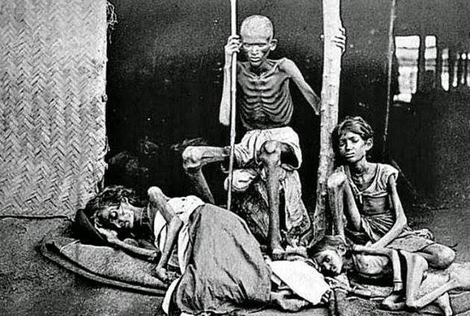
Chinese Famine Post Mao's Revolution. Human life has no value in a communist state. In India, we do face this issue though not nearly at the same level, thankfully.

​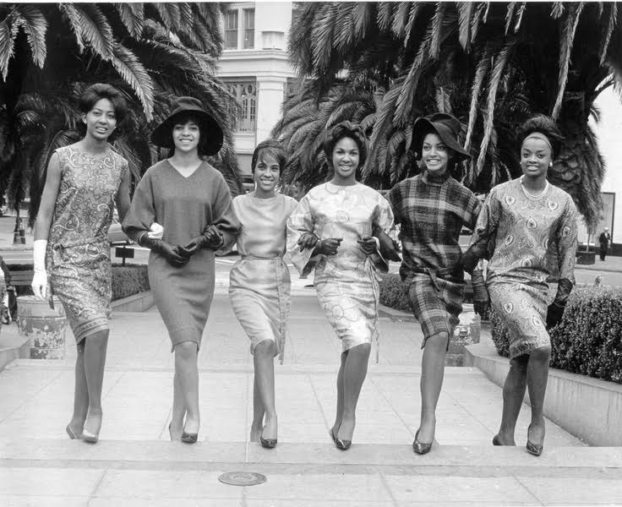
Meanwhile, this was America in the 1960s
I’m ending this article right (because just like the government, I like to keep my articles small because truth doesn’t need a lot of explanations) by saying this:
“Socialists take away your rights because they don’t believe that human beings are inherently good, (classical) liberalism negates this view and says, when left on his own, an individual finds his way to fulfilling his happiness, perhaps by contributing something to the society perhaps not, it’s his choice”.
And the result? USSR collapsed after starving millions not only of food but of choice too. I hope we can save our country from this atrocity too, Jai Hind.
(Fun Fact: Many Soviet Spies Deployed In USA, Never Returned)
Note:
People these days talk a lot about the Scandinavian model. It's a failed model. After adopting social welfare policies in the 1950s, things have gone downhill for Scandinavia. Even the oil rich countries like Norway, which previously equated to the USA in terms of standard of living, are now half as good on those indicators. Socialism, in all its forms, kills human aspiration and dignity, and when people start resorting to drugs to compensate for it, socialists begin cracking down on drugs. They are the masters of addressing the symptoms, not cause.
Now let me ask you a question, Americans are given rights to possess military style firearms in order to be able to defend themselves in case the government turns tyrant. Why is it, that the first thing a socialist regime does after coming to power, that they attack these rights? Hmmmm….

