Genetically modified crops and Bt-brinjal – a handout for the People of India
OUR PARTY’S POSITION
Our party is committed to the health, wealth and all-round success of Indians. This cannot be achieved without a strong focus on science. Equally, we are very cautious about supporting modern technologies that have not been proven. However, we believe that there is more than sufficient evidence to declare that scientifically approved GM crops are extremely safe. These crops can dramatically improve human and environmental health in India.

WORLD HEALTH ORGANISATION’S STRONG SUPPORT FOR GM CROPS
This is what the WHO says on its website:

Are GM foods safe?
GM foods currently available on the international market have passed safety assessments and are not likely to present risks for human health. In addition, no effects on human health have been shown as a result of the consumption of such foods by the general population in the countries where they have been approved.
How is a safety assessment of GM food conducted?
The safety assessment of GM foods generally focuses on: (a) direct health effects (toxicity), (b) potential to provoke allergic reaction (allergenicity); (c) specific components thought to have nutritional or toxic properties; (d) the stability of the inserted gene; (e) nutritional effects associated with genetic modification; and (f) any unintended effects which could result from the gene insertion.

INDIA’S OWN REGULATOR HAD FINALISED ALL STEPS FOR APPROVAL FO BT-BRINJAL IN 2009
2002: India fully tested Bt and approved Bt cotton on 26 March 2002. This crop has dramatically improved production and farmer welfare. Today over 90 per cent of cotton in India is Bt cotton.
2009: The GEAC (India’s statutory regulator) concluded after extensive studies from 2000 to 2009 that Bt brinjal is safe for humans. All it needed was to exercise its legal power and issue the approval. Through a major blunder, it reported the results to the then Minister as a courtesy but the Minister (Jairam Ramesh) went well outside his powers and placed a moratorium on Bt brinjal. The Minister’s only area of training is in basic engineering. He had zero knowledge of biology. In his great arrogance he over-ruled India’s best scientists and ignored the fact that Bt brinjal had been invented in India – a matter of great national pride. Our party believes that Bt brinjal is technically validated in India and politicians are blocking its use out of their ignorance, arrogance and spite fo science.
BANGLADESH REGULATOR APPROVED BT BRINJAL IN 2013
Bangladesh did its own testing and approved Bt brinjal in 2013. Their Agriculture Minister has confirmed that the improved GM varieties do not harm human or environmental health. Today 17 per cent of Bangladesh's brinjal farmers have adopted Bt brinjal and this uptake is increasing every year.
ENVIRONMENTAL PROTECTION AGENCY OF USA EXPLAINS WHY BT IS SAFE
EPA tested the Bt protein repeatedly for over 20 years and says: “The EPA believes that protein instability in digestive fluids and the lack of adverse effects using the maximum-hazard dose approach eliminate, in general, the need for longer-term testing of Bt protein plant incorporated protectants”.

Visit: http://swarnabharat.in/gm
WORLDWIDE APPROVALS OF A WIDE RANGE OF GM (INCLUDING BT) CROPS
To date, 517 genetically modified organisms including foodcrops have been approved globally by various regulators. These include: alfalfa, apple, Argentine canola, bean, carnation, chicory, cotton, cowpea, creeping bentgrass, eggplant (brinjal), eucalyptus, flax, maize (corn), melon, papaya, petunia, plum, Polish canola, Poplar, potato, rice, rose, safflower, soybean, squash, sugar beet, sugarcane, sweet pepper, tobacco, tomato and wheat. Dozens more are under various stages of trials and testing before commercial release.
MASS-SCALE ADOPTION OF GM (INCLUDING BT) CROPS ACROSS THE WORLD
As an illustration, this chart about adoption by USA (including of Bt crops) is taken from the Time magazine
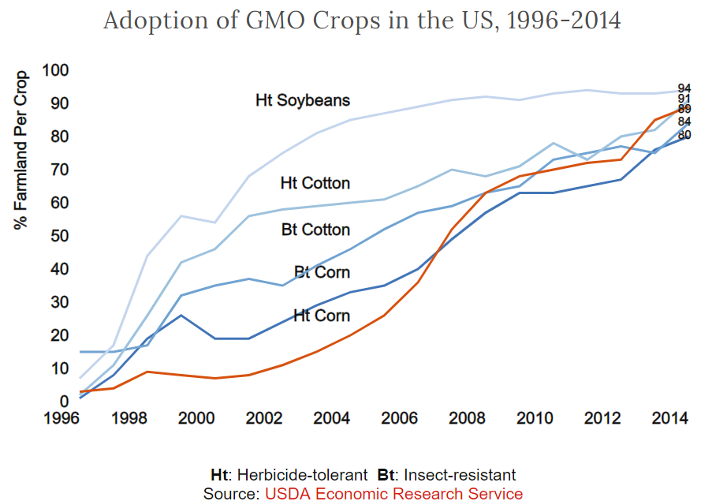
Trillions of animal meals and billions of human meals containing GM crops have been consumed since 1995 across the world with not a single reported instance of adverse effects. In India around 11 lakh tonnes of cottonseed oil is consumed domestically, almost all of it made from Bt cotton, which has the Bt protein. And a vast amount of GM canola oil is imported from places like Canada each year. No Indian has taken ill from this.
STRONG SPPORT FOR GM CROPS BY ALL MAJOR GLOBAL EXPERT BODIES AND REGULATORS
All of the world’s major scientific and regulatory bodies have confirmed that the food and feed derived from GM crops is safe – on par with conventionally produced food. These bodies are too many to name, but include the six major science academies in India, the American Medical Association, the National Academy of Sciences (USA), Food Standards Australia & New Zealand, the Royal Society of Medicine (UK), the European Commission and the World Health Organisation.
But what about the “hundreds” of studies that anti-GM activists keep talking about?
Over two thousand studies dealing with the safety of GMOs have confirmed their safety. A handful of studies, published in poor quality journals without adequate controls, have raised some minor questions, most of them entirely speculative. Not a single demonstrated case of harm to any human has been proven to date.
ISSUED ON 10 JUNE 2019 TO SUPPORT FARMERS UNDERTAKING CIVIL DISOBEDIENCE IN AKOLA AGAINST ATROCITIES BY THE HARYANA GOVERNMENT AND BANS ON SCIENTIFIC PROGRESS BY THE GOVERNMENT OF INDIA
Visit: http://swarnabharat.in/gm
JOIN SWARNA BHARAT PARTY TO FIGHT THE ANTI-SCIENCE SOCIALISTS. Let’s make India sone ki chidiya.

